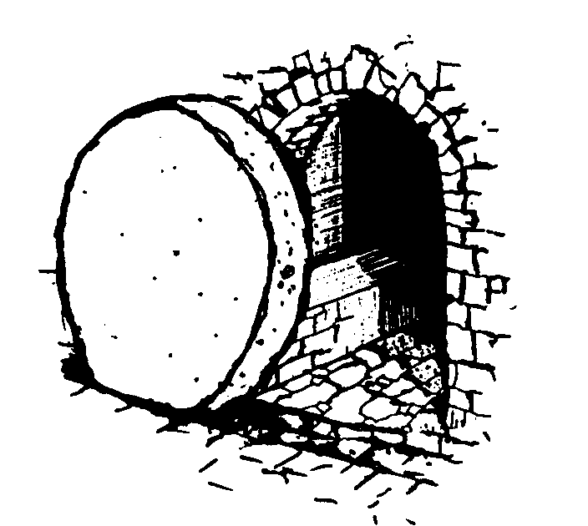
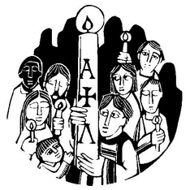
The EASTER VIGIL is our gathering to celebrate the Resurrection of the Lord. The Paschal Candle is lit from the Easter Fire and carried as our symbol that the Risen One is now with us. CHRIST OUR LIGHT !
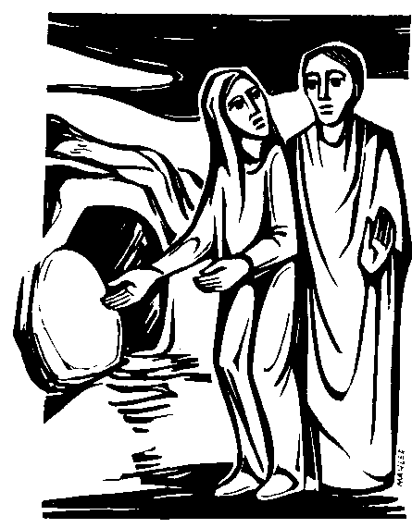

We recall in reading the Easter Gospel that Jesus appeared in the Garden to Mary. She was searching for the body of Jesus as the grave was empty. Presuming this person was the gardener she asked him where the body was. Jesus simply spoke her name “ Mary” and suddenly she recognised her friend and said “ Rabuni” “ Master” Jesus sent her to find the others and to tell them this GOOD NEWS. Mary is called the “ Apostle to the Apostles “
Rushing to the Tomb, Peter and John discovered everything as Mary had shared with them.

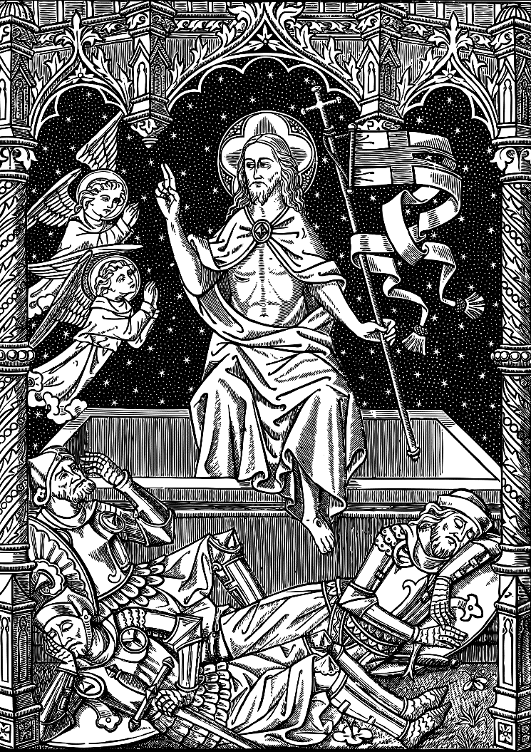
An old etching shows us Jesus rising up The soldiers asleep as He rises in Glory. ALLELUIA

