RISEN
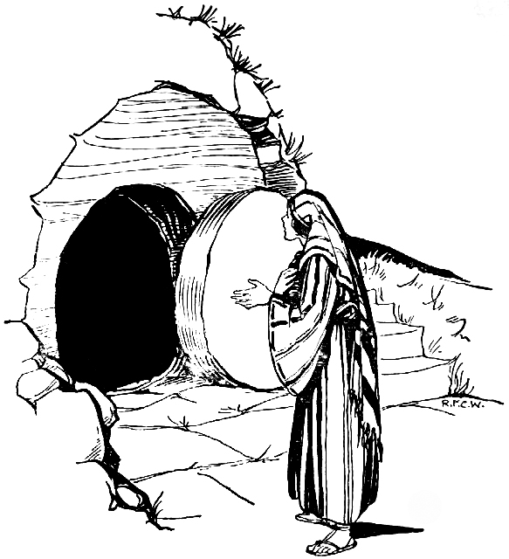

THE EVIDENCE
Let’s imagine that we are detectives investigating the disappearance of the body of Jesus. Let us then interview various people who we were witnesses of what happened. Let’s find out “who done it”!
1) Our first Witnesses: Joseph of Arimathea and Nicodemus
“Yes we went to Pilate and asked for the body of Jesus. We were both followers of Jesus but we had kept that a secret up to this point. But now we plucked up our courage and we asked Pilate if we could bury the body of Jesus. He gave us permission and we took him down from the cross and prepared him hastily for burial. There wasn’t much time – it was almost the start of the Sabbath when no work could be done. As we took down his body there was no doubt in our minds that he was indeed dead. When the soldier had pierced his side with a spear congealed blood and clear fluid had flowed out – a sure sign that the body has been dead for at least a few hours. He was stone cold when we took him down from the cross and put him in the tomb. We wrapped his body in a mixture of myrrh and aloes weighing about 100 pounds. And then we rolled the stone over the entrance of the tomb and left. It was the beginning of the Sabbath and no work could be done on that day.”
2) Our next witnesses: the Soldiers guarding the tomb
“On the Saturday morning we were told to guard the tomb of Jesus in case his disciples came to steal his body. You see, Jesus had actually said that he was going to rise again after three days, and the Chief Priests had asked Pilate to be allowed to guard the tomb. So on that Saturday morning we went into the tomb to check that his body was still there and then we rolled the stone back over the entrance and sealed it. This was done by stretching ropes across the entrance and sealing them with a lump of clay impressed with the Chief Priest’s seal. There was no way that anyone could move that stone without breaking the seal.
Then we watched and guarded the tomb. Early in the morning there was a great earthquake. And then, in a blinding shining light, an angelic being came down from Heaven and rolled the stone away. We were terrified! We could not move – we were like dead men. Eventually, when we came round, we ran off and told the Chief Priests what had happened. They were shocked and horrified but they got together with the elders of the people and together they came up with a concocted story. They give us money and told us to say that his disciples had come in the night and stolen his body while we were sleeping. But I tell you: we were not sleeping, we had watched all night long. We were afraid of getting in trouble with the Roman Governor but the the Chief Priests said that they would make everything right with him. We are telling the truth now. Don’t let us be punished.”
3) Our next witness: one of the Chief Priests
“To be honest, we have no idea what happened to the body of Jesus. His disciples are out and about telling everyone that he is alive. One of them, Simon Peter, spoke to a huge crowd on the day of Pentecost. He was claiming Jesus had risen from the dead. He talked about King David’s tomb being in the city of Jerusalem and King David’s body still lying there to this day. But he also said to them ‘the tomb of Jesus is empty, he has risen’. Well, it is true that the tomb is empty – you can go and look at it. We Chief Priests have no way of explaining this. The soldiers came up with some story about an angel but we don’t know what to believe.
You Roman’s can’t explain it either. I would say to Pilate, ‘if you have his body then why don’t you just produce it. We haven’t got the body, but if we had it we certainly would produce it and scotch all these rumours’.”
4) Our next witness: one of his followers, Mary Magdalene
“I came to the tomb early on the Sunday morning with some other women. We were not aware that the Romans had set a guard and sealed the tomb and we were hoping to be able to roll the stone away ourselves and to put some extra spices on the body of Jesus. You see, there had not been enough time to adequately prepare his body because of the Sabbath.
But when we got there the tomb was empty, the stone was rolled away and angels appeared and told us that he was alive! And then, as we ran off, we met Jesus himself! He greeted us, and we worshipped him with joy.
Some time later he also appeared to the other disciples. Numerous times over the last few weeks he has appeared to his followers. He showed himself first to the Apostles and then to others who believed in him. At one of his appearances there were at least five hundred of his followers who saw him. You can ask them if you don’t believe me. Or you could ask Peter, or John, or Thomas, or any of the other Apostles. I tell you: he’s alive! He has now gone back to heaven but he is alive. And he has filled us with his Holy Spirit so that we can go out to all the world with his good news.”
This then is the evidence of some of the witnesses
Conclusion
So then “who done it?” Who moved the stone? Who took the body, and what happened to it? Anyone who wishes to debunk the Resurrection has to answer these questions. The evidence of the witnesses indicates that an angel moved the stone, that God took the body and raised Jesus up to eternal life. He appeared to his followers for forty days and then ascended to his Father. At present he is seated at God’s right hand, from whence he shall return one day to judge the world.
I like to think that evidence such as this would have been enough to convince the most sceptical of Roman officers. It’s all there in the Bible. You know, you can’t explain it any other way, unless you’re going to make the Apostles and the Gospel Writers out to be liars. These were people who were prepared to die for their faith in the Risen Lord, and some of them actually were martyred. It would have been much easier for them to have escaped martyrdom by denying the Resurrection. But they couldn’t, because they knew it was true.
“Christ is risen: He is risen indeed!”

Perhaps the most compelling reason to believe in the Resurrection is the total conviction of the Apostles and so many disciples that they had seen Him risen and were prepared to bring this Good News or Gospel throughout the Roman World in the first Century CE in most cases embracing persecution and terrible executions when in fact they could have been spared their lives if they had admitted it was untrue or a hoax. They embraced their deaths proclaiming Jesus was Lord of the living and the dead. Stephen was the first martyr and you can read about his death in the Acts of the Apostle.
