Lenten ‘journey’
A Sacred Space

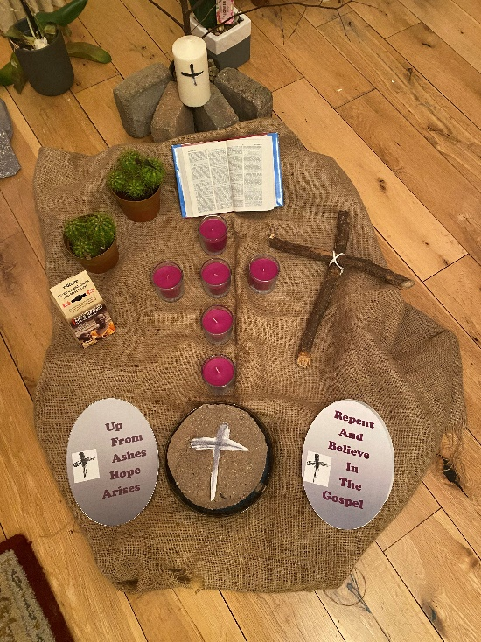
Lentscape
Elements (suggested)
- Piece of hessian fabric creating a desert scene, reflecting the ‘journey’ Jesus made for forty days.
- Two small pieces of wood tied together forming a rugged cross, reflecting where this ‘journey’ would take Jesus where he would ultimately reveal the Father’s love.
- Lenten Cross of light (similar to the Advent wreath we are familiar with leading to Christmas) in this case lighting a candle for each of the six weeks of Lent beginning the Monday after Ash Wednesday 7th March and each successive Monday after, timing for us the 40 day (6 week) ‘journey’ that is Lent.
- A Trocaire box, reflecting the possibility of giving as a consequence of our reflecting on what we have and on our capacity to share with those who don’t.
- Bowl of ashes from where the journey takes its first steps. Marked with the ‘sign of the Cross’ together we recognize in each other a commitment to companion each other through the ‘journey’
- Two small Lenten banners (included, maybe laminated if possible) cut and placed in the Lentscape.

- The cross, also included to be used as placed on the bowl of ash reminding us of the tradition of wearing this sign on our forehead, including this in the event that due to covid restrictions the practice is still not possible.
- Bible. God speaking through generations.

Up
From
Ashes
Hope
Arises

Repent
And
Believe
In
The
Gospel

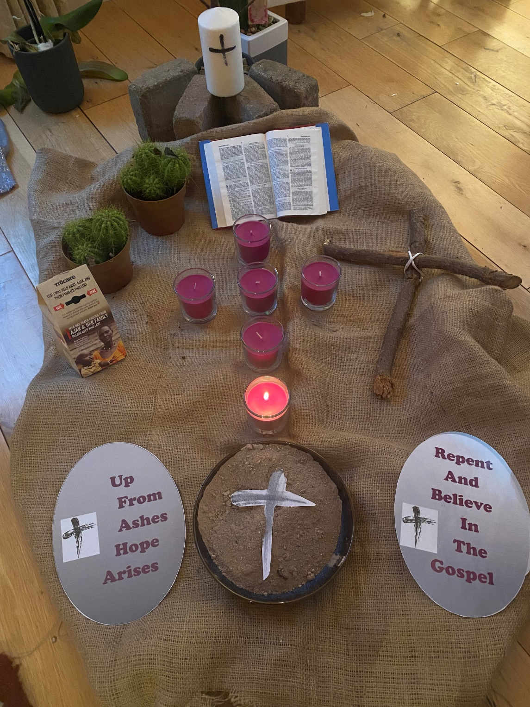
Lent Week 1
Temptation…

As our journey takes hold and we’ve left the uncertainty of, will I, won’t I??
Now to deal with the temptation to go on or give up.

May the light of this first candle of our Lentscape, cast light for my ‘journey’ and our ‘journey’. Enough light to resist the temptation of giving up on myself, on others or on Jesus’ companionship as I try to see the best me possible.

“From ashes hope rises”

Lent Week one

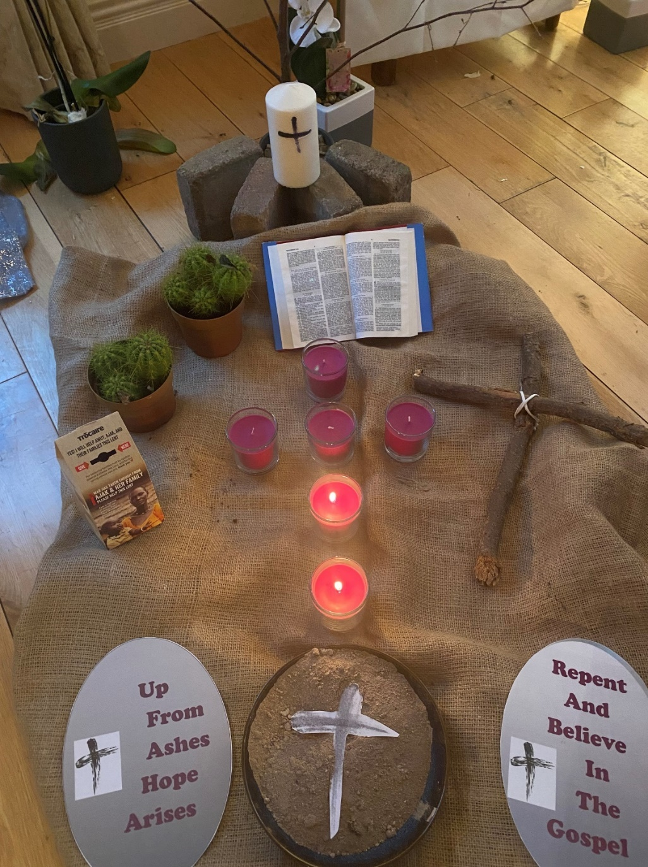
Lent week 2
Forgiveness……

“God is forgiveness, dare to forgive and God will be with you, God is forgiveness, love and do not fear” (Taizé Chant)

Forgiveness is a serious companion to temptation.
So often there is the temptation NOT to forgive and we are left with a festering problem… that’s true with forgiveness of self as well as of others.

May the second light of the Lenten Cross illuminate a courage within us that might help us DARE to forgive.

Lent Week two

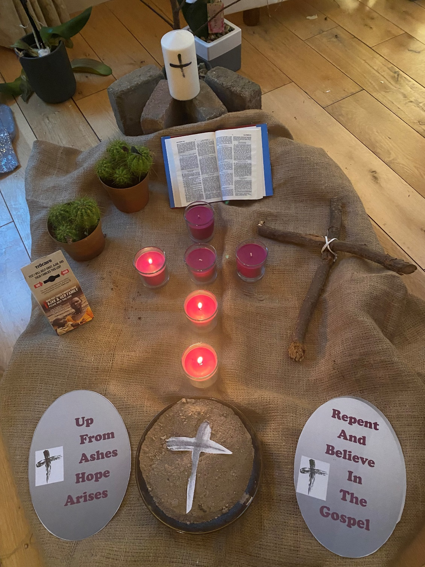
Lent Week 3
Giving…..

An old saying ‘God loves a cheerful giver’
We do experience first world problems for sure, problems for us for sure, but in Global terms there are many who don’t have what WE have.
Lent usually challenges an awareness of those who DON’T HAVE.

May the third light, help to shed light beyond ourselves … not just far away bur also right around us. In our country, parish, school as well as globally. What can I give from what I HAVE?

Lent Week Three

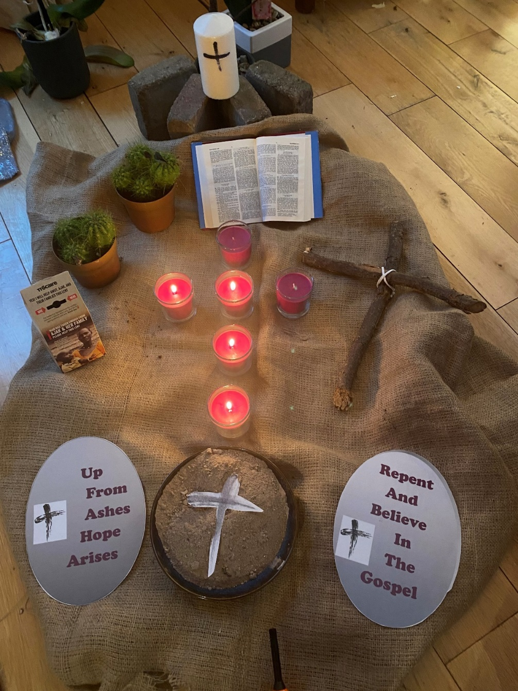
Lent Week 4
Word….

God speaks through generations. We call the Bible ‘The Word of God’
I heard it put another way recently… as ‘The Word of our Ancestors’
We are more aware of the ‘Word of God’ than we think, it has been past on to us from generations before us. It has, without us realizing it, informed the words we use.

May the fourth light of the Lenten Cross reveal to us the power of ‘WORD’ the things we say and the mark it leaves on those who hear it.

“People will forget what you said, they will forget what you did. But people will never forget the way you made them feel” (Maya Angelou)

May we try this week not just to hear the words we say and but also to hear just how the one who is hearing us is left feeling.

Lent Week Four

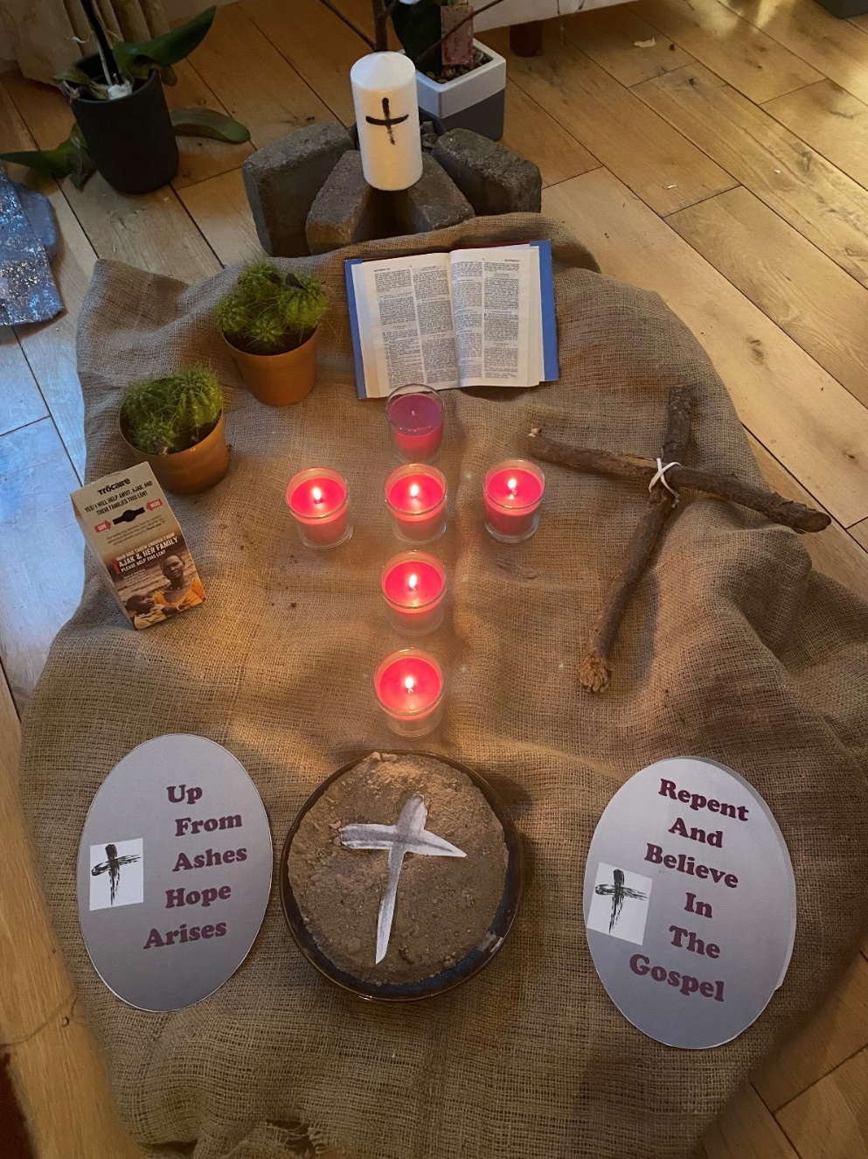
Lent Week 5
Prayer….

Prayer, our whispered words with God.
‘I ask …….’ I wait and the waiting breeds uncertainty.
Then, like any relationship, there is the need to say ‘Thank you’ …….
With prayer, there might be a third ingredient ….
A sense of ‘wonder and awe’

May the fifth candle of this Lenten Cross awaken our eyes to nature all around us that is waiting with pent up energy, waiting and ready to burst into new life.

Open our eyes and see the wonder of this planet ‘Our home’.

Lent Week Five

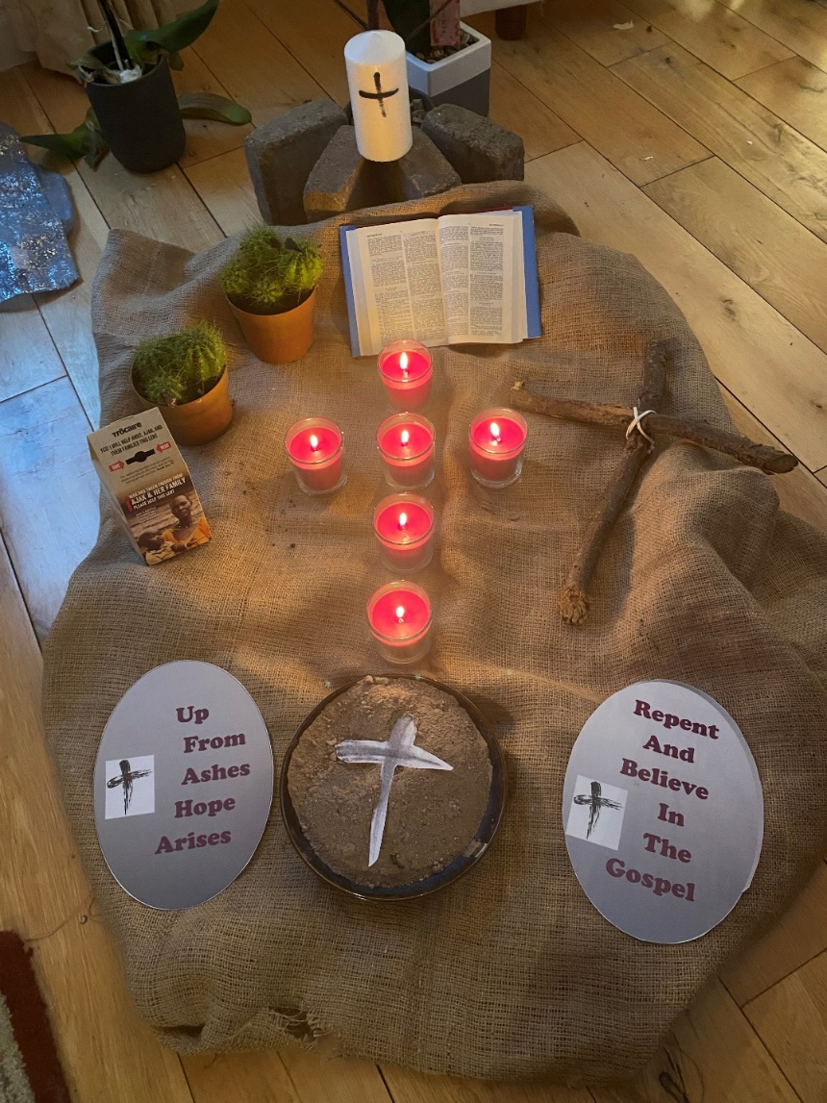
Lent Week 6
‘Journey’ - What’s next?

Our journey began with the sign of the Cross with Ashes of Ash Wednesday.

This marked the beginning of the 40 days where we were mindful of Jesus’ 40 days in the desert just before he set out on his three years of ‘public ministry’

He was tempted, he persevered, and three years later his ‘journey’ brings him to Jerusalem. To Calvary, to the Cross, not of ashes but of wood. To his crucifixion and to his death.
But his ‘journey’ was a ‘journey’ to Calvary and beyond.
‘From ashes, hope rises’

May the light of this sixth candle on our Lenten Cross shine a light beyond Calvary to Resurrection. May it reveal to us hope for new life, renewed and forgiveness

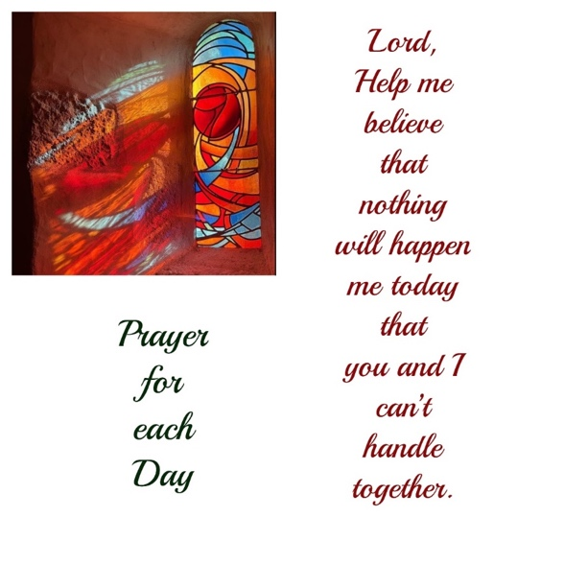

Lent Week
Six

