Christmas Reflection
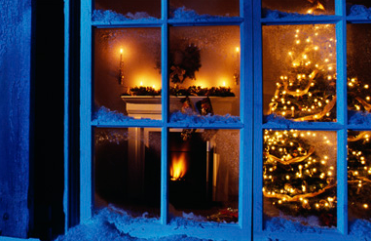
On December 25, two thousand and twenty one years ago, Christ Our Saviour was born.
God the Creator envisioned the future, over two thousand years forward and showed it to Mary and Joseph.
A beautifully decorated evergreen tree stood proudly in the centre of the household, boasting bold shades of red and green. A gold star sparkled on top of the tree and children beneath it laughed and clutched their expensive gifts.
The house was a feast for the senses as delicious smells of meats slowly cooking in the oven filled the air. A rich cake with tiny figures skating on a rink of sweet white icing took pride of place on the kitchen table.
Mary and Joseph were filled with awe and delight at the vision; so much joy and celebration all because of their wonderful son!
They continued to watch. Both the old and the young exchanged gifts wrapped in coloured paper and embraced after looking at the contents. The phrase “Happy Christmas!” was repeated several times.
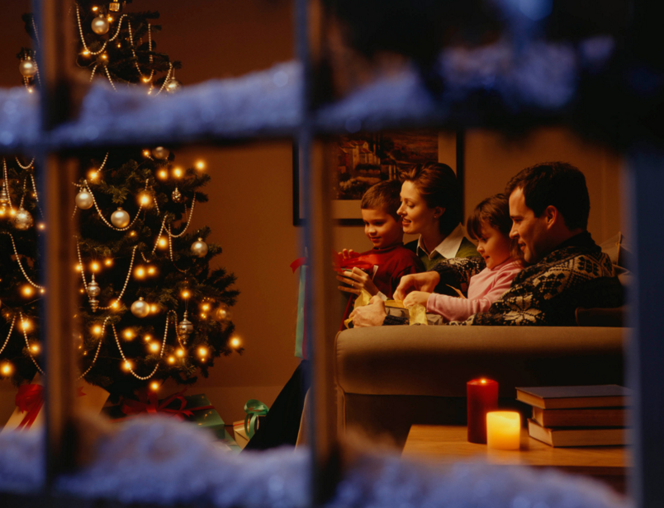
The people then sat at a long table and enjoyed a feast of steaming vegetables, tender meats, sugared cakes and fine wines. They chinked their glasses together and began to eat the delicious meal.
A sadness grew in the hearts of Mary and Joseph… a celebratory day for their birth of their Son… and yet… his name was said not even once.
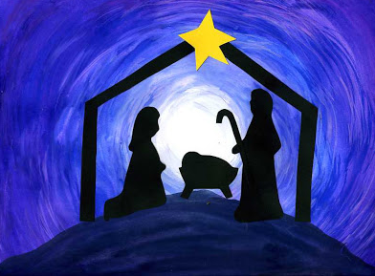

A Christmas Prayer
Jesus, the Light of the World, as we celebrate your birth . . . .
may we begin to see the world in the light of the understanding you give us.
As you chose the lowly, the outcasts, and the poor
to receive the greatest news the world has ever known,
so may we worship you with peace, hope, love and joy in our hearts.
May we also remember our brothers and sisters less fortunate
than ourselves in this season of giving.
Amen.

