What does the Bible tell us about Jesus?

Luke’s Gospel (NRSVCE)

The Birth of Jesus
2 In those days Caesar Augustus issued a decree that a census should be taken of the entire Roman world. ² (This was the first census that took place while^{[a]} Quirinius was governor of Syria.) ³ And everyone went to their own town to register.
⁴ So Joseph also went up from the town of Nazareth in Galilee to Judea, to Bethlehem the town of David, because he belonged to the house and line of David. ⁵ He went there to register with Mary, who was pledged to be married to him and was expecting a child. ⁶ While they were there, the time came for the baby to be born, ⁷ and she gave birth to her firstborn, a son. She wrapped him in cloths and placed him in a manger, because there was no guest room available for them.
⁸ And there were shepherds living out in the fields nearby, keeping watch over their flocks at night. ⁹ An angel of the Lord appeared to them, and the glory of the Lord shone around them, and they were terrified. ¹⁰ But the angel said to them, “Do not be afraid. I bring you good news that will cause great joy for all the people. ¹¹ Today in the town of David a Saviour has been born to you; he is the Messiah, the Lord. ¹² This will be a sign to you: You will find a baby wrapped in cloths and lying in a manger.”
¹³ Suddenly a great company of the heavenly host appeared with the angel, praising God and saying,
¹⁴ “Glory to God in the highest heaven,
and on earth peace to those on whom his favor rests.”
¹⁵ When the angels had left them and gone into heaven, the shepherds said to one another, “Let’s go to Bethlehem and see this thing that has happened, which the Lord has told us about.”
¹⁶ So they hurried off and found Mary and Joseph, and the baby, who was lying in the manger. ¹⁷ When they had seen him, they spread the word concerning what had been told them about this child, ¹⁸ and all who heard it were amazed at what the shepherds said to them. ¹⁹ But Mary treasured up all these things and pondered them in her heart. ²⁰ The shepherds returned, glorifying and praising God for all the things they had heard and seen, which were just as they had been told.
²¹ On the eighth day, when it was time to circumcise the child, he was named Jesus, the name the angel had given him before he was conceived.

Jesus Presented in the Temple
²² When the time came for the purification rites required by the Law of Moses, Joseph and Mary took him to Jerusalem to present him to the Lord ²³ (as it is written in the Law of the Lord, “Every firstborn male is to be consecrated to the Lord”^{[b]}), ²⁴ and to offer a sacrifice in keeping with what is said in the Law of the Lord: “a pair of doves or two young pigeons.”^{[c]}
²⁵ Now there was a man in Jerusalem called Simeon, who was righteous and devout. He was waiting for the consolation of Israel, and the Holy Spirit was on him. ²⁶ It had been revealed to him by the Holy Spirit that he would not die before he had seen the Lord’s Messiah. ²⁷ Moved by the Spirit, he went into the temple courts. When the parents brought in the child Jesus to do for him what the custom of the Law required, ²⁸ Simeon took him in his arms and praised God, saying:
²⁹ “Sovereign Lord, as you have promised,
you may now dismiss^{[d]} your servant in peace.
³⁰ For my eyes have seen your salvation,
³¹ which you have prepared in the sight of all nations:
³² a light for revelation to the Gentiles,
and the glory of your people Israel.”

³³ The child’s father and mother marvelled at what was said about him. ³⁴ Then Simeon blessed them and said to Mary, his mother: “This child is destined to cause the falling and rising of many in Israel, and to be a sign that will be spoken against, ³⁵ so that the thoughts of many hearts will be revealed. And a sword will pierce your own soul too.”
³⁶ There was also a prophet, Anna, the daughter of Penuel, of the tribe of Asher. She was very old; she had lived with her husband seven years after her marriage, ³⁷ and then was a widow until she was eighty-four.^{[e]} She never left the temple but worshiped night and day, fasting and praying. ³⁸ Coming up to them at that very moment, she gave thanks to God and spoke about the child to all who were looking forward to the redemption of Jerusalem.
³⁹ When Joseph and Mary had done everything required by the Law of the Lord, they returned to Galilee to their own town of Nazareth. ⁴⁰ And the child grew and became strong; he was filled with wisdom, and the grace of God was on him.

The Boy Jesus at the Temple
⁴¹ Every year Jesus’ parents went to Jerusalem for the Festival of the Passover. ⁴² When he was twelve years old, they went up to the festival, according to the custom. ⁴³ After the festival was over, while his parents were returning home, the boy Jesus stayed behind in Jerusalem, but they were unaware of it. ⁴⁴ Thinking he was in their company, they travelled on for a day. Then they began looking for him among their relatives and friends. ⁴⁵ When they did not find him, they went back to Jerusalem to look for him. ⁴⁶ After three days they found him in the temple courts, sitting among the teachers, listening to them and asking them questions. ⁴⁷ Everyone who heard him was amazed at his understanding and his answers. ⁴⁸ When his parents saw him, they were astonished. His mother said to him, “Son, why have you treated us like this? Your father and I have been anxiously searching for you.”
⁴⁹ “Why were you searching for me?” he asked. “Didn’t you know I had to be in my Father’s house?”^{[f]} ⁵⁰ But they did not understand what he was saying to them.
⁵¹ Then he went down to Nazareth with them and was obedient to them. But his mother treasured all these things in her heart. ⁵² And Jesus grew in wisdom and stature, and in favour with God and man.

MATTHEW’S GOSPEL
Chapter 2

Joseph Accepts Jesus as His Son
¹⁸ This is how the birth of Jesus the Messiah came about^{[d]}: His mother Mary was pledged to be married to Joseph, but before they came together, she was found to be pregnant through the Holy Spirit. ¹⁹ Because Joseph her husband was faithful to the law, and yet^{[e]} did not want to expose her to public disgrace, he had in mind to divorce her quietly.
²⁰ But after he had considered this, an angel of the Lord appeared to him in a dream and said, “Joseph son of David, do not be afraid to take Mary home as your wife, because what is conceived in her is from the Holy Spirit. ²¹ She will give birth to a son, and you are to give him the name Jesus,^{[f]} because he will save his people from their sins.”
²² All this took place to fulfill what the Lord had said through the prophet: ²³ “The virgin will conceive and give birth to a son, and they will call him Immanuel”^{[g]} (which means “God with us”).
²⁴ When Joseph woke up, he did what the angel of the Lord had commanded him and took Mary home as his wife. ²⁵ But he did not consummate their marriage until she gave birth to a son. And he gave him the name Jesus.

The Magi Visit the Messiah
2 After Jesus was born in Bethlehem in Judea, during the time of King Herod, Magi^{[h]} from the east came to Jerusalem ² and asked, “Where is the one who has been born king of the Jews? We saw his star when it rose and have come to worship him.”
³ When King Herod heard this he was disturbed, and all Jerusalem with him. ⁴ When he had called together all the people’s chief priests and teachers of the law, he asked them where the Messiah was to be born. ⁵ “In Bethlehem in Judea,” they replied, “for this is what the prophet has written:
⁶ “‘But you, Bethlehem, in the land of Judah,
are by no means least among the rulers of Judah;
for out of you will come a ruler
who will shepherd my people Israel.’^{[i]}”
⁷ Then Herod called the Magi secretly and found out from them the exact time the star had appeared. ⁸ He sent them to Bethlehem and said, “Go and search carefully for the child. As soon as you find him, report to me, so that I too may go and worship him.”
⁹ After they had heard the king, they went on their way, and the star they had seen when it rose went ahead of them until it stopped over the place where the child was. ¹⁰ When they saw the star, they were overjoyed. ¹¹ On coming to the house, they saw the child with his mother Mary, and they bowed down and worshiped him. Then they opened their treasures and presented him with gifts of gold, frankincense and myrrh. ¹² And having been warned in a dream not to go back to Herod, they returned to their country by another route.

The Escape to Egypt
¹³ When they had gone, an angel of the Lord appeared to Joseph in a dream. “Get up,” he said, “take the child and his mother and escape to Egypt. Stay there until I tell you, for Herod is going to search for the child to kill him.”
¹⁴ So he got up, took the child and his mother during the night and left for Egypt, ¹⁵ where he stayed until the death of Herod. And so was fulfilled what the Lord had said through the prophet: “Out of Egypt I called my son.”^{[j]}
¹⁶ When Herod realized that he had been outwitted by the Magi, he was furious, and he gave orders to kill all the boys in Bethlehem and its vicinity who were two years old and under, in accordance with the time he had learned from the Magi. ¹⁷ Then what was said through the prophet Jeremiah was fulfilled:
¹⁸ “A voice is heard in Ramah,
weeping and great mourning,
Rachel weeping for her children
and refusing to be comforted,
because they are no more.”^{[k]}

The Return to Nazareth
¹⁹ After Herod died, an angel of the Lord appeared in a dream to Joseph in Egypt ²⁰ and said, “Get up, take the child and his mother and go to the land of Israel, for those who were trying to take the child’s life are dead.”
²¹ So he got up, took the child and his mother and went to the land of Israel. ²² But when he heard that Archelaus was reigning in Judea in place of his father Herod, he was afraid to go there. Having been warned in a dream, he withdrew to the district of Galilee, ²³ and he went and lived in a town called Nazareth. So was fulfilled what was said through the prophets, that he would be called a Nazarene.

WORKSHEET “What does the Bible tell us about St Joseph?

Read the stories about St Joseph from the Gospels of Matthew and Luke.
Read the following sentences and answer either True or False for each statement.
- Joseph was a descendant of King David. _________
- Joseph was married to Elizabeth. _________
- Joseph travelled from Bethlehem to Nazareth to register in the Census. ________
- Shepherds found Joseph, Mary and Jesus in a stable. ________
- Joseph and Mary brought Jesus to be presented in the Temple in Jerusalem. _________
- When Jesus was 11 Joseph and Mary brought him to Jerusalem for the Festival of Passover. _________
- Joseph and Mary found Jesus in the Temple three days later.
_________
- Jesus continued to be disobedient to Joseph and Mary when they returned to Nazareth. _________
- An Angel told Joseph that Mary was going to have God’s Son.
________
- An Angel told Joseph to bring Mary and Jesus to Jerusalem for safety. ________

Extension Activity
In your RE Journal re-write all of the False sentences so they are True.

Worksheet The Church and St Joseph

Complete the table below to build a Fact file on St Joseph.

BORN

DIED

FEAST DAY

SYMBOLS LINKED TO ST JOSEPH

PATRONAGE

THE SLEEPING ST JOSEPH

In Matthew’s Gospel an Angel appears to Joseph several times when he is sleeping. Pope Francis tells us that Joseph watches over the Church – even while he sleeps!! Using the handout you are going to create a Prayer Pillow for St Joseph.
- Cut out and colour the image of the Sleeping St Joseph.
- Fold the provided A4 page along the dotted lines.
- Stick the image of St Joseph in the centre of an A4 page.
- Glue the edges of the page together.
- Write a prayer of petition to St Joseph and place it in inside the Prayer Pillow – just like Pope Frances does!!

Symbols of the Pure Heart of Joseph
Label the diagram of St Joseph to show your understanding of the symbols of the Pure Heart of Jesus.

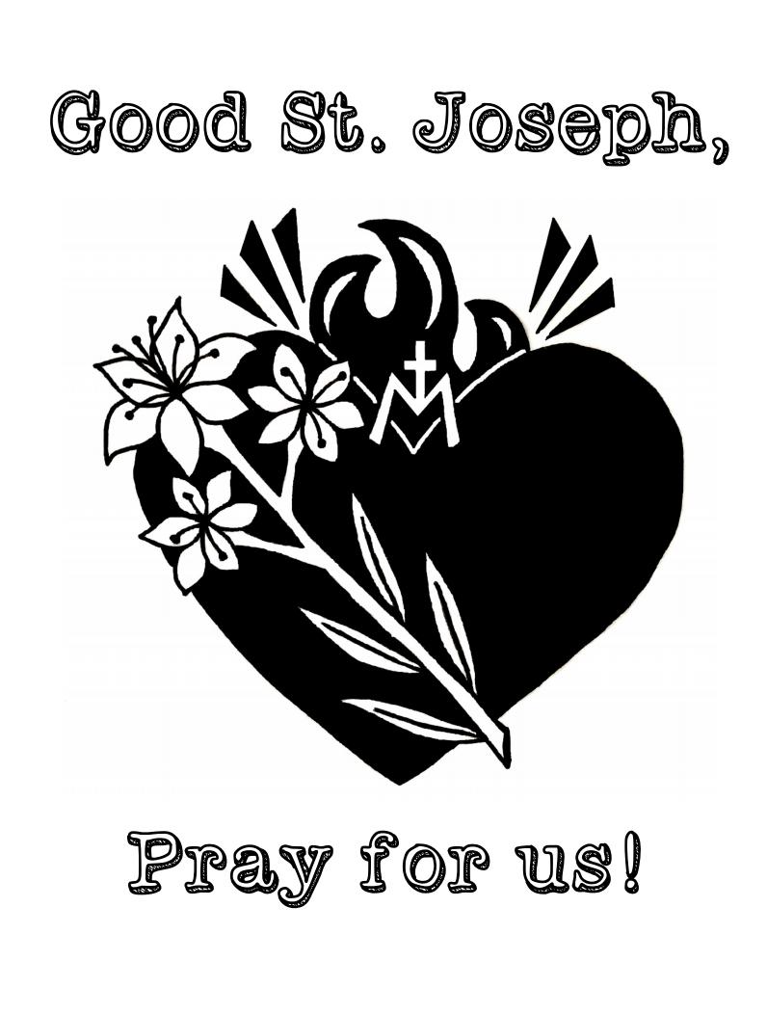

Worksheet “How Did St Joseph Show His Faith In God?
- State ONE way in which Joseph showed his obedience to God. __________________________________________________________________________________________________________________________________________________________________
- State ONE way Joseph showed he was a good father. __________________________________________________________________________________________________________________________________________________________________
- State ONE way Joseph showed his faith in God. __________________________________________________________________________________________________________________________________________________________________
- State ONE way Joseph showed he was a good protector. __________________________________________________________________________________________________________________________________________________________________

Triptych of St Joseph
Use the images below to make a triptych to St Joseph
