Lent classroom liturgy for young people

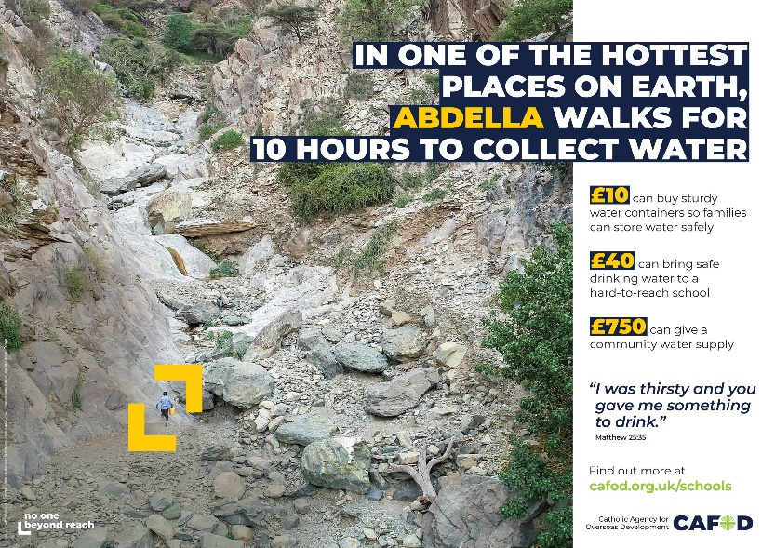
This liturgy is written to be used early in Lent.
It can be used as your liturgy for
Ash Wednesday, if this falls within your
school’s term time.

At the time of writing, as Covid restrictions
continue, protocols for distribution of ashes
have not yet been published. If you wish to
distribute ashes during the liturgy, please
follow the advice of your diocese.

Length: 30 mins

You will need:
- A table, crucifix, Bible and candles to create a focal point
- CAFOD Lent poster for schools (download at cafod.org.uk/secondary)
- A display board, with pins or blu tac, near the poster (people attach prayers to this)
- Quiet music or hymns
- A slip of paper for each participant; if time, water drop shaped (template below).
- Readers
- If this is your Ash Wednesday service: Ashes

You might have music or a hymn for gathering and settling, such as: Come back to me, by Gregory Norbert; Lord, I need you, by Matt Maher; I’ll Stand, by Hillsong; Open my eyes, Lord, by Jesse Manibusan

-------------------------------------------------------------------------

Leader: In the name of the Father, and of the Son, and of the Holy Spirit.

All: Amen.

Lent explained

Reader: The Christian season of Lent is beginning.
Lent is 40 days when we pray, fast and give as we prepare to celebrate Easter.
In prayer, we put aside time to be with God and to let God love us.
In fasting, we give up something we want, so that we can be open to what God wants.
In almsgiving, we give generously to others, as God has been generous to us.

Opening prayer

Reader: Let us pray. [Pause]
Loving and compassionate God,
We believe that change is possible. And we believe that we can help to change the world.
As Lent begins, we pray that, through our Lenten journey,
you will change our hearts and help us to build a better world,
where every person’s dignity is respected, and everyone can live life to the full.
We make this prayer, with faith, through Christ our Lord.

All: Amen.

Scripture reading (part of the second reading for Ash Wednesday, taken from the Missal)

Leader: Let’s listen to our scripture reading for the first day of Lent, from the prophet, Joel.

Reader: ‘Now, now – it is the Lord who speaks – come back to me with all your heart, fasting, weeping, mourning.’ Let your hearts be broken, not your garments torn. Turn to the Lord your God again, for he is all tenderness and compassion, slow to anger, rich in graciousness, and ready to relent.

The word of the Lord.

All: Thanks be to God.

Reflection on scripture

Leader: In the days of the prophet Joel, his people had strayed away from God. Joel called them to be sorrowful because they had not been open to God’s love: “Let your hearts be broken”, in other words, “opened”.

Sometimes we try to protect our hearts by saying, “I’m okay, I don’t need any help”. But if we can open the door of our hearts to God in prayer this Lent, then God who is “all tenderness and compassion”, will come into our hearts. God will begin to heal us, so that we can allow ourselves to be loved and can better love other people.

The reading also calls us to fast. Lent fasting is one way to let God love others through us. When we give up crisps, chocolate or something else that we enjoy, we stand in solidarity with people who do not have enough. It’s like saying, “I want to stand beside you in your need”.

Lent is also a time to give. This Lent, CAFOD asks us to Walk for Water – to do a sponsored walk to help people who have to walk miles every day to fetch water for their families. People like Abdella, a 23-year-old young man who spends ten hours a day collecting water in one of the hottest regions on earth. Through CAFOD, Catholic schools and parishes in England and Wales can support Abdella’s community in Ethiopia.

May our prayer, fasting and giving this Lent help to build a world where everyone’s basic needs are met.

CAFOD story

Leader: Let’s find out more about Abdella and his family.

Show the young people’s Lent video or use slides from our Lent assembly powerpoint. Both are at cafod.org.uk/secondary/lent. Alternatively, you could play all or parts of our national assembly for Lent.

Our [school/year/class] [sponsored Walk for Water/other fundraiser] will be on [date] at [time]. Please think about how you can join in and who could sponsor you so that we can make a huge difference to people like Abdella.

Distribution of ashes and/or Writing prayers

Leader: We now have a minute or two for reflection. You are invited, in silence, to write on your paper a prayer for people who do not have access to clean water.

Quiet music could be played during this time.

If ashes are being distributed:  You now have an opportunity to receive your ashes. The ashes remind us that God made us, that we sometimes turn from God, and that we need to turn again towards God this Lent.  Please wait in silence until you are called forward and take this opportunity to speak and listen to God in your heart.  After receiving the ashes, attach your prayer to the display as a sign that, this Lent, we want to support people who are forced to walk for water.  Pupils come up in turn to receive ashes then attach their paper to the display. | If ashes are not being distributed:  Please wait in silence until you are called forward to attach your prayer to the display as a sign that, this Lent, we want to support people who are forced to walk for water.  Take this opportunity to speak and listen to God in your heart.  Pupils come up in turn to attach their paper to the display.

Show slides from the Lent assembly to aid reflection while people wait to come forward.

Prayers of intercession

Leader: Let us bring all our prayers to God, our loving Father. The response is: Hear our prayer.
(Each prayer can be read by a different person.)

Loving God, we pray for ourselves as we begin this season of Lent. Help us to open our hearts to you so that you can show us your love.
Lord, in your mercy: Hear our prayer.

Merciful God, we pray for our school community. As we pray, fast and give to others, help us also to be generous and forgiving towards one another.
Lord, in your mercy: Hear our prayer.

Creator God, we thank you for our world. Thank you for the gift of water, which brings life to all things. Help us all to care for the world you have entrusted to us.
Lord, in your mercy: Hear our prayer.

God of justice, we pray for communities like Abdella’s, who have to work so hard to get the water they need. Through our sponsored walks and other fundraising, help us to support communities so that they can safely provide for their families.
Lord, in your mercy: Hear our prayer.

Let us take a moment of silence for our own prayers (pause for a slow count of ten).

Father God, we pray together for all these intentions, using the words your Son gave us:

Our Father…

Final prayer

If ashes have been distributed:  Reader: Lord, may these ashes remind us what really matters during Lent.  In our prayer, deepen our awareness of God’s love within us.  In our fasting, make us more aware of other people’s needs.  In our giving, help us to build a better world.  May our Lenten prayer, fasting and giving renew us to celebrate Easter with joy.  All: Amen | If ashes have not been distributed:  Reader: Lord, bless us during Lent.  In our prayer, deepen our awareness of God’s love within us.  In our fasting, make us more aware of other people’s needs.  In our giving, help us to build a better world.  May our Lenten prayer, fasting and giving renew us to celebrate Easter with joy.  All: Amen

Leader: In the name of the Father, and of the Son, and of the Holy Spirit.

All: Amen.

To find out more about this year’s theme and how to Walk for Water this Lent, visit cafod.org.uk/secondary/lent

[Water droplet template is on the following page]



