Fully Alive 1

Worksheets
Lessons 9-15

Veritas

Lesson 9: The Dead Sea Scrolls

Worksheet 13

Imagine the scene when the Dead Sea Scrolls were discovered and draw a picture. On the lines provided, write a brief account of why these scrolls are so important.

________________________________________________________________________________________________________________________________________________________________________________________________________________________________________________________________________________________________________________________________________
Lesson 10: The Story of Ruth in the Old Testament
Worksheet 14

Fill in the missing words using the word bank.

Word Bank
David loyal care daughters-in-law know Naomi kind people Boaz died mother’s Judah Obed begged relative famine prayed work married live happy Ruth delighted God husband corn marry family admired

There was a terrible ____________in the land of ______________, so _______, her ____________ and their two sons decided to move away from there to find a better life. The family soon found ______ and settled down in a new country. The two boys grew up and ___________ two local women. Naomi was_________. She liked her two daughters-in-law, who were called Orpah and_______.
Years later, Naomi’s husband and two sons_______. The women were very sad. Naomi decided to go back to Bethlehem, as she still had ___________ there and the famine was over. She ___________ to God that it would all work out. Ruth, one of the _____________-__-____, wanted to go with her. Naomi tried to get Ruth to return to her own __________ house. Ruth said ‘no’. She wanted to go with Naomi. She __________ Naomi to let her come with her. Ruth told Naomi, ‘Wherever you go, I will go; wherever you live, I will____. Your people will be my ________, and your God will be my_____.’
So Ruth went with Naomi to Bethlehem. In order to _____ for Naomi, she got a job working in the fields gathering _______. The fields belonged to a man called_______. Boaz was a ____________ of Naomi. He told the other workers to be ______ to Ruth. He saw how kind and _________ she was to Naomi. Boaz liked Ruth. Soon they got to ______ each other very well. Naomi was ______________ when Ruth told her that she and Boaz were to __________. Eventually they had a son, whom they named _______. Ruth was the great grandmother of King __________.

Lesson 11: The Evangelists
Worksheet 15

Explain what each symbol means and name the Evangelist that each symbol relates to. Then colour in the symbols.

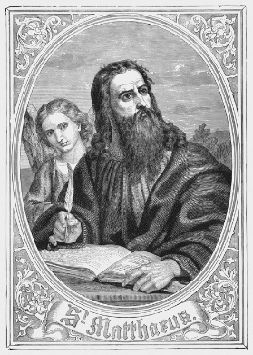

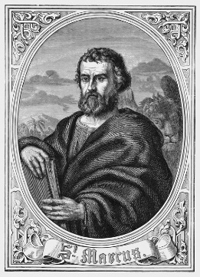

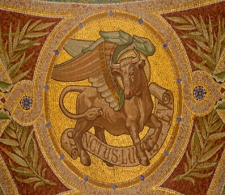

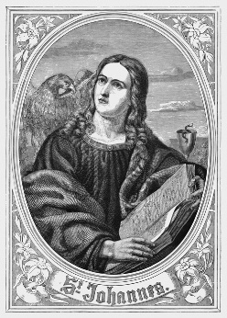

Lesson 11: The Evangelists

Worksheet 16

- Which Evangelist was the first to write his Gospel and for whom did he write it?
__________________________________________________________________________________________________________________________________________________________________

- Which Evangelist was the last to write his Gospel and when did he write it?
__________________________________________________________________________________________________________________________________________________________________

- Why do the four Evangelists differ slightly in their accounts of the story of Jesus?
_____________________________________________________________________________________________________________________________________________________________________________________________________________________________________________________________________________________________________________________________________________________________________________________________________________________

- Do you think it’s important for Christian communities today to read the Gospels? Why or why not?
_____________________________________________________________________________________________________________________________________________________________________________________________________________________________________________________________________________________________________________________________________________________________________________________________________________________

Lesson 12: The Gospel According to Mark

Worksheet 17

- Look up Mark 1:1. Copy the words into the box below and decorate it.

- Fill in the missing words in this paragraph.

The author of the Gospel according to Mark is believed to be the man named Mark who was _____________ to _________ the Apostle. Mark’s Gospel was the _______ Gospel to be written. It was written sometime between AD ____ and ____. It was written for Greek-speaking __________ (non-Jewish) people of ________. The main point of Mark’s Gospel is that Jesus is the _______ of _______.

Lesson 12: The Gospel According to Mark

Worksheet 18

1. Look up the following verses in the Gospel of Mark and complete the statements.

Mark 1:1 tells us that Jesus was ______________________________________________________
Mark 1:41 says that Jesus was _______________________________________________________
Mark 3:5 says that Jesus was ________________________________________________________
Mark 10:14 says that Jesus welcomed the ______________________________________________
Mark 11:12 says that Jesus was _______________________________________________________
Mark 14:34 says that Jesus was______________________________________________________
__________________________________________________________________________________

2. Choose your favourite story about Jesus from Mark’s Gospel and write it out in your own words on the lines below. Say why you particularly like this story.

__________________________________________________________________________________________________________________________________________________________________________________________________________________________________________________________________________________________________________________________________________________________________________________________________________________________

Lesson 13: The Bible and the Teaching Authority of the Church

Worksheet 19
- Explain the following terms:

Sacred Scripture
__________________________________________________________________________________________________________________________________________

Sacred Tradition
__________________________________________________________________________________________________________________________________________

Magisterium
__________________________________________________________________________________________________________________________________________

- Explain why we might need help when considering what a story or passage from the Bible means.
__________________________________________________________________________________________________________________________________________
__________________________________________________________________________________________________________________________________________

Lesson 14: The Importance of the Bible Today

Worksheet 20

1. In the speech bubble below, write about why you think the Bible is important for people today.

2. Write out ten facts that you now know about the Bible.
____________________________________________________________________________________________________________________________________________________________________________________________________________________________________________________________________________________________________________________________________________________________________________________________________________________________________________________________________________________________________________________________________________________________________________________________________________________________________________________________________________________________________________________________________________________________________________________________________________________________________________________

Lesson 15 : Lectio Divina

Worksheet 21

Lectio Divina Activity

Read this story for yourself:

Jesus Blesses Little Children
Some people brought children to Jesus for him to place his hands on them, but the disciples scolded the people. When Jesus noticed this, he was angry and said to his disciples, ‘Let the children come to me, and do not stop them, because the Kingdom of God belongs to such as these. I assure you that whoever does not receive the Kingdom of God like a child will never enter it.’ Then he took the children in his arms, placed his hands on each of them, and blessed them. (Mark 10:13-16)

Then draw or write about what this story is saying to you, or what it means to you.

