Fully Alive 1

Teacher Notes
Lessons 9-12

Veritas

Lesson 9: The Dead Sea Scrolls (optional lesson)

Starter Exercise
- Show Slide 2, the image of the Dead Sea Scrolls, and ask the students what they think it is. If anyone suggests the Dead Sea Scrolls, ask them to share with the class what they know about them.
- Then explain that the Dead Sea Scrolls were a very important discovery made by a young boy in 1947 near Jerusalem and we are going to learn more about them in the lesson today.

Slide 2:
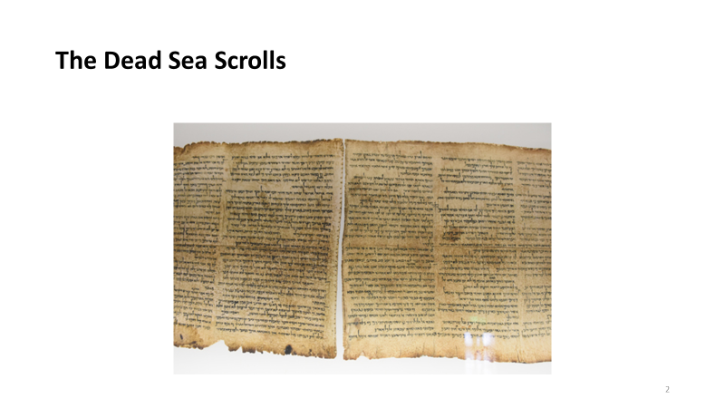

Learning Intentions
- Show Slide 3, the ‘Learning Intentions’ for this lesson.

Slide 3:
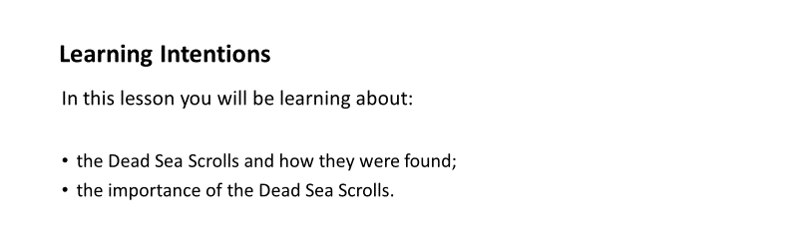

- Show Slide 4, which gives a brief summary of how the Dead Sea Scrolls were found.

Slide 4:
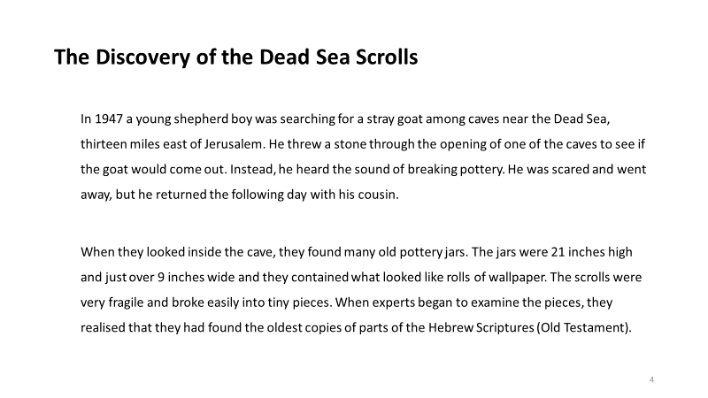

Let’s Talk…
- How do you think the young shepherd boys felt when they discovered the old pottery jars in the cave? What might they have expected to find in the jars?
- How do you think they would have felt when they were told what was in the jars?
- Why do you think the scrolls had not been found before that?

Video: Why are the Dead Sea Scrolls so important?
- Show the video clip entitled ‘Why are the Dead Sea Scrolls so important?’ on this link:

https://www.youtube.com/watch?v=xUwLDzs91CI

- This video clip contains informative and interesting footage on how and when the scrolls were found and the significance of this find.
- After the students have viewed and discussed the content of the video, show Slide 5, which provides some summary facts about the Dead Sea Scrolls and why they are so important.

Slide 5:
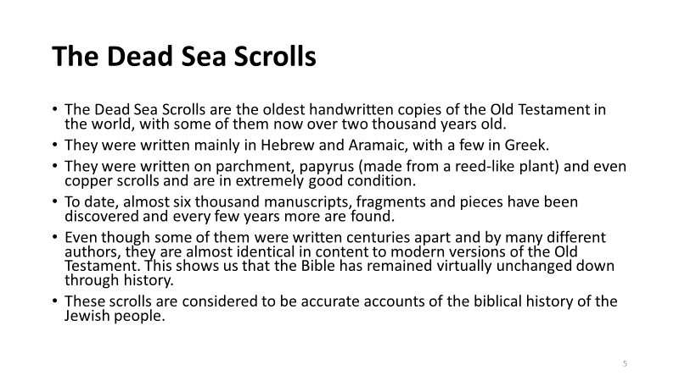

Let’s Investigate/Research …
- Working alone or in small groups, search for ‘Dead Sea Scrolls’ online and see what else you can find out about them.
- Share your findings with the class.

Let’s Get Creative …
- Write your own news report about the discovery of the Dead Sea Scrolls. Explain why this is such an important discovery for the world.

Let’s Work Together …
- Form into small groups. Imagine you are the ones who find the scrolls in the cave. Prepare a small role-play to act out for the class.
- The role-play should include finding the jars, the conversation that takes place between you as you speculate about what might be in them, deciding who you will tell about what you have found, their reactions etc.

Revision Exercise
- Invite the students to complete Worksheet 13.

Let’s Pray …
Show Slide 6. Prayerfully, bring the lesson to a close.

Slide 6:
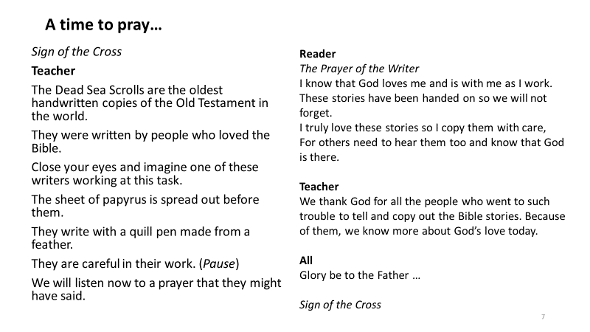

Lesson 10: The Story of Ruth

Starter Exercise
- Ask the students to write down the names of their closest friends or family members, and then to write beside each name one quality that they most admire in this person. Encourage them to focus on qualities like kindness, unconditional love, loyalty, bravery, and so on – qualities that reflect the person’s good character/nature.
- Tell the students that the story they will explore in the lesson comes from the Book of Ruth in the Old Testament and it is about a woman named Ruth who had many great qualities.

Learning Intentions
- Show Slide 2, the ‘Learning Intentions’ for this lesson.

Slide 2:
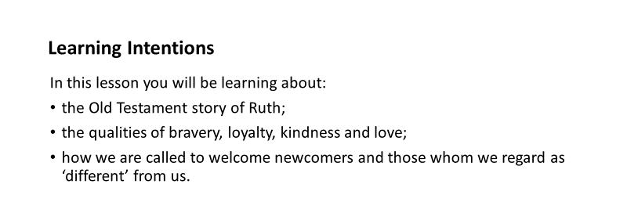

Core Content: The Story of Ruth
- Play the video clip of the story of Ruth from the Old Testament.

Let’s Talk …
- Ruth had to leave her homeland with her family because of the famine in that land. Can you name some of the countries in the world today that still suffer from famine?
- What are the main causes of famine?
- What do you think of the way Ruth chose to stay with Naomi? What qualities of character did she show by doing so?
- How do you think Ruth might have felt about having to look for work among strangers?

Show Slide 3, which outlines how Ruth showed bravery, loyalty and unconditional love when she chose to leave her own country and accompany Naomi to a foreign land.

Slide 3:
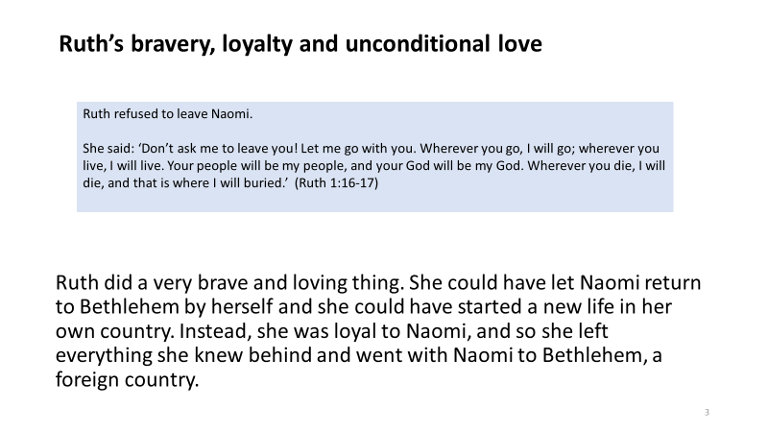

Show Slide 4, which tells of how newcomers are often not welcomed in their host country. It includes a statement from Pope Francis on this topic.

Slide 4:
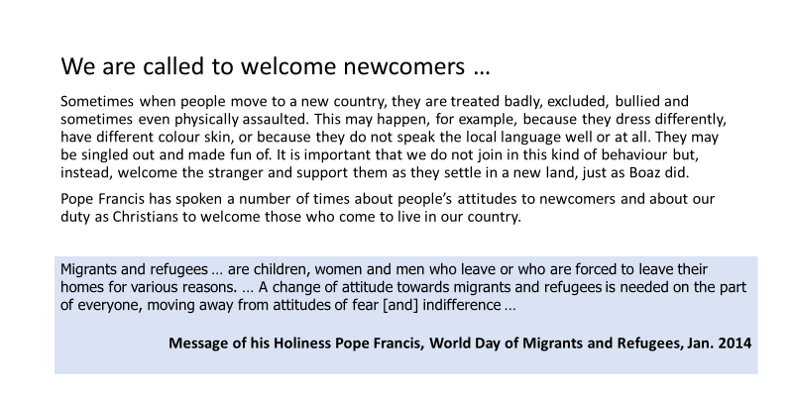

Let’s Talk …
- Ruth was a stranger in a foreign land. Who are the people in our country who might be regarded as strangers? How are these people sometimes treated badly in our country?
- What do you think it would be like to be made feel unwelcome in the place where you live?
- Where have you seen examples of newcomers to our country, or to the neighbourhood where you live, being welcomed and treated well? How were they welcomed?
- What do you think it would be like to be made feel welcome when you find yourself living in a new place/in a new school?
- What could we learn about how we should treat newcomers from the way Boaz acted in the story of Ruth?

Let’s Think/Reflect …
- Ask the students to look around at the people in their class. Some may be from faraway places, or they may simply be newcomers to the class. Perhaps there are newcomers in other classes or year groups too.
- Invite the students to reflect in silence for a few moments as you call out the following questions:
- How have new people been welcomed into our school community?
- How have you made others feel welcome in this class/this school?
- Are there other things that you could do?
- Then invite the students to form into small groups for the next activity.

Let’s Work Together …
- Working with the others in your group, decide on five things that you could do to help make someone new feel welcome in your class or school or neighbourhood.
- Share these ideas with the rest of the class.

Let’s Get Creative …
- Make a poster that welcomes newcomers to your parish, your town or city.
- Display the finished posters around your school.

Revision Exercise
Invite the students to complete Worksheet 14.

Let’s Pray …
Show Slide 5. Prayerfully, bring the lesson to a close.

Slide 5:
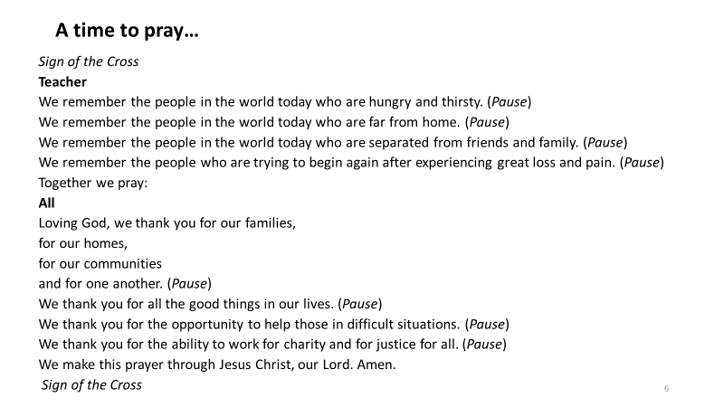

Lesson 11: The Evangelists

Starter Exercise
- You might like to begin by inviting the students to name their favourite books and also the people who wrote them. Do they ever choose a book because they like a particular author? Why might someone like one writer more than another?
- Tell the students that, in the times when the Bible was written, very few people could read or write. Stories were mostly handed down in oral form – passed on from one generation to the next by storytellers. In this lesson they are going to learn about the writers of the first four books of the New Testament – the Gospels.

Learning Intentions
- Show Slide 2, the ‘Learning Intentions’ for this lesson.

Slide 2:
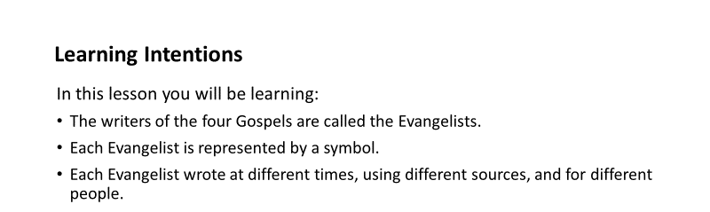

Core Content: The Evangelists
- Show Slide 3, which introduces and explains the term ‘The Evangelists’.

Slide 3:
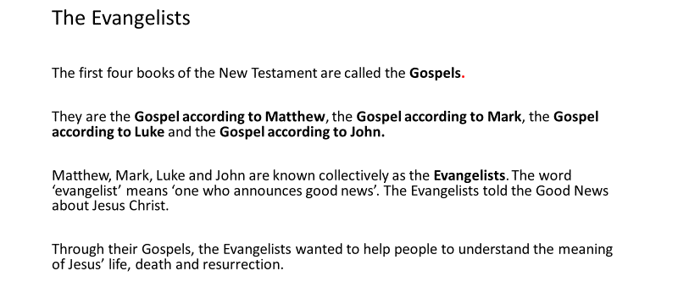

Symbols of the Evangelists
- Show Slides 4 and 5, which introduce and explain the symbols of the Evangelists.

Slide 4:
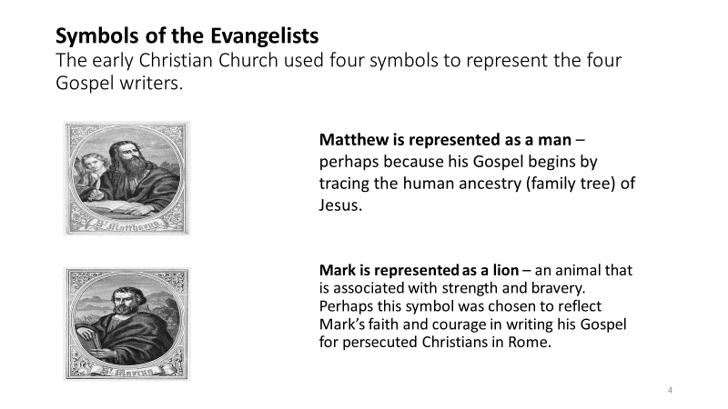

Slide 5:
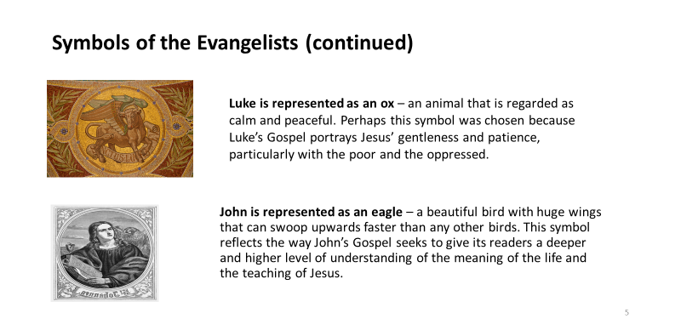

- Invite the students to complete the exercise on Worksheet 15.

Let’s Investigate …
- Show Slides 6 and 7, which take a closer look at what each of the Evangelists wrote, when they wrote, where they got their information, and who their intended audience was.

Slide 6:
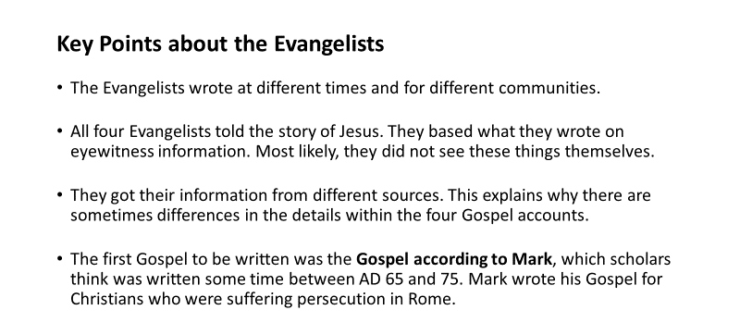

Slide 7:
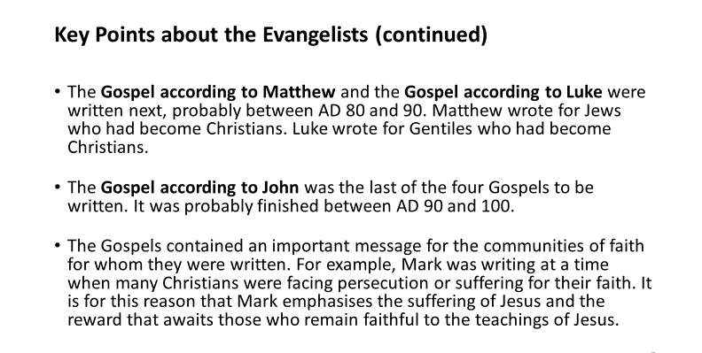

- Invite the students to answer the questions on Worksheet 16.

Let’s Talk
- Have you ever heard two people describe the same event differently? How is that possible?
- Does this help you to understand how the four Evangelists tell the story of Jesus in different ways?

Let’s Pray …
Note: You will need individual images of the four symbols of the Evangelists for this prayer time.
- Show Slides 8, 9 and 10. Prayerfully, bring the lesson to a close.

Slide 8:
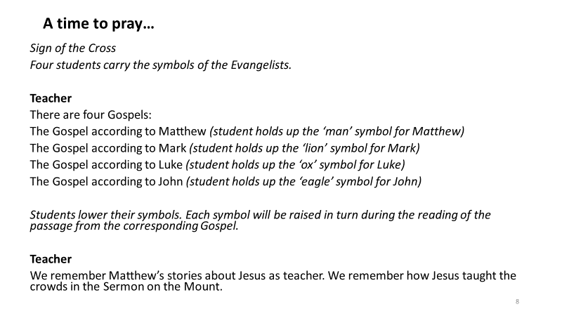

Slide 9:
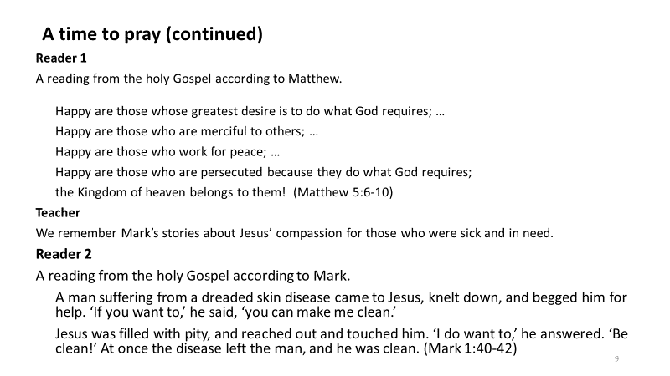
Slide 10:
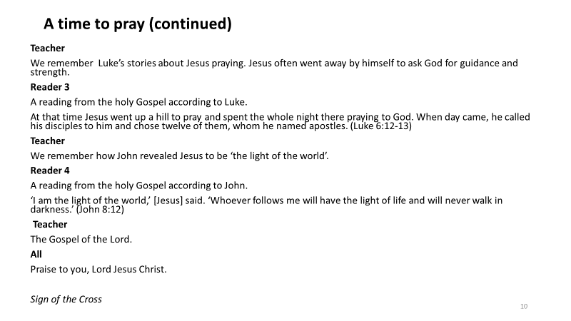

Lesson 12: The Gospel According to Mark

Recap on Lesson 11
- Briefly recap on Lesson 11, where the students were introduced to the Evangelists and to the symbols associated with them.
- Tell the students that this lesson will focus on the Evangelist Mark, whose Gospel was the first Gospel to be written. They will also become familiar again with some of the best-known stories from Mark’s Gospel.

Learning Intentions
- Show Slide 2, the ‘Learning Intentions’ for this lesson.

Slide 2:
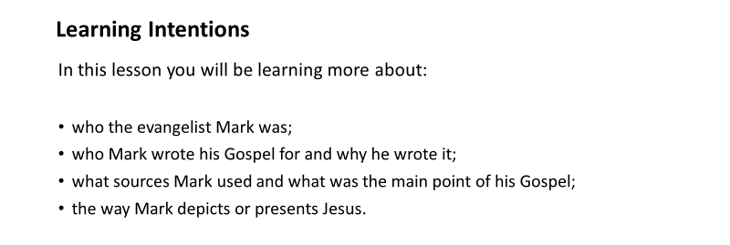

- Show Slide 3, a Fact-File on the Gospel according to Mark.

Slide 3:
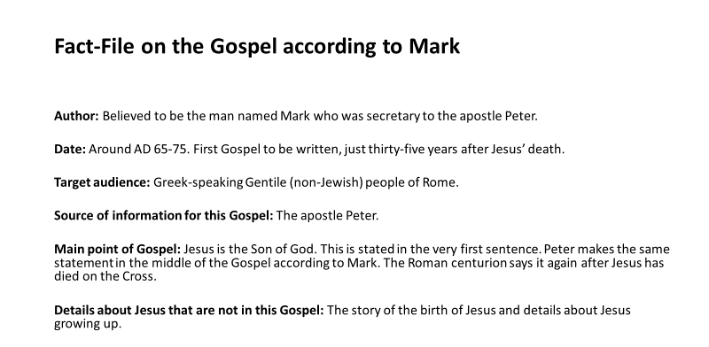
- Invite the students to complete the exercises on Worksheet 17.

How Mark presents Jesus
- Show Slide 4, which examines how Mark presents Jesus in his Gospel.

Slide 4:
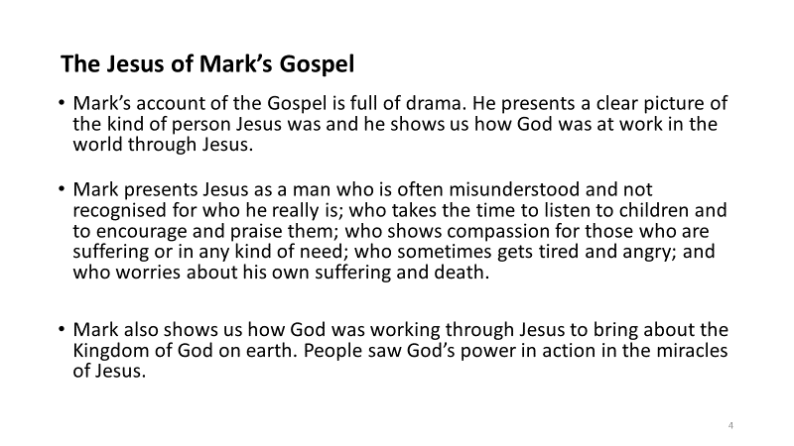

Let’s Work Together …
Note: Each pair or group of students will need a copy of the Bible.
- Have the students form into pairs or groups for this activity.
- Show Slide 5, which invites them to look up and read a selection of stories from the Gospel of Mark, and to take note as they do so of the characters, what Jesus says and does, the human emotions that Jesus portrays in each story and how the people reacted to what Jesus did and said.
Slide 5: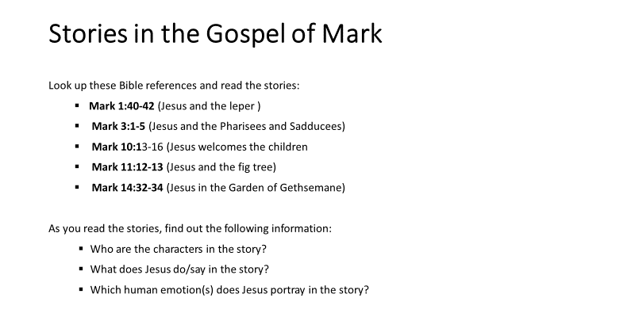

- After they have completed the above activity, invite the students to do the exercises on Worksheet 18.

Let’s Pray …
Show Slides 6 and 7. Prayerfully, bring the lesson to a close.

Slide 6:
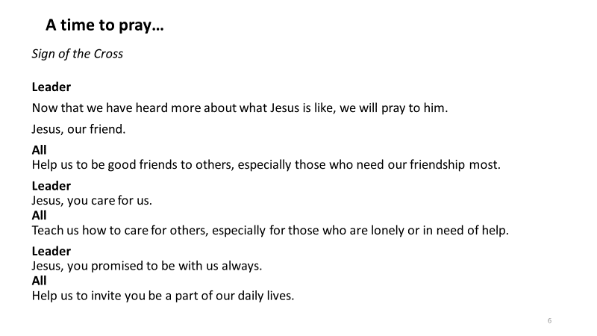

Slide 7:

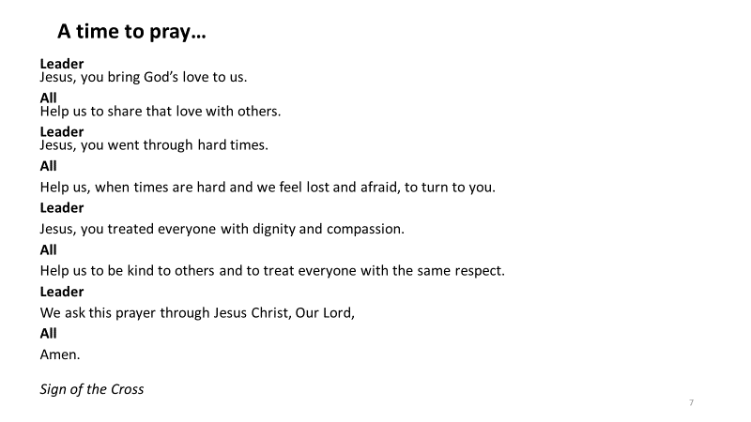

Lesson 13: The Bible and the Teaching Authority of the Church

- Show Slide 2, the ‘Learning Intentions’ for this lesson.

Slide 2:
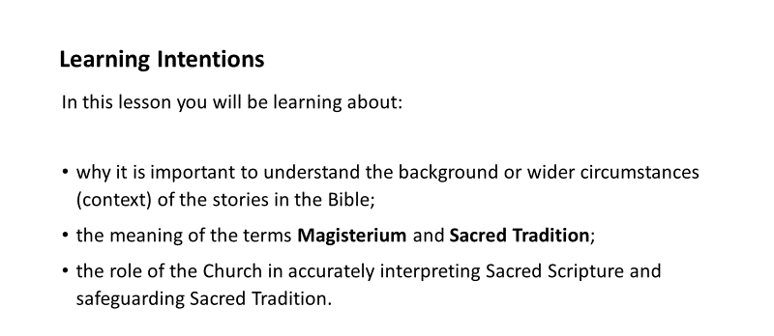

Starter Exercise
- Show Slide 3, which contains two newspaper headlines. The purpose of this and the ‘Let’s Talk’ that follows is to give the students an opportunity to discover for themselves what can happen when you take something out of context. [There is no need to introduce the word ‘context’ yet. It will be introduced in Slide 4.]

Slide 3:
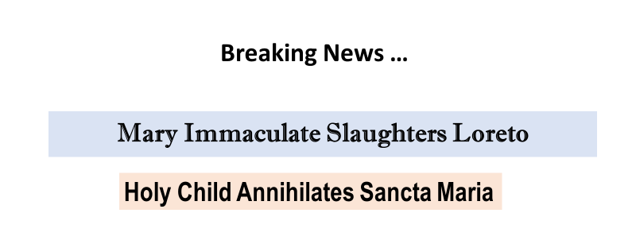

Let’s Talk …
Note: It is important that you allow the students to speculate as to what stories might lie behind these headings before you tell them what the headings actually represent, i.e. they refer to competing sports teams in four Catholic schools.
- What do you think these headings might refer to? What could be the stories behind them?
- If you saw these headings in a newspaper or online, what would you need to do in order to know what they actually meant?

Let’s Think …
- Think of a situation or message that you misinterpreted or misunderstood because you didn’t have all the information you needed to know.
- What consequences resulted from this? [The next activity will involve the students sharing their stories.]

Let’s Work Together …
- Share your story of a situation or message that you misinterpreted or misunderstood with the person beside you. With their help, see if you can answer the following questions:
- What could you have done that might have prevented the misinterpretation?
- How might you avoid misinterpreting a situation or message in the future?

Introduce the word ‘context’
- Show Slide 4, which introduces and explains the word ‘context’.

Slide 4:
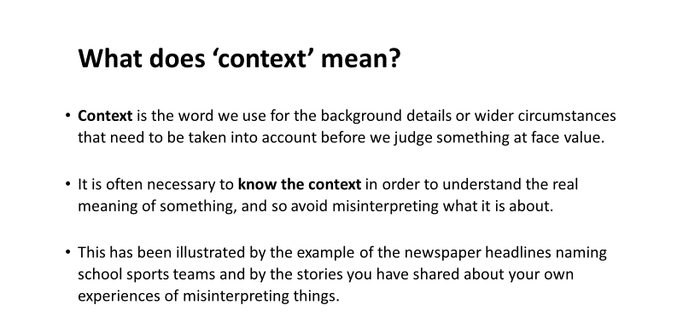

Exploring ‘context’ in relation to the Bible
- Show Slides 5 and 6, which discuss ‘context’ in relation to the Bible.

Slide 5:
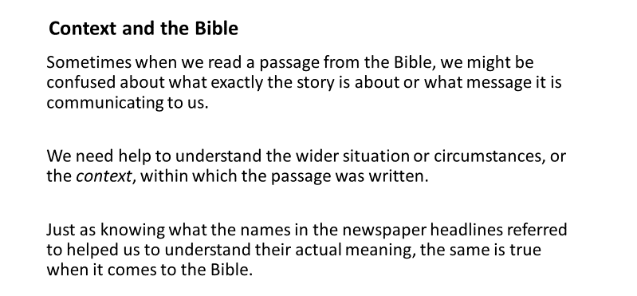

Slide 6:
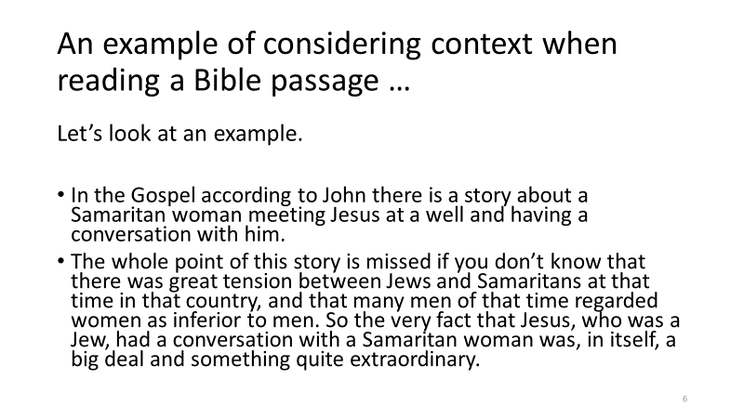

- Show Slide 7, which is a statement from the Catechism of the Catholic Church on the importance of taking context into account when reading the Bible.

Slide 7:

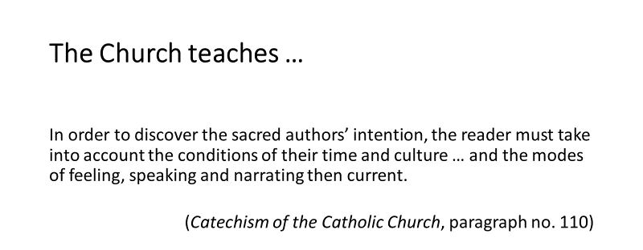

Exploring the role of the Magisterium in relation to Sacred Scripture and Sacred Tradition
- Show Slides 8 and 9, which introduce the terms ‘Sacred Tradition’ and ‘the Magisterium’, and which explain the role of the Magisterium in giving the correct and accurate interpretation to the Word of God contained in both Sacred Scripture and Sacred Tradition.

Slide 8:
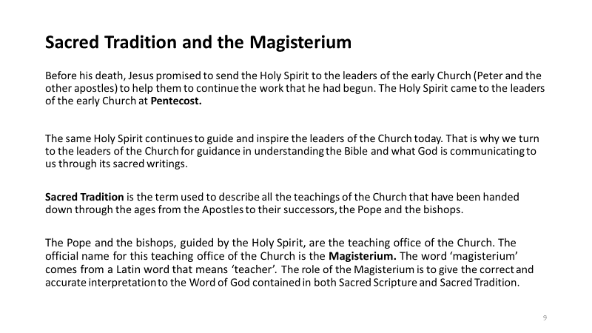

Slide 9:
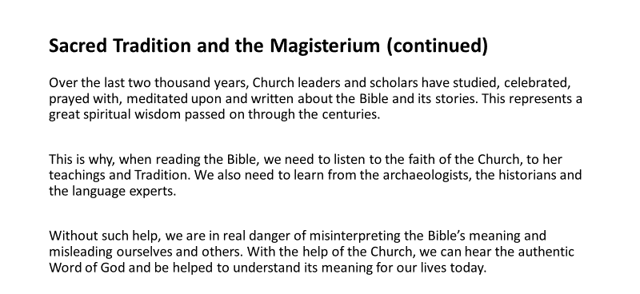

- Show Slide 10, which is a statement from the Catechism of the Catholic Church on the role of the Magisterium.

Slide 10:
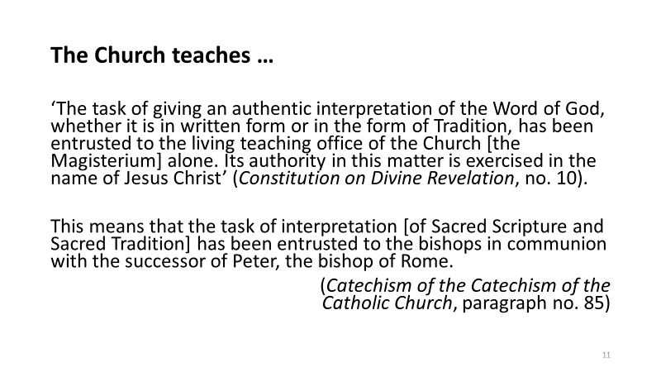

Let’s Talk…
- You have just heard that the teaching office of the Church is called the Magisterium, and that it is made up of the Pope and the bishops. Do you know the Pope’s name?
- Who is the bishop of your diocese or the archbishop of your archdiocese?
- It’s not just the Pope and the bishops who are the successors of the Apostles and the other leaders of the early Church. Priests are also leaders in the Church. Can you name the priest or priests in your parish?
- Have you ever heard of or maybe even read some of the letters to the Church that were written by the Pope? If so, what was the topic of the letter(s)?
- What might be the dangers in interpreting the Bible on your own, without reference to the Church’s teaching and Tradition?

Revision Exercise
- Invite the students to complete Worksheet 19.

Let’s Pray …
Show Slides 11, 12 and 13. Prayerfully, bring the lesson to a close.

Slide 11:
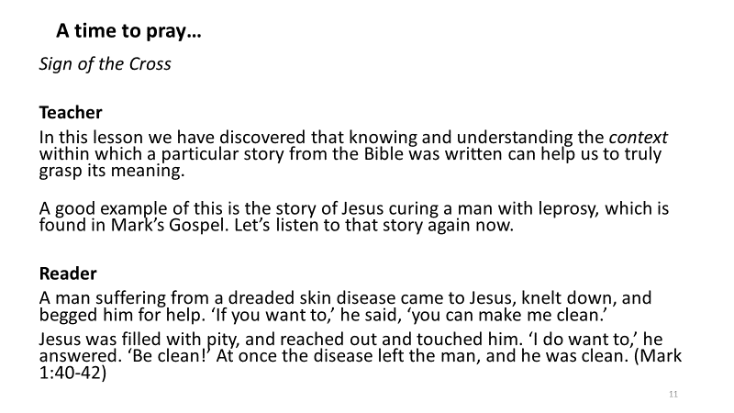

Slide 12:
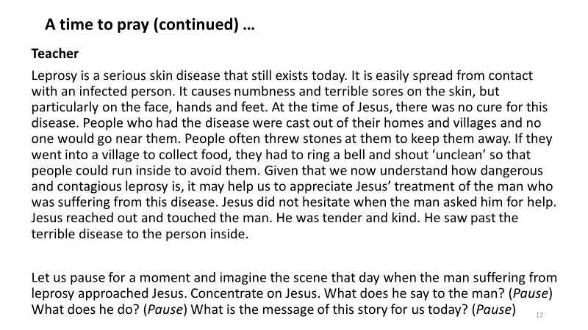

Slide 13:
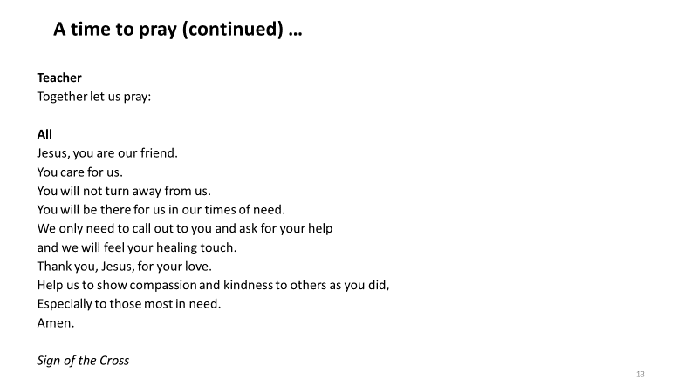

Term 1, Lesson 14. The Importance of the Bible Today

Learning Intentions
- Show Slide 2, the ‘Learning Intentions’ for this lesson.

Slide 2:
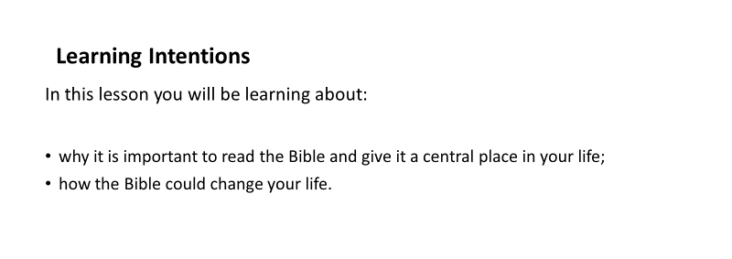

Starter Exercise
- Show Slide 3, which presents a selection of responses from people who were asked what the Bible is.

Slide 3:
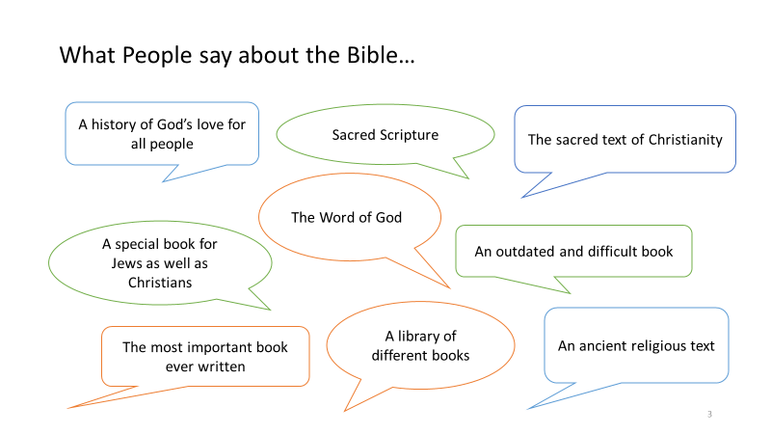

Let’s Talk …
- Which of the descriptions of the Bible in this slide best reflect your own view of what the Bible is?
- Do you disagree with any of the above descriptions of the Bible? If so, which ones, and why do you disagree with them?
- What is your own attitude to the Bible and what has shaped or influenced this attitude?
- Can you think of any situations where you might turn to the Bible for help? Share some examples.

More facts about the Bible
- Show Slide 4, which presents some facts about the Bible.

Slide 4:
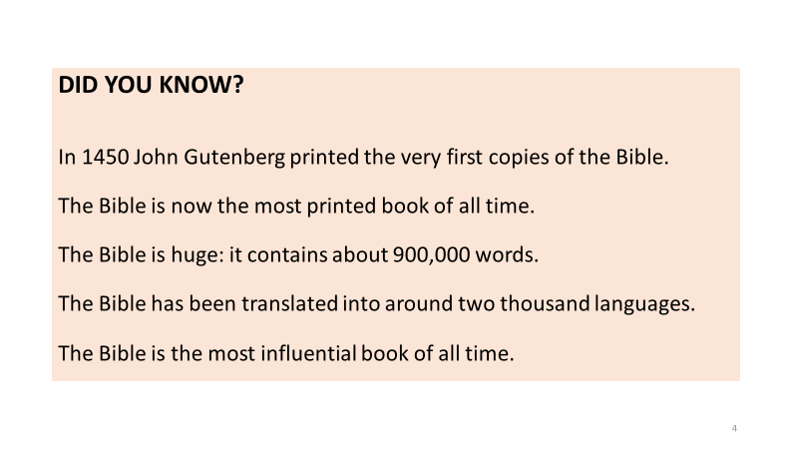

Let’s Talk…
- Do any of the facts on this slide surprise you? Why or why not?

Let’s Investigate/Research …
- Working on your own or with a partner, conduct some research online to see if you can come up with some more interesting facts about the Bible.
- Share what you discover with the class.

The Bible Today
- Show Slide 5, which discusses the relevance of the Bible for today’s world.

Slide 5:
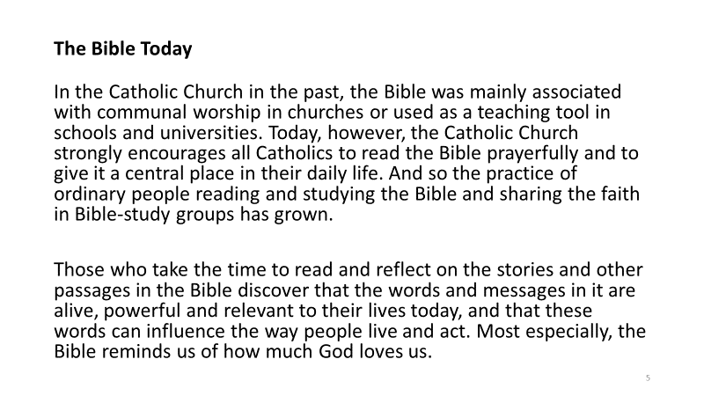

Let’s Talk …
- How often do you read the Bible – occasionally, once a week, never?
- What would encourage you to spend more time reading the Bible?
- Have any words in the Bible ever influenced you in any way? If so, tell the class about that.

Worksheet Exercises
- Refer the students to the two exercises on Worksheet 20.

How to read the Bible
- Show Slide 6, which gives some advice on how we should approach reading passages or stories from the Bible.

Slide 6:
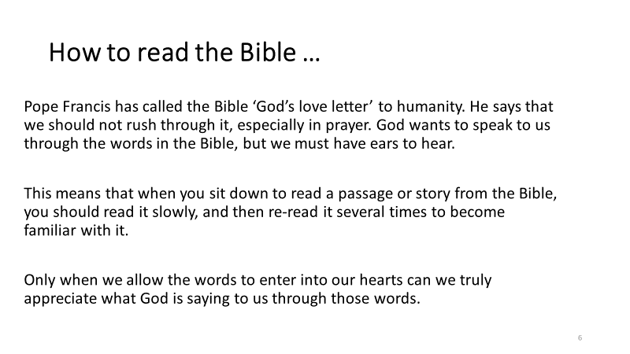

Let’s Pray …
Prayerfully, bring the lesson to a close with the prayers on Slides 7 and 8.

Slide 7:
A time to pray …
Sign of the Cross

Teacher
We will end this lesson by praying the Prayer on Opening the Bible to remind us to open our minds and hearts to God’s Word whenever we read passages or stories from Sacred Scripture.

All
Bless us, O God, so that in opening the Bible
I may open my mind and my heart to your Word.
May your Word nourish me
as it nourished Jesus.

Slide 8:
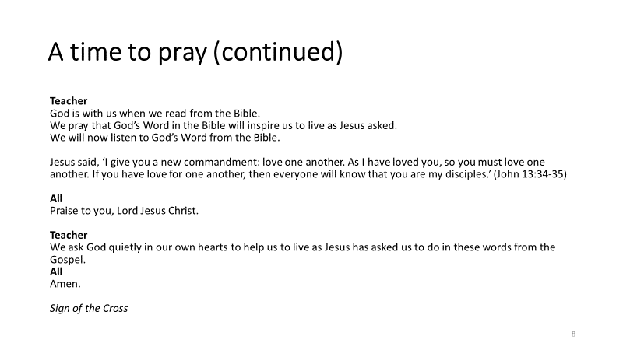

Lesson 15: Lectio Divina

Learning Intentions
Show Slide 2, the ‘Learning Intentions’ for this lesson.

Slide 2:
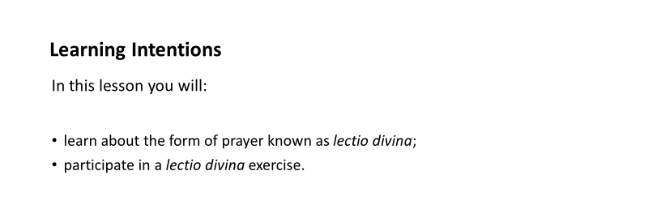

What is lectio divina?
- Show Slide 3, which gives a brief explanation of lectio divina and how it is practised.

Slide 3:
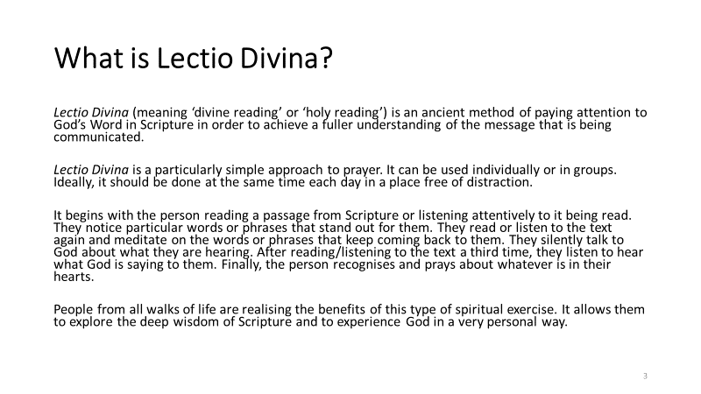

Let’s Talk …
- Do you know anyone who practices lectio divina? If so, tell us about that.
- Do you think you would like to try it? How do you think it might benefit you?

A Lectio Divina Exercise
- Show Slide 4, which outlines the steps involved in lectio divina. Tell the students that they are now going to take part in a lectio divina activity using these steps.

Slide 4:
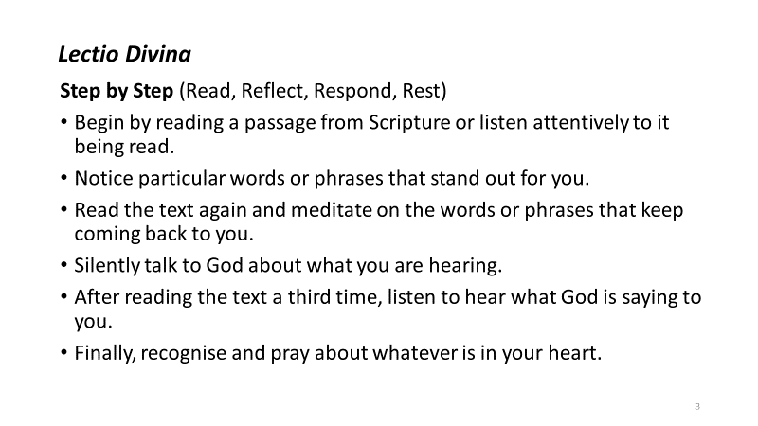

Note: If the school has an oratory or a prayer room, you might prefer to take the students there for this activity.
- Begin with the Sign of the Cross. You might also like to light a candle.
- Invite the students to find a comfortable sitting position and to become calm and still. You might suggest that they sit with their backs straight, with palms resting on their knees and their eyes closed.
- When everyone is settled and quiet, read the following short passage from the Gospel according to Mark. Allow a few moments for silent reflection after the reading. You may read the passage from Slide 5 or directly from the Bible.

Slide 5:
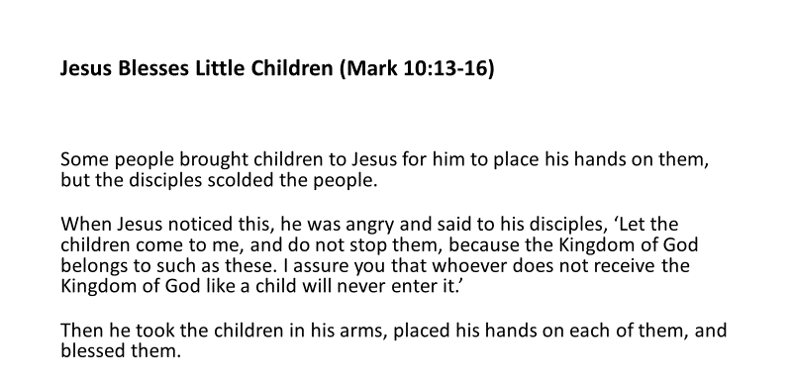

- Now read the story again, allowing for some silent reflection before proceeding with the next steps.

Reflect
- Encourage the students to reflect, using these or similar questions:
- As you listened to the story, what words, images or ideas did the Holy Spirit bring to your heart? What words, phrases or images stood out for you? (Pause)
- Think about how those words, images or ideas make you feel? (Pause)
- What might God be saying to you through this story? (Pause)

Respond
- Refer the students to Worksheet 21, which contains the text of the Gospel story that they have just heard.
- Invite them to read the story in silence for themselves and then to either draw or write on the worksheet about the meaning or message that they have taken from it. (Give ten minutes for this exercise).

Rest
- Ask the students to remain where they are, resting comfortably with God, listening to what God is saying to them right now.

Sign of the Cross

Let’s Share …
- Invite some of the students to share their experience of practising lectio divina with the class. What did they find difficult? What did they enjoy? Did taking the time to read and reflect on the story in this way help them to imagine Jesus with the disciples and the little children, and so help them to enter better into the story? Did they notice any particular words, phrases or images? Did they get a sense of what God what God was saying to them through the story?
- Would they like to try this at home using another Bible story? Or would they like to try more of this in school?

Let’s Investigate/Research …
- Find out about any Lectio Divina group in your parish.
- Report your findings to the class.

