Fully Alive 1

Worksheets
Lessons 4-8

Veritas

Lesson 1: A New Beginning

Worksheet 1

1. Circle/colour in one of the emojis below that most accurately describes how you are feeling about starting in a new school.

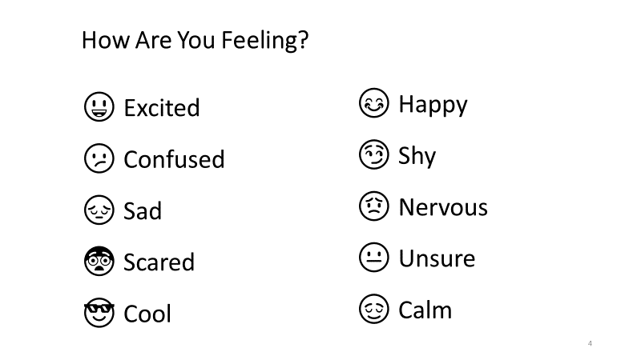
Explain why you are feeling that way.
______________________________________________________________________________________________________________________________________________________

2. Name one person or thing that has helped you to settle in during your first few days in your new school. Write about how this person or thing has helped you.
______________________________________________________________________________________________________________________________________________________
Lesson 1: A New Beginning
Worksheet 2

Different Subjects Teach Us Different Skills
Choose one subject from the school timetable and draw an image below to represent something that you might learn from this subject. Name the subject and the skill on the lines below.

Subject: _________________________ Skill: ___________________________

Lesson 2: What’s Different about Religion Class?
Worksheet 3

Describe in your own words what Religion class means to you. You might mention, for example:
- what you do in Religion class that is different from what you do in other classes:
- what you learn in Religion class that is different from the kind of things you learn in other classes;
- how what you do and learn in Religion class helps you to make better choices;
- how what you learn in Religion class brings you closer to God.

_____________________________________________________________________________________________________________________________________________________________________________________________________________________________________________________________________________________________________________________________________________________________________________________________________________________________________________________________________________________________________________________________________________________________________________________________________________________________________________________________________________________________________________________________________________________________________________________________________________________________________________________________________________________________________________________________________________________________________________________________________________________________________________________________________________________________________________________________________________________________________

Lesson 3: God Communicates with Us

Worksheet 4

1. Fill in the blanks using the Word Bank.

From the beginning of time, ____ has communicated with human beings. One of the ways in which God communicates with us is through the _______. The Bible is God’s ______. It is the sacred text for all Christians.
We have all heard stories from the Bible about how God communicated with Adam and Eve, our first ________; with Noah, who saved the people and animals from the Great ________; and with ____________, whom God invited to become the leader of a great nation of people called the Israelites, or God’s _________People.
We have also heard about how God inspired other great __________ such as Moses and the __________ to remind the people of how God wanted them to live.

As well as inspiring the writers of the sacred books of the Bible and the prophets to communicate his message, God also communicated with his people through his Son, ________. God sent Jesus to live among us as a human being.

The purpose of Jesus’ life, _______ and resurrection was to teach us about who God is and that God _______ us. God wanted people to understand and follow the way of life that Jesus showed them.

The very first followers, or disciples, of Jesus were the twelve _________. Out of their preaching the early Church developed, and the followers of Jesus eventually become known as_____________. There are over two __________ Christians in the world today.
Word Bank
Christians leaders death Chosen parents apostles prophets Jesus billion Bible Flood God loves Word Abraham

2. Draw lines to match each name with the correct description.

Moses | God made flesh – the founder of Christianity
Mary | Leaders sent by God to remind the people to live as God wanted them to
Adam and Eve | Chosen by God to build a huge boat to save people and animals from the Great Flood
Prophets | Chosen by God to lead the Israelites out of their slavery in Egypt
Jesus | Young girl from Nazareth in Galilee whom God chose to be the mother of Jesus
 | The first human beings

Lesson 4: The Bible
Worksheet 5

The Books of the Bible
Fill in the missing names in this illustration of the books of the Bible.

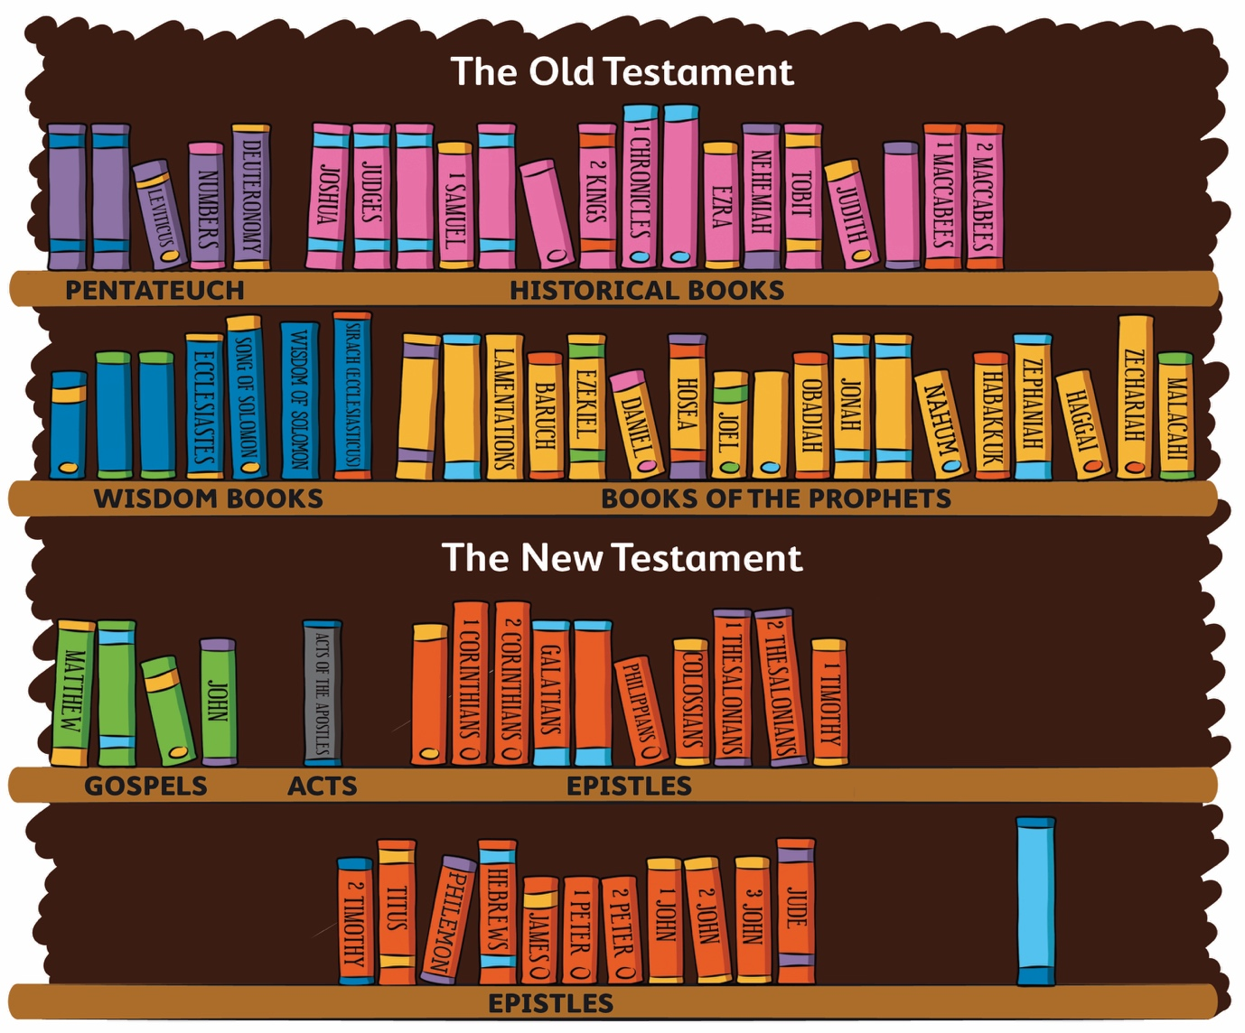

Lesson 4: The Bible
Worksheet 6

Answer the following questions. You may need to check the illustration on the previous worksheet for the answers to questions 7, 8 and 9.
- What does the word ‘Bible’ mean?
_________________________________________________________________
- Over what period of time was the Bible written?
__________________________________________________________________
- Name three people who wrote some of the stories in the Bible.
__________________________________________________________________
- How many books are there in the complete Bible?
_____________________________________________________________
- What is the first part of the Bible called and what language was it originally written in?

_____________________________________________________________________

- What is the second part of the Bible called and what language was it originally written in?

______________________________________________________________________

- What is the name of the first book of the Bible? ____________________________

- What is the name of the last book of the Bible? ___________________________

- Which of the books of the Bible are about women?

__________________________________________________________________

- Why is it important for Christians to read and reflect on passages from both the Old and the New Testaments?

__________________________________________________________________________
__________________________________________________________________________
__________________________________________________________________________

Lesson 5: The Old Testament
Worksheet 7

Answer the following questions with the help of the interactive ‘Bible Library’.
- Name the four collections of books found in the Old Testament.
_____________________ _____________________________ ___________________________
_________________________

- Write a sentence to describe what is in each of the following books:

- Genesis
______________________________________________________________________________________________________________________________________________________
- Exodus
______________________________________________________________________________________________________________________________________________________
- Ruth
______________________________________________________________________________________________________________________________________________________
- Tobit
______________________________________________________________________________________________________________________________________________________
- Esther
______________________________________________________________________________________________________________________________________________________
- Job
______________________________________________________________________________________________________________________________________________________
- Psalms
______________________________________________________________________________________________________________________________________________________
- Amos
______________________________________________________________________________________________________________________________________________________
- Jonah
______________________________________________________________________________________________________________________________________________________
- Haggai
______________________________________________________________________________________________________________________________________________________

Lesson 6: The New Testament
Worksheet 8

Answer the following questions. You will need to use the interactive ‘Bible Library’ for the final question.
- What are the first four books in the New Testament called?
- What is the name of the book that tells us about the early followers of Jesus?
- What kind of things did the writers of the Letters in the New Testament write about?
- What does the Book of Revelation contain?
- Write a sentence to describe what is in each of the following books:

Mark
__________________________________________________________________________________________________________________________________________________________

Acts of the Apostles
__________________________________________________________________________________________________________________________________________________________

Galatians
__________________________________________________________________________________________________________________________________________________________

1 Timothy
__________________________________________________________________________________________________________________________________________________________

Hebrews
__________________________________________________________________________________________________________________________________________________________

1 Peter
__________________________________________________________________________________________________________________________________________________________

1 John
__________________________________________________________________________________________________________________________________________________________

Revelation
__________________________________________________________________________________________________________________________________________________________

Lesson 6: The New Testament
Worksheet 9

‘Bible Rap’ Lyrics

Chorus
The Bible is a library of books,
The Word of God written long ago.
The Bible is a library of books,
Shows the love of God for us all.

- Are you listening closely ‘cause I’ve got something to say
About a great and mighty book that we’re gonna read today?
This books has lots of books inside it, actually seventy-three,
And all the books were written to be read by you and me.
Stories ‘bout the life of people long before Christ’s birth;
Stories ‘bout the life and deeds of Jesus Christ on earth;
Books with wise words there to guide us, helping us to live;
Psalms that praise our Saviour and thank him for what he gives.

- There’s Genesis and Exodus, Leviticus and Zephaniah,
Numbers, Judith, Joshua, Deuteronomy and Jeremiah,
Psalms and Proverbs, Chronicles, Samuel and Nehemiah,
Ezra, Wisdom, Joel and Amos, Ruth, Daniel and Obadiah,
Romans and Corinthians, Galatians and Ephesians,
Timothy and Titus too, and Peter and Philippians,
Revelations, Hebrews, Matthew, Mark and Luke and John,
The last four are the Gospels, now you know them sing along.

Lesson 7: Finding Our Way Around the Bible
Worksheet 10

Find and write out the answers to these questions by looking up the Bible references that are shown in brackets.

- What did God create? (Gen 1:1)
_________________________________________________________________

- Where did Noah’s Ark come to rest after the flood? (Gen 8:4)
_________________________________________________________________

- What age was Abraham when God asked him to leave his home country? (Gen 12:4)
_________________________________________________________________

- What did God tell Moses to do? (Ex 3:5)
_________________________________________________________________

- What was the name of Moses’ brother, the one who spoke for him? (Ex 4:14)
_________________________________________________________________

- What family and possessions did Job have? (Job 1:2-3)
_________________________________________________________________

- Where did Jonah spend three days and three nights? (Jon 1:17)
_________________________________________________________________

- What three things does God ask of his people? (Mic 6:8)
_________________________________________________________________

- Whom did Jesus cure? (Mk 10:46-52)
_________________________________________________________________

- At whose well did Jesus meet a woman who was drawing water? (Jn 4:5-6)
_________________________________________________________________

- On what was Jesus resting his head when a storm blew up? (Mk 4:38)
_________________________________________________________________

- What did Jesus say about people who work for peace? (Mt 5:9)
_________________________________________________________________

- What kind of tree did Zacchaeus climb to get a better view of Jesus? (Lk 19:4)
_________________________________________________________________

- Name the person to whom the Acts of the Apostles is addressed? (Acts 1:1)
_________________________________________________________________

- What did St Paul want his friends to remember? (Col 4:18)
_________________________________________________________________

- Where did St Paul leave Titus and what instruction did he give him? (Titus 1:5)
_________________________________________________________________

Lesson 8: The Bible is the Inspired Word of God
Worksheet 11

Inspired by the Gift of the Holy Spirit
The seven gifts of the Holy Spirit are: Wisdom, Understanding, Right Judgement [Counsel], Courage [Fortitude], Knowledge, Reverence [Piety], and Wonder and Awe in God’s presence [Fear of the Lord].) Choose one of these gifts and describe a time when you felt inspired by the Holy Spirit to use it.

______________________________________________________________________________________________________________________________________________________________________________________________________________________________________________________________________________________________________________________________________________________________________________________________________________________________________________________________________________________________________________________________________________________________________________________________

Lesson 8: The Bible is the Inspired Word of God
Worksheet 12

1. Draw lines linking the words in the left column with the words that best match them in the right column. Then write out the full sentences on the lines provided.

The Bible is the … | were inspired by the Holy Spirit to write what God wanted them to reveal.
The Bible gradually … | Sacred Scripture.
The human authors of the Bible … | The Word of God.
The Bible is also called … | the Old Testament (Hebrew Scriptures) and the New Testament (Christian Scriptures).
The Bible was written … | sacred and unique text.
The Bible is divided into two main parts: … | error because the human authors were inspired by the Holy Spirit in what they wrote.
The Bible is a … | reveals what God is like. This is called Revelation.
The Bible is without … | over many centuries by many different authors.

2. Explain what it means when we say that the human writers of the Bible were ‘inspired’ by the Holy Spirit.

________________________________________________________________________________________________________________________________________________________________________________________________________________________________________________________________________________________________________________________________________

