Fully Alive 1

Teacher Notes
Lessons 4-8

Veritas

Lesson 4: The Bible

Recap on Lesson 3
- Briefly recap on Lesson 3, recalling that God has communicated with human beings since the beginning of time. Remind the students that we can read the many stories of how God communicated with people down the ages in the Bible, including the story of Jesus, whom God sent to show us what the love of God is like.
- Tell the students that this lesson will give them a brief overview of the Bible, before they examine its contents in more depth.

Learning Intentions
- Show Slide 2, the ‘Learning Intentions’ for this lesson.

Slide 2:
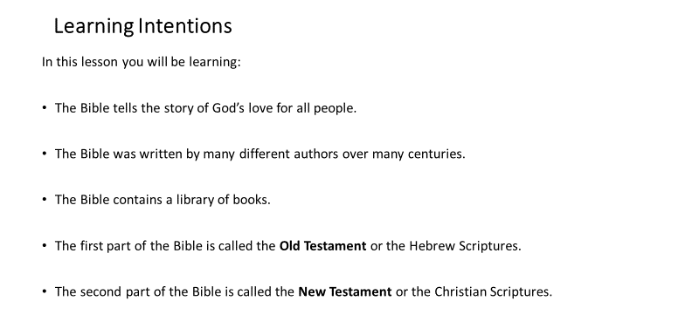

Core Content: The Bible is a library of books
- Show Slide 3, which provides some facts about the Bible, including why it is regarded as a library of books rather than a single book.

Slide 3:
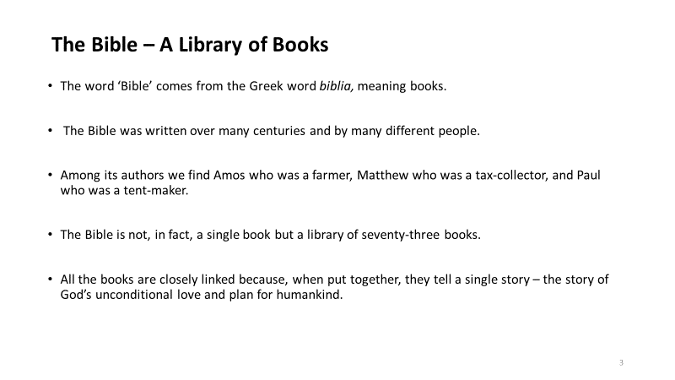

- Show Slide 4, which is an illustration of all the books in the Bible.
- Refer the students to Worksheet 5, which has the same illustration of the books of the Bible in black and white but with some of the names of the books missing from the illustration. You might leave Slide 4 on display to allow the students to find and fill in those missing names.

Slide 4:
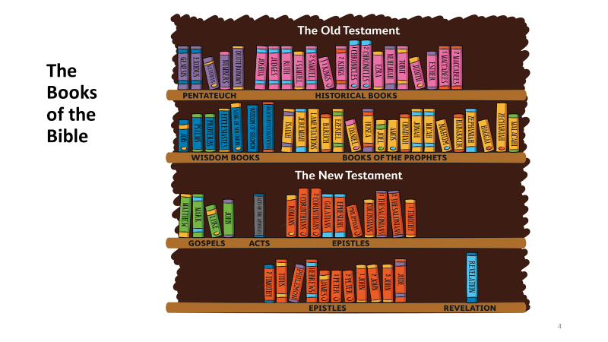

The parts of the Bible
- Show Slide 5, which briefly explains what is in the two main parts of the Bible.

Slide 5:
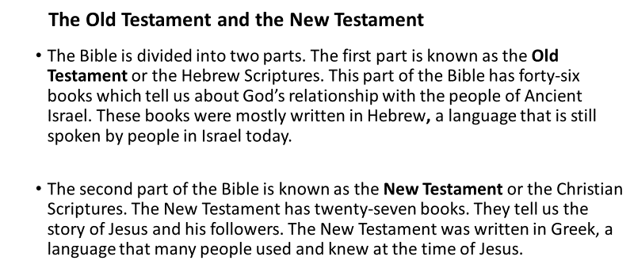

Let’s Talk …
- Which Bible stories or characters do you remember hearing about before? Do you know if those stories are from the Old Testament or the New Testament?
- Which part of the Bible are you more familiar with? Why do you think this is so?
- Have you ever read or heard a story or a passage from the Bible that had a lasting impact on you? If so, you might like to share that story with the class.

The relationship between the Old Testament and New Testament
- Show Slide 6, which gives us the teaching of the Church on the relationship between the Old Testament and the New Testament. The Old Testament helps us to understand better some of the things that we read in the New Testament about what Jesus said and did. Together, the Old Testament and the New Testament make up the Word of God.

Slide 6:
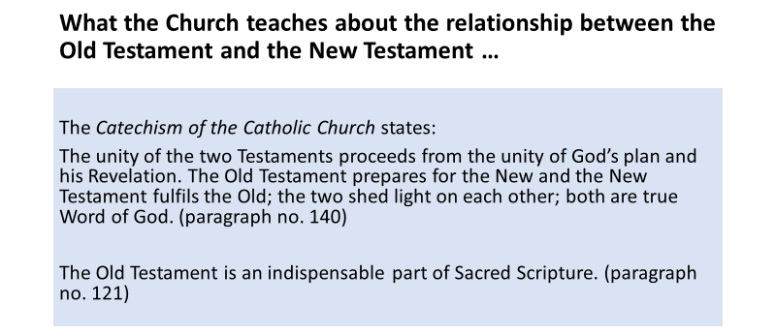

Why do Christians read the Bible?
- Show Slide 7, which highlights why Christians read the Bible. It also features a quote from Pope Francis urging people to read from the Bible every day.

Slide 7:
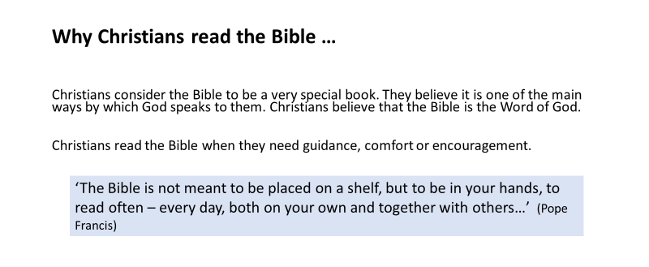

Let’s Think …
- Pope Francis has described the Bible as a ‘love letter from God’ and he urges young people to read the Bible every day. Why do you think he does this?
- How do you think the Bible might provide its readers with ‘guidance, comfort or encouragement’? Can you think of any Bible story that might do so?

Let’s Get Creative …
Note: The students may need some art materials for this activity.
- Invite the students to design a cover for the Bible.

Revision Exercises
- Refer the students to Worksheet 6, which has two exercises based on the information about the Bible that the students have been given in this lesson.

Let’s Pray …
Prayerfully, bring the lesson to a close with the prayers on Slide 8.

Slide 8:
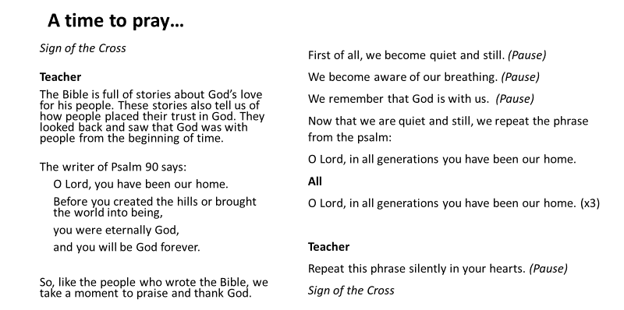

Lesson 5: The Old Testament

Recap on Lesson 4
- Briefly recap on Lesson 4, recalling that the Bible is a library of books and that it has two main parts: the Old Testament and the New Testament.
- Tell the students that this lesson will focus on the Old Testament.

Learning Intentions
Show Slide 2, the ‘Learning Intentions’ for this lesson.

Slide 2:
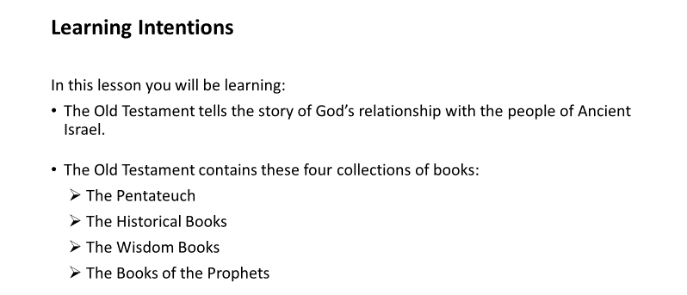

Core Content: The Old Testament
- Show Slides 3, 4 and 5, which present some key facts about the Old Testament and the collections of books in it.

Slide 3:
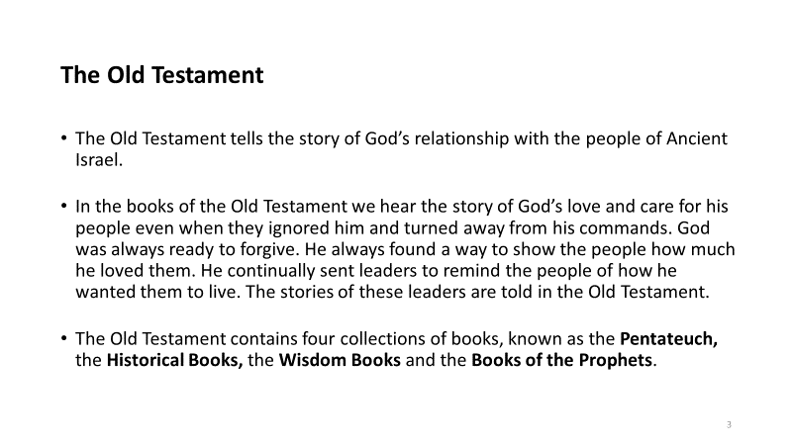
Slide 4:
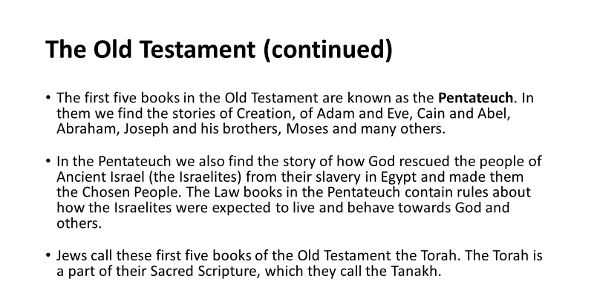

Slide 5:
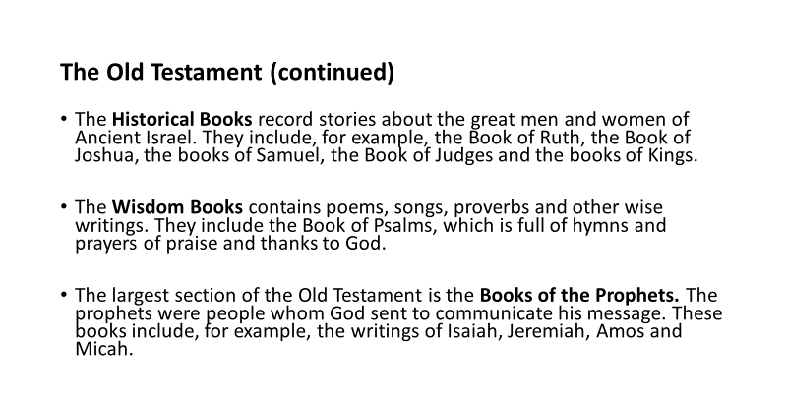

Bible Library (Interactive Resource)
- Before the students complete Worksheet 7, introduce them to the interactive ‘Bible Library’ (online). When you click on the name of the section of the Bible or on the name of a book, a new tab will open containing more information. This will allow the students to become familiar with the different categories of books and with the contents of the books in the Old Testament.
- Now refer the students to the exercise on Worksheet 7.

Research and Get Creative …
Note: The students may need some art materials for this activity.
- Identify a story, psalm or wise saying from the Old Testament.
- Make a poster based on your choice, including either a direct quotation from the Old Testament or a brief summary of the story.
- Title the work and include in the title the collection of books from which the passage or story is taken.

Jesus and the Old Testament
- Show Slide 6, which describes Jesus’ connection with the Old Testament.

Slide 6:
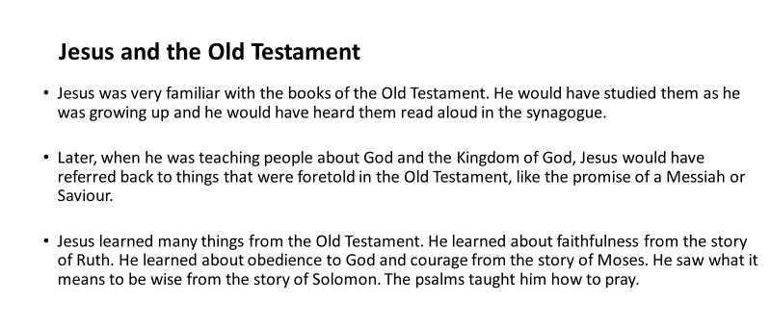

Let’s Think …
- Can you think of an occasion when Jesus used a quotation from the Old Testament while he was teaching people? [Note: If the students are not able to come up with an example, you could read the following passage from Luke 4:16-19, which tells us of how Jesus read aloud from the book of the prophet Isaiah in the synagogue.]

Jesus stood up to read the Scriptures and was handed the book of the prophet Isaiah. He unrolled the scroll and found the place where it is written,
‘The Spirit of the Lord is upon me,
because he has chosen me to bring good news to the poor.
He has sent me to proclaim liberty to captives
and recovery of sight to the blind,
to set free the oppressed
and announce that the time has come
when the Lord will save his people.’

- Why is it important for Christians today to read the stories from the Old Testament?

Let’s Pray …
Prayerfully, bring the lesson to a close with the prayers on Slide 7.

Slide 7:
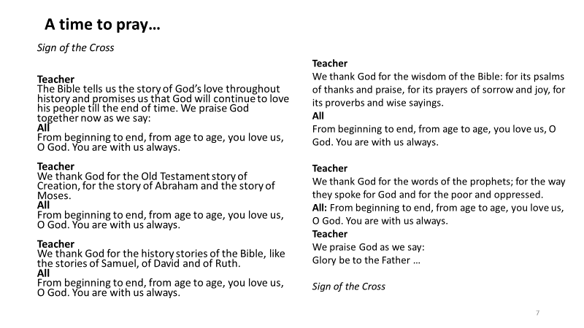

Lesson 6 The New Testament

Recap on Lesson 5
- Briefly recap on Lesson 5, where the students learned about the books of the Old Testament.
- Tell the students that this lesson will focus on the New Testament.

Learning Intentions
- Show Slide 2, the ‘Learning intentions’ for this lesson.

Slide 2:
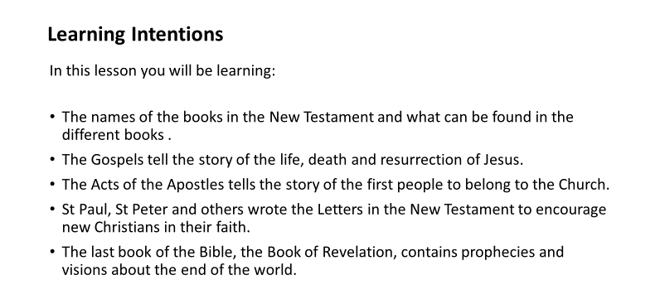

Core Content: The New Testament
Show Slides 3, 4 and 5, which present some key facts about the New Testament and the collections of books in it.

Slide 3:
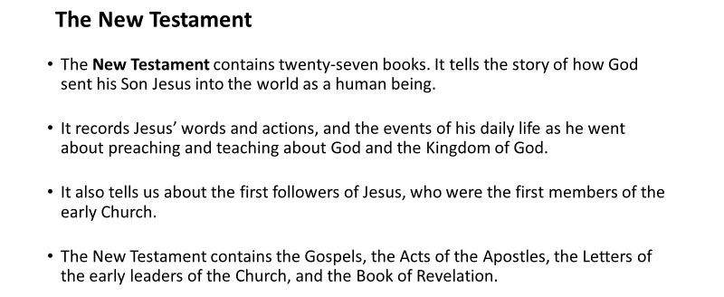

Slide 4:
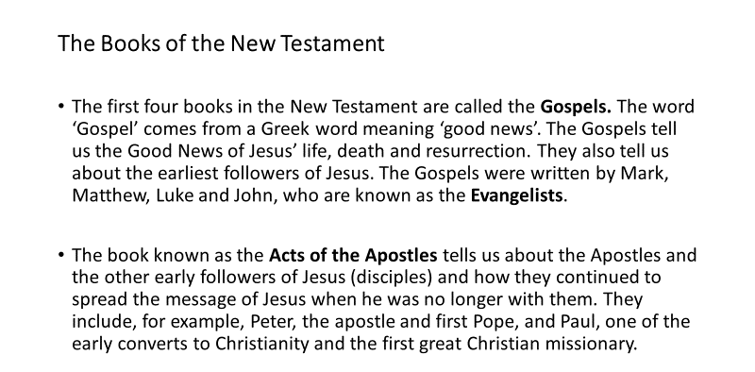

Slide 5:
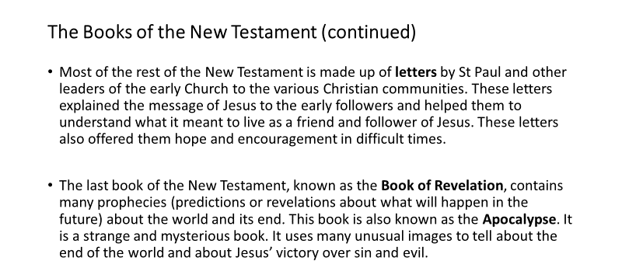

- Refer the students to Worksheet 8, which includes a recap on the content of the above slides. They may need to use the interactive ‘Bible Library’ to access the information required for this worksheet.

Research and Get Creative …
Note: The students may need some art materials for this activity.
- Identify a story that you like from the New Testament.
- Make a poster based on your choice. You might include on it one or more direct quotations from the story or a brief summary of the story.
- Title the work and say which part of the New Testament the story comes from.

Optional Music Activity
- You might like to teach the students the ‘Bible Rap’ (see lyrics below), which will help them to recall the names of the different books in the Bible. The lyrics are on Worksheet 9 and the recording is also available online.

Bible Rap
Chorus:
The Bible is a library of books,
The Word of God written long ago.
The Bible is a library of books,
Shows the love of God for us all.

- Are you listening closely ‘cause I’ve got something to say
About a great and mighty book that we’re gonna read today?
This books has lots of books inside it, actually seventy-three,
And all the books were written to be read by you and me.
Stories ‘bout the life of people long before Christ’s birth;
Stories ‘bout the life and deeds of Jesus Christ on earth;
Books with wise words there to guide us, helping us to live;
Psalms that praise our Saviour and thank him for what he gives.

- There’s Genesis and Exodus, Leviticus and Zephaniah,
Numbers, Judith, Joshua, Deuteronomy and Jeremiah,
Psalms and Proverbs, Chronicles, Samuel and Nehemiah,
Ezra, Wisdom, Joel and Amos, Ruth, Daniel and Obadiah,
Romans and Corinthians, Galatians and Ephesians,
Timothy and Titus too, and Peter and Philippians,
Revelations, Hebrews, Matthew, Mark and Luke and John,
The last four are the Gospels, now you know them sing along.

Let’s Pray …
Prayerfully, bring the lesson to a close with the prayer on Slide 6.

Slide 6:
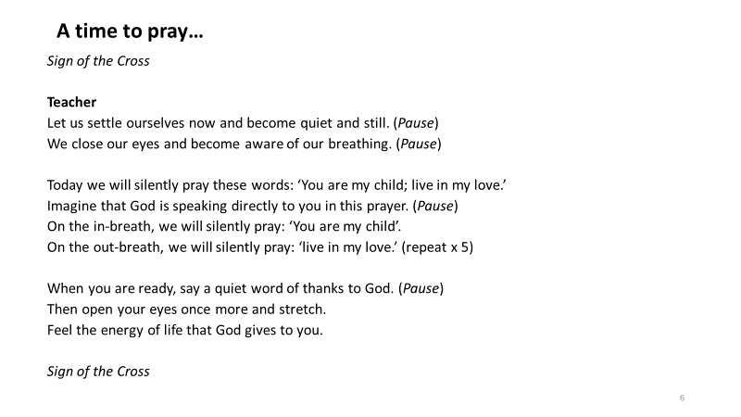

Lesson 7: Finding Our Way Around the Bible

Note: For this lesson, it is essential that each student has access to a Bible.

Starter Exercise: Short Quiz on the Bible
- Ask the students to form teams of two or three. Each team appoints one person to write down the answers to the questions.
- Show Slide 2, which contains eight questions on the Bible, and give the students time to read through them quietly and to have one person record their answers on a page.

Slide 2:
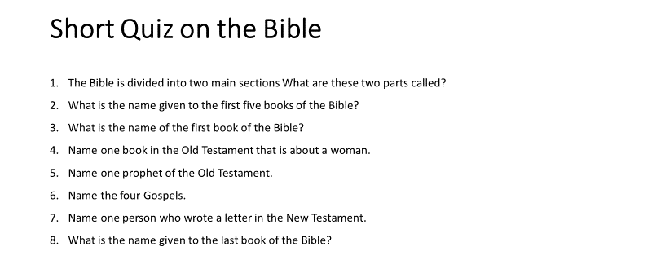

- When the students have completed this task, check and, where necessary, correct each team’s answers.
- Then tell the students that in this lesson they will learn how to find a particular story or passage in the Bible.

Learning Intentions
- Show Slide 3, the ‘Learning Intentions’ for this lesson.

Slide 3:
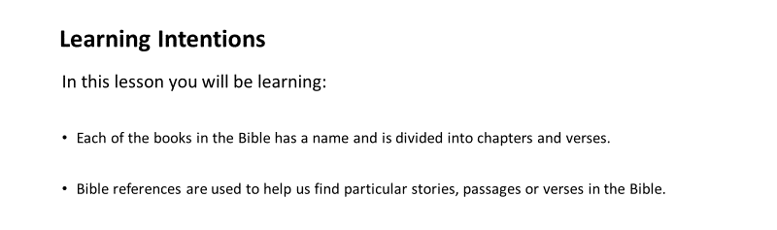
Core Content: Looking up a Bible Reference
Note: Ensure that each student has a Bible.
- Show Slide 4, which explains the difference between a chapter and a verse in the Bible and invites the students to locate both in their own Bibles.

Slide 4:
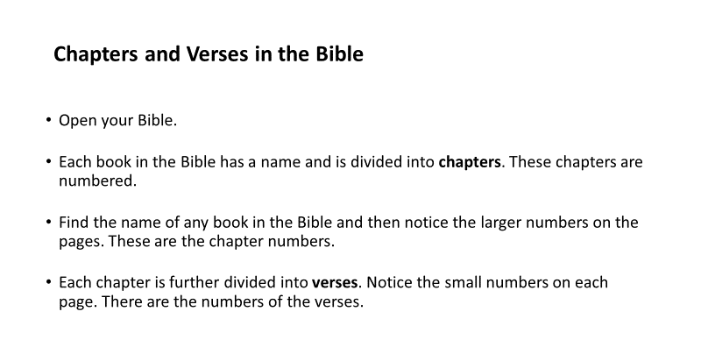

- Show Slide 5, which explains what a Bible reference is and ask the students to find Mark 1:16 in their own Bibles. Invite a student to read the verse from their Bible. [You may choose other verses for the students to look up.]

Slide 5:
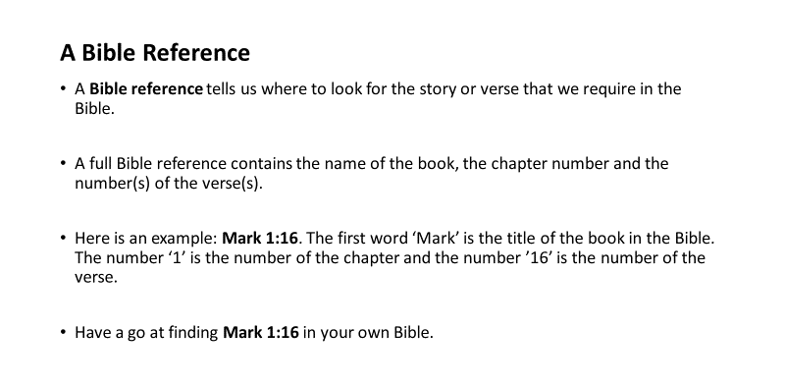
- Show Slide 6, which gives another example of a Bible reference, but this time it is one in which the name of the book has been shortened and there is more than one verse being referred to.

Slide 6:
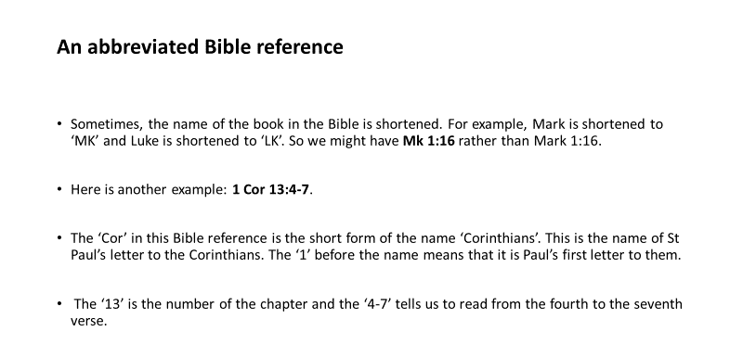

- Refer the students to Worksheet 10, an exercise that will give them further practice at using Bible references to find passages and stories in the Bible. You might like to add a time element to encourage a bit of healthy competition and fun to the task.

Let’s Get Creative …
Note: The students may need some art materials for this activity.
- Invite the students to design and make a bookmarker featuring their favourite verse of Scripture.

Let’s Pray …
Prayerfully, bring the lesson to a close with the prayers on Slides 7 and 8.

Slide 7:
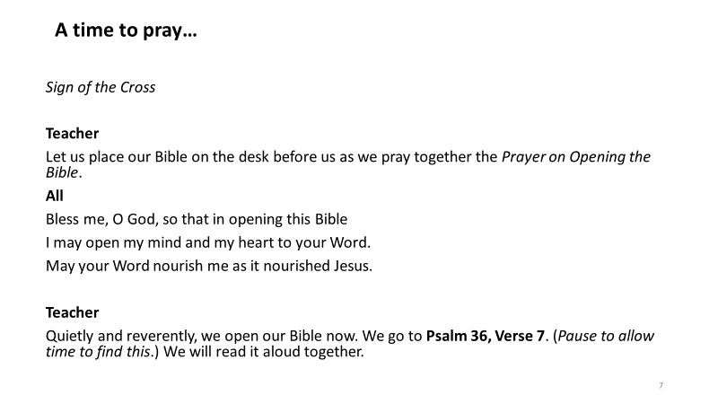

Slide 8: 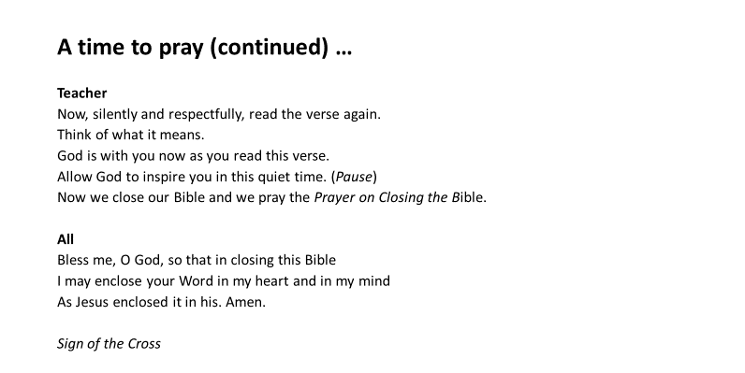

Lesson 8 The Bible Is the Inspired Word of God

Learning Intentions
- Show Slide 2, the ‘Learning Intentions’ for this lesson.

Slide 2:
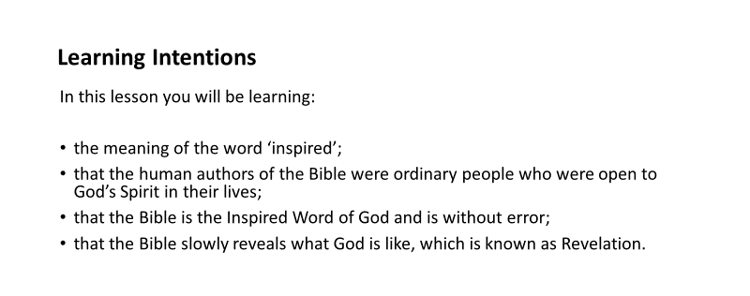

Starter Exercise: Exploring what it means to be inspired
- Either read the story ‘Farewell Fearghal’ (text below), or play the audio file of it that is online. Alternatively, you may prefer to record your own audio file.
- In the story, a teenager recalls how he felt ‘inspired’ in a challenging situation.

Story: Farewell Fearghal
Tom was quite nervous as he made his way to the podium to speak at the memorial service for his friend, Fearghal. Fearghal and Tom had been best friends since primary school and their families had become friends as well. Now Fearghal was dead, after a long battle with leukaemia, and Tom had been nominated to speak about him on behalf of his class.
Tom glanced at his notes and began to speak hesitantly … ‘Fearghal Burns was a great guy … he was the best friend anyone could have … and now he’s gone.’
Tom could feel the emotion welling up in his voice and he didn’t know if he could continue. Then, suddenly, he could see Fearghal’s smiling face in front of his eyes, and some of his friend’s last fun posts to the blog he had set up in his final months crossed his mind. He couldn’t repress a smile and, without further hesitation, he knew what he wanted to say.
Tom went on to speak for a further ten minutes, recalling in vivid detail the aspects of Fearghal’s personality that made him such a well-loved and popular character. He spoke of Fearghal’s bravery during his illness and how he was always more concerned about hearing his friends’ stories or troubles than dwelling on his own. In spite of his illness, Fearghal’s blog had never failed to entertain, and his courage in the face of death had helped everyone to come to terms with his loss.
After Tom’s speech, the applause was heartfelt and sustained.
The school principal, Mr Murphy, was warm in his congratulations: ‘You really brought Fearghal to life there, Tom.’
‘To be honest, Sir,’ Tom replied, ‘it felt as if I was inspired by Fearghal. Does that sound stupid?’
Later that evening, talking to another friend, Tom tried to analyse what had happened: ‘One moment I was tongue-tied, and then the words just seemed to come from somewhere … it was as if someone was helping me. Could it have been Fearghal?’

Let’s Talk …
- What do you think Tom meant by the word ‘inspired’?
- Have you ever felt inspired to say something or to do something? If so, share your story.
- Sometimes people feel inspired to help others in different ways, for example, to help people who are in need. Where do you think such inspiration might come from?

The Bible is the inspired Word of God
- Show Slide 3, which explains why the Bible is the ‘inspired Word of God’.

Slide 3:
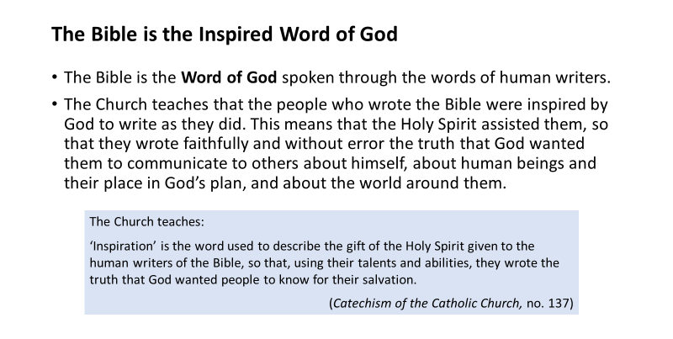

Let’s Talk …
- Explain what it means to say that the human writers of the Bible were ‘inspired’.
- You received the gifts of the Holy Spirit at Baptism and these gifts were strengthened in you at Confirmation. Can you recall the names of those gifts? (Wisdom, Understanding, Right Judgement [Counsel], Courage [Fortitude], Knowledge, Reverence [Piety], and Wonder and Awe in God’s presence [Fear of the Lord].)
- Refer the students to Worksheet 11, which invites them to choose one of the seven gifts of the Holy Spirit and describe a time when they felt inspired by the Holy Spirit to use this gift.

The Bible is without error
- Show Slide 4, which explains why the Bible is without error in the truths it teaches and which introduces the term inerrancy.

Slide 4:
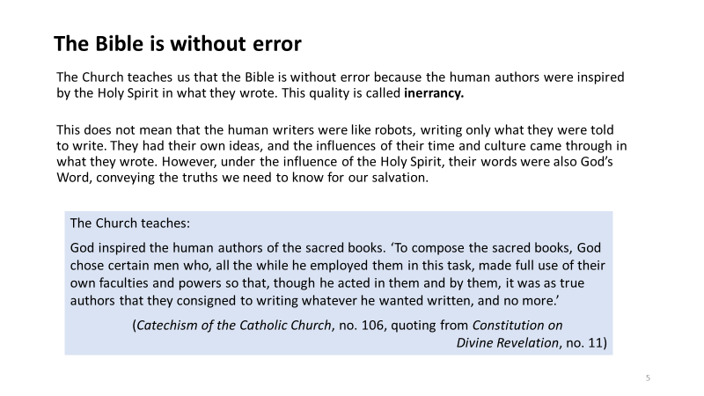

Let’s Talk…
- Why is the Bible believed to be ‘without error’?

Let’s find out more about the human authors of the Bible …
Show Slide 5, which gives some background information on the human writers of the Bible – the times in which they lived, and how the circumstances of those times influenced what they wrote.

Slide 5:
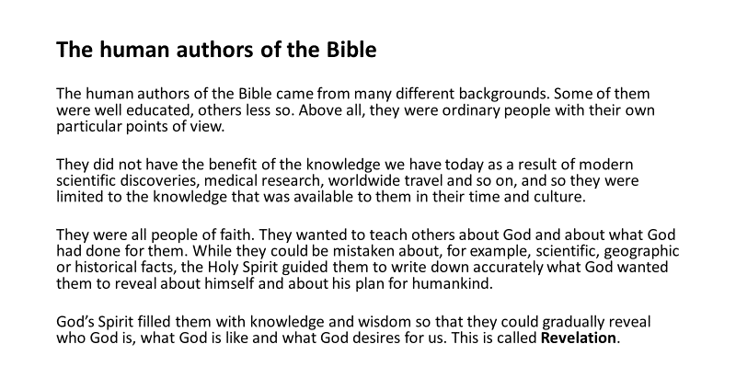

Let’s Talk …
- What kind of people were the human authors of the Bible?
- How do you think the fact that they were people of faith helped them to be inspired by the Holy Spirit?
- What was their aim? What did they want to achieve through their writings?
- Why might they have been mistaken about some scientific, geographical or historical facts? And why is that less important than the messages they were seeking to communicate?
- What do you understand the term ‘Revelation’ to mean?

Let’s Think …
- Refer the students to Worksheet 12, which contains two revision exercises based on the information that they have been given in this lesson.

Let’s Pray …
Prayerfully, bring the lesson to a close with the prayers on Slide 6.

Slide 6:
