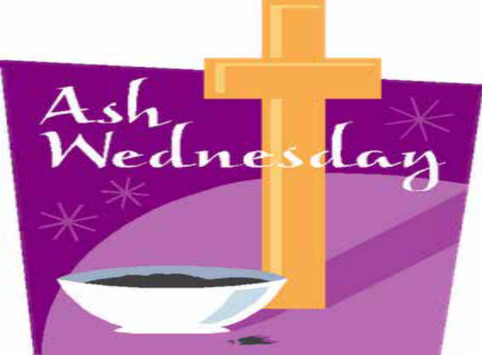

Introduction
The cross of Ashes that is placed on your forehead on this special day is a sign for everyone to see that you are willing to repent and believe the Good News. These ashes were once the palms of Palm Sunday so they are also ashes of hope. We take them too, to remind ourselves that we are part of God’s creation.

Opening Prayer
Dear God, you give us life and all of the wonders of creation. Sometimes we sin and turn away from your love. Help us to remember today that even when we do this that you are always with us. As we wear these ashes help us to feel your healing, forgiving presence. Amen

Sacred Space
Reader l As we start our Lenten journey, we place a Bible in our Sacred Space. May what we read in these sacred scriptures be stepping stones for us this Lent.
Reader 2 As we start our Lenten journey, we place Holy Water in our Sacred Space. This water reminds us of our baptism and God’s overflowing love for us.
Reader 3 As we begin our Lenten journey we place a Cross in our Sacred Space which reminds us that God sent his only son to earth to die for us and to show us how to live by his example.
Reader 4 As we start our Lenten journey, we place a list of our Lenten promises in our Sacred Space. We have made these promises so that we will try to be better people who are growing ever closer to God.
Reader 5 We place a Candle in our Sacred Space which we light as a reminder that God is the Light of the world and is always with us.

Gospel Reading
Gospel: Mark 1: 14-15
A reading form the gospel according to Mark
Jesus went to Galilee and preached the Good News from God. “The right time has come, he said, and the Kingdom of God is near! Turn away from sin and believe the Good News.”
The gospel of the Lord
All: Praise to you, Lord Jesus Christ.

Lenten Reflection
Lent and the lead up to the great feast of Easter can be seen as a time of fasting and then feasting… Pope Francis offers us the following reflection on what we can fast from over the next 40 days.

- Fast from hurting words and say kind words
- Fast from sadness and be filled with gratitude
- Fast from anger and be filled with patience
- Fast from pessimism and be filled with hope
- Fast from worries and trust in God
- Fast from complaints and contemplate simplicity
- Fast from pressures and be prayerful
- Fast from bitterness and fill your heart with joy
- Fast from selfishness and be compassionate to others
- Fast from grudges and be reconciled
- Fast from words and be silent so you can listen

Distribution of Ashes
Leader
If you are ready to carry the Good News of Jesus to everyone that you know, come forward to receive the ashes on your forehead, “Turn away from sin and be faithful to the Gospel” is said as the ashes are distributed to each person.

Closing Prayer
Dear God, as we wear these ashes today help us to remember that you always love us. Help us not to be too busy to feel you with us in our daily lives. Make us a forgiving, healing community. Help us to turn away from things that take us away from your love. Amen

