Week of Prayer for Christian Unity 2020
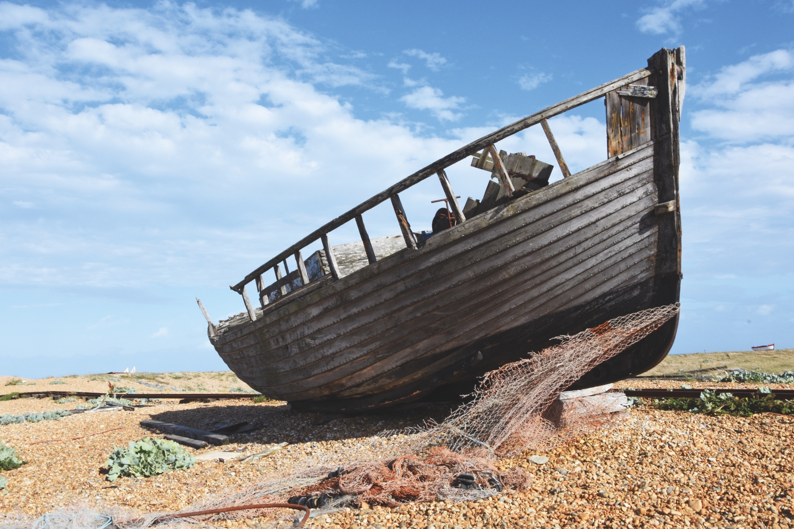



Caredigrwydd anghyffredin / Cineáltas neamhghnách
www.ctbi.org.uk/weekofprayer
18-25 January
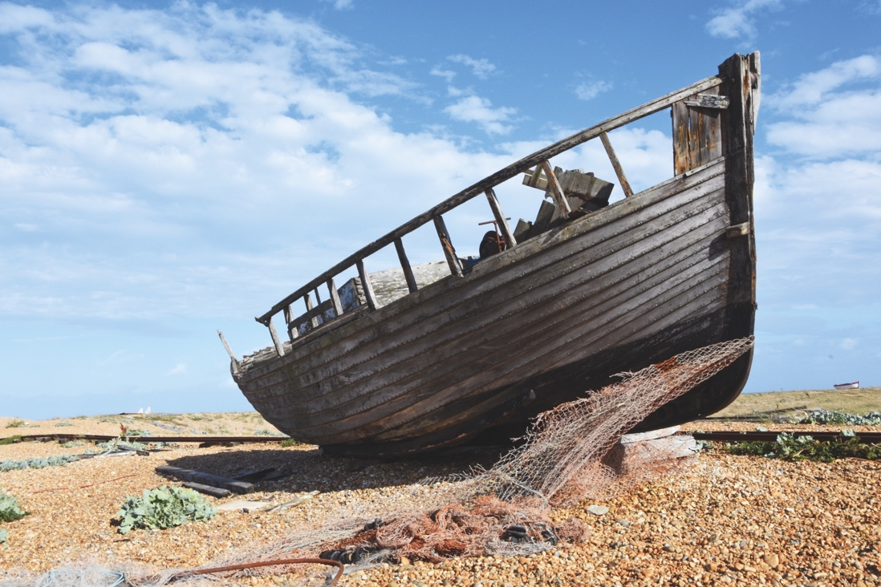
Welcome

We look but what kind of looking do we do? How do we see and understand ourselves, especially in light of our relationship with the Living Christ? We know that God speaks to us in still small voices, but also in the people and places we least expect. In supposed barren hard places there can spring unimaginable beauty and nourishment.

In spite of the turbulence of the world at the present time, we also discover
acts of kindness, of love, forgiveness and hospitality in places or from people we did not expect. As in the natural world, there are still the places where the water of life seeps into the mainstream and brings colour and joy and offers a hopeful future.

But it is only when we immerse ourselves in the vitality of all that life brings do we find this water of life seeping into the main steam. Our Bible story gives us a visceral story of human fear, survival, hope and love. It will invite us to reflect upon the abundance of God’s grace and fullness, that we can see if only we stop and look closely at what is in front of us. In the most difficult situations, inhospitable places and even in the most inhospitable people, there we will find something of God’s grace.

We are invited in this year’s Week Of Prayer for Christian Unity materials to see God working through people and places which offer unusual kindness. If only we would do the appropriate kind of looking.
Bob Fyffe, General Secretary,
Churches Together in Britain and Ireland
Unusual kindness

2
Introduction to this year’s theme
Our prayer for Christian unity is deeply rooted in the Bible. We pray for unity because Jesus prayed that His disciples would be one, that the world might believe (John 17:20-21). St Paul also urged the churches to which he wrote to recognise their unity in Christ, even though there was much diversity within them (1 Corinthians 12:12-27).

For the churches in Malta, the Bible has special relevance for the shared life of the churches there, for the Gospel first came to Malta in the events that are told in the Acts of the Apostles, where St Paul and those with him encountered unusual kindness from the inhabitants. Many people in Britain and Ireland will have visited Malta on holiday and seen the place where these events are believed to have taken place. This is a reminder that Christianity is not merely a spirituality, but a faith rooted in events in human history: the redemption of humanity and the whole of creation. The unity for which we pray therefore serves to make Christ known in the world.

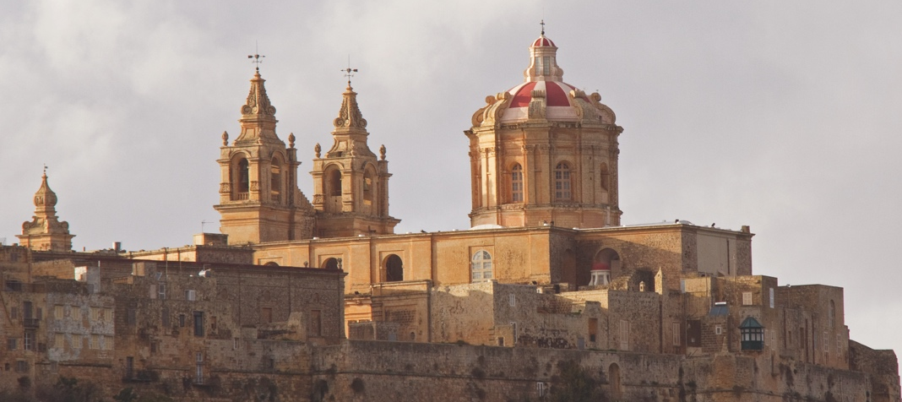
The story of St Paul’s being shipwrecked on Malta in Acts 27 and 28 leads us, during this Week of Prayer for Christian Unity, to reflect upon many aspects of our own lives and the lives of our churches. As we approach one another, seeking unity, we recognize that we sometimes carry baggage from history, tradition and cultural expectation, which can weigh us down and threaten to overwhelm us. There is the danger that, in the face of that experience, we might
St. Paul’s Cathedral, Mdina, Malta
Week of Prayer for Christian Unity

3


lose sight of the hope which first called us and so give up reaching for the light which Christ offers us.
Unusual kindness

4

St Paul challenged his fellow travellers, sailors, soldiers and prisoners to keep up their courage. In the face of apparent desperation and hopelessness, we are challenged to put our trust in God and allow ourselves to be held and carried through the waters. There will be times when we are broken, as individuals and as churches, and looking back we shall see not just the one set of footprints in the sand, but hundreds, as we are surrounded and supported by those who love us. There will be times when, standing in the storms of our own making, we are challenged to demonstrate unusual kindness in the face of worldly indifference.

To demonstrate unusual kindness is to see the sister and brother in the monster’s shame and know that they too are children of God. To demonstrate unusual kindness is to give without counting the cost, and to allow ourselves to be given unto without questioning worth. As we reflect upon, and pray for, Christian unity, we acknowledge the injury that we have caused, the pain that

we carry, the baggage that we must jettison. We pray for Christian unity as the place from which we can move onward in faith and in hope for the redemption of the world and the restoration of creation.
Week of Prayer for Christian Unity

For this year’s Week of Prayer for Christian Unity, we accompany the churches of Malta, praying with and alongside them, praying also for them in their Christian journey as they seek the unity for which Christ prayed. And we rejoice with them that Malta traces its Christian origins back to the time of the Apostles. And in so doing, we enter into the drama of St Paul, those that travelled with him, and the inhabitants whom they met, to discover our shared unity, and in so doing recognise the importance of unusual acts of kindness that bear witness to the Gospel of peace and reconciliation.
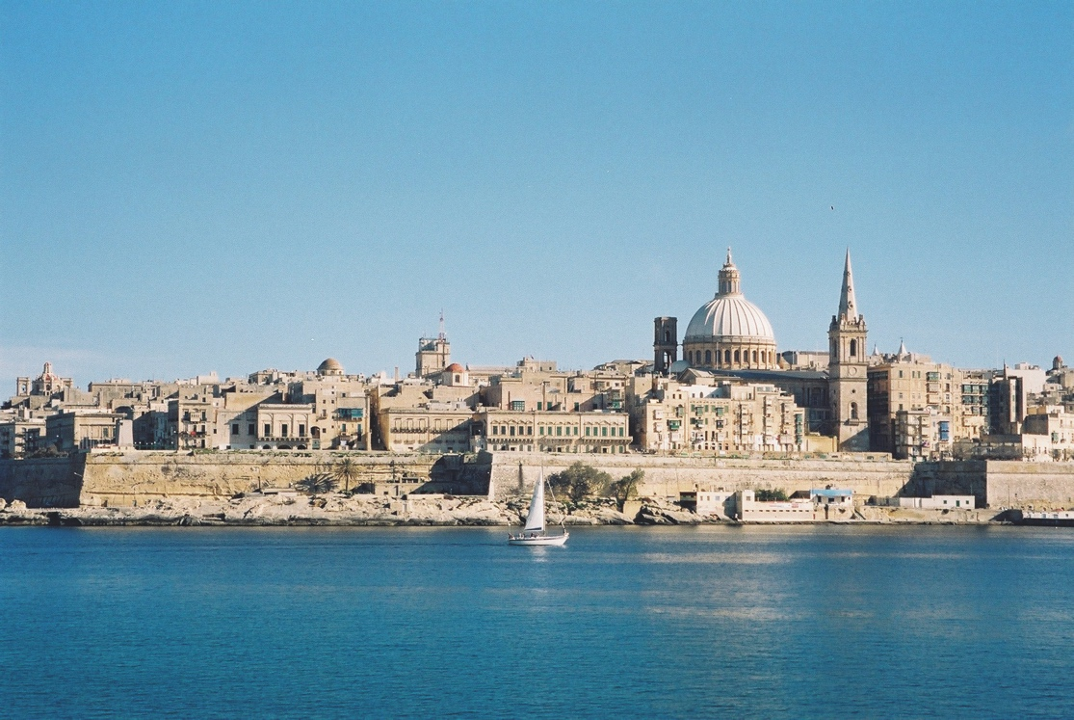
5
St. Paul’s Pro Cathedral, Valletta, Malta

Acts 27:18-19,21
DAY 1
Acts 27:18-19,21
“We were being pounded by the storm so violently that on the next day they began to throw the cargo overboard and on the third day with their own hands they threw the ship’s tackle overboard… Since they had been without food for a long time, Paul then stood up among them and said, “Men, you should have listened to me and not have set sail from Crete and thereby avoided this damage and loss.”
Psalm 85
Luke 18:9-14
Reflection
To live an untethered life
means that we may well find ourselves
at the mercy of wind and wave.
Besieged by storm and circumstance,
carried by the tide,
thrown off course,
we can find ourselves run aground,
clinging to the hope –
that we might loosen our grip of
individual claim and right,
Unusual kindness

6
and hold to a shared ownership
of this rock of truth.

Fissure cracks unearthed by
seismic change,
fresh and raw –
now open to the elements –
make it easy for fracture and
the heartbreak of division
and disunity
to split our truth apart.
But as we find each precious piece,
like flotsam and jetsam
washed up on distant shore and held
safe in the hands of someone else,
might we come together
and re-form?
As a new picture emerges
a re-seeing
re-imagining
reconciling of ourselves and each other.
We are all at the mercy of the storm regardless of where
we stand.
Port or starboard,
aft or stern
it’s the same boat,
traversing the same waters.
Whether we sink or swim
might well depend
upon who
or what
we cling to
or let go of.

Reconciliation

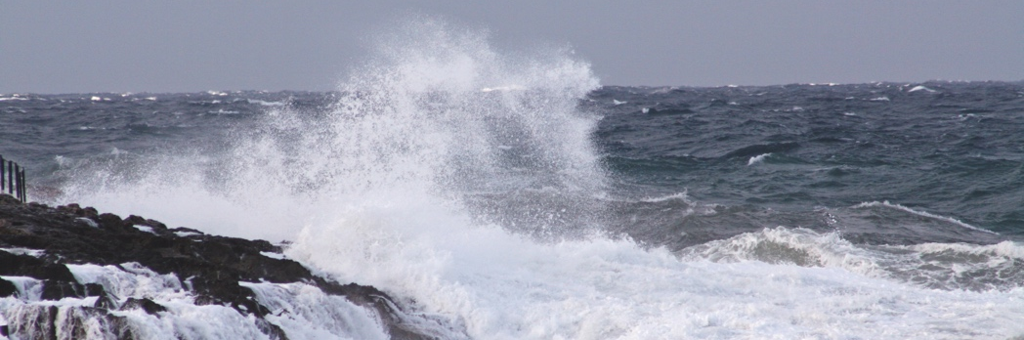

Prayer
Reconciling God,
as we feel the pain of past mistakes,
shy away
and retreat to individual strongholds;
help us surrender
a false sense of who we are,
all that tethers us,
and all that we hold precious.
Bind us to humility and compassion,
as we learn together,
to receive from You,
abide in You and Your love. Amen.

Questions
- What are the important things we need to carry with us as we journey together towards unity?
- What things might we need to let go of as we journey together towards unity? What challenges does that bring?
- What are our shared hopes for our community? What might our common prayers for our community be?

Go and Do (see www.ctbi.org.uk/goanddo)
Global: Be inspired to unity by the churches of South Sudan and their work for reconciliation.
Local: How might the churches in your area dialogue around the issues affecting your wider community?
Personal: Seek reconciliation for a broken relationship in your life.
7
Week of Prayer for Christian Unity

Acts 27:20
Acts 27:20

“When neither sun nor stars appeared for many days, and no small tempest raged, all hope of our being saved was at last abandoned.”
DAY 2
Psalm 119:105-110
Mark 4:35-41

Reflection
TRANSFUSION
I believe another
Not Him.
A cup of bitterness taints my being.
My eyes fail me,
I lose the light
and my life disengages
and halts.

Movement, spied in my darkness
frightens then brings relief.
I am not dying alone
But dying we are.
The battering storm of hope denied,
Will abandon us to fate.

A flicker flecks my blindness
I fall prostrate
As flecks materialise into Him,
Unusual kindness

8

My true and tender Father.

Held in His unbreakable arms
I still…

The storm may do its worst.
Slathered in His salve of love
Hope’s transfusion
Gently renews my being
Do not fear the pain
It sings the song of life.
Prayer
Prayer
Father, Your precious word illumines our steps and without You we remain lost and disorientated.
Holy Spirit, teach us through Your word and each other to travel our Father’s path together, walking gently on Creation.
May each gathering of Your people in churches everywhere crave Your guiding, consoling and transforming presence.
Give us the honesty we need to recognise when we lose or obscure Your light for others.

Give us grace to hold onto You, ready and able to share Your light.
We ask this in the name of Your Son Jesus, who calls us His followers, to be light to the world. Amen.
Seek and show Christ’s light
Questions
- In what circumstances do I lose sight of God?
- We prayed that we might walk gently on Creation. What is my responsibility confronted by the storm of climate change?
- What responsibility do we have as a community to address climate change?

Go and Do (see www.ctbi.org.uk/goanddo)
Global: Take action by adding your voice to the call to address the climate emergency.
Local: Are your churches involved in the eco-church/ eco-congregations award?
Personal: Individual actions on reducing carbon are not enough to make the difference but together they add up.
Week of Prayer for Christian Unity

9

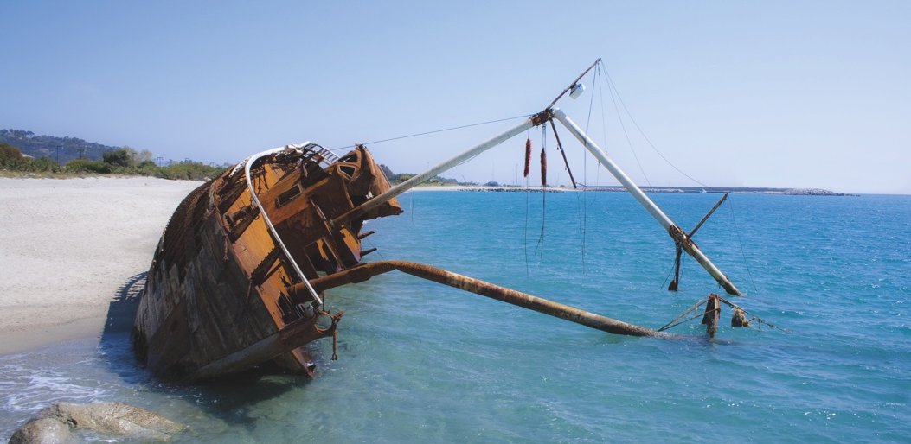

Acts 27:22,34
“I urge you now to keep up your courage, for there will be no loss of life among you, but only of the ship… none of you will lose a hair from your heads…”
DAY 3
Reflection

Keep up your courage
when the storms of life
wash you up
on an unexpected shore.
Unusual kindness

10
Keep up your courage
take barricades down
welcome the stranger
become the guest.

Keep up your courage

Psalm 27

Mathew 11:28-30

listen to the other
seek to understand
disagree agreeably.

Keep up your courage
when the ship runs aground
prepare a new vessel
chart another course.

Keep up your courage
stowaways, castaways
whatever our crew
it’s all hands on deck
creation made new.

Keep up your courage

Prayer
God of mercy,
lost and disheartened,
we turn to You.
Instil in us Your hope and courage.
May our churches strive for
the unity
for which Your Son prayed on the eve of His passion.
We ask this through Him who lives and reigns with You and the Holy Spirit for ever and ever.
Amen.

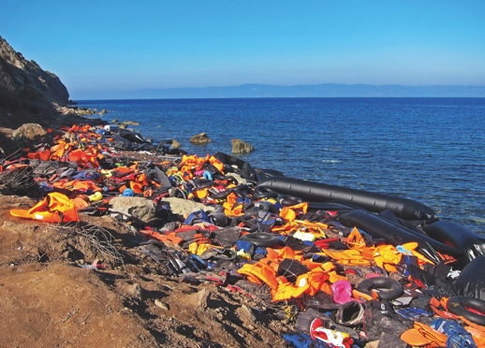

Questions
- What are the practices that you can use to keep up your courage?

- What are your hopes and fears for the churches in your area?

- How might you keep up your courage together to chart a course into the future?

Go and Do (see www.ctbi.org.uk/goanddo)
Global: Read and respond to the stories of perilous journeys by sea.

Local: Provide welcome and hospitality for those recently arrived into the UK and Ireland.

Personal: Reflecting on your own journey, how might you assist others on journeying today?
Week of Prayer for Christian Unity

11

Notes for the worship service
As an island nation, boats are an important part of Maltese life. The Scripture reading describes a perilous sea voyage by St Paul. A boat is also symbolic of the sometimes tempestuous journey Christians make together towards unity. For these reasons, the Christian churches of Malta suggest that, prior to the service, a boat or a large model of a boat is placed in the worship space.
The passage from Acts at the heart of our service provides wonderful opportunities for simple actions, sounds and multimedia that could accompany the text as it is proclaimed.
Children are seldom present at ecumenical gatherings. Here is a perfect opportunity for each community hosting this service to invite their local schools to participate by doing an art project that creates (even sides of) a boat into which some children can sit. Simple representations of the nautical items mentioned in the text could be crafted. This may also have the added benefit of welcoming their parents and guardians to our service.
At the moment mentioned in the Acts passage, sounds of the storm could accompany the proclamation (tennis balls in boxes shaken, sheets of tin foil rattled, rainsticks). In the course of the reading, several items are described as being used or thrown overboard and cut loose: ship’s tackle, ropes, anchors, lifeboats, steering oars, a foresail. Cardboard cut-outs could suffice, decorated or otherwise. Pieces of wood and bed sheets could be used to good effect. The sound of grains of rice being poured into a box could conjure up the image of wheat being thrown into the sea. Without the dramatic accompaniment of the text becoming overly complex, let your imaginations and creative skills give glory to God. YouTube videos of storms at sea could be relayed on screens.
To this end, it may be best if the entire Acts passage is proclaimed by one person from one well-lit location, who introduces the text at the beginning. Given its length and technical nautical language, the text requires very careful proclamation and might best be proclaimed from a point near the boat. There is no need for further announcing of chapter and verse references until the very end when “This is the Word of the Lord” concludes the reading. This will provide the necessary continuity and rhythm to hold together the segments of the Scripture as they are being punctuated by responses, psalms and hymns etc.
Other Leader and Reader roles in the service can of course be led by a variety of Christian representatives.
12

Week of Prayer for Christian Unity 2020

ECUMENICAL WORSHIP SERVICE

Order of Service



© Churches Together in Britain and Ireland

The Gathering
Unusual kindness

14
Introductory hymn

For the healing of the nations (Cwm Rhondda)

(Or a hymn which is sung to a well-known tune and reflects the themes of the Acts passage and the service as a whole.)

If you wish, during the singing of the introductory hymn, church leaders and representatives enter the venue for the ecumenical service of prayer for Christian unity. They are led by a participant carrying the Bible for all to see. The Bible is placed in a place of honour in the centre of the worshipping community.
Words of welcome
Leader The grace of our Lord Jesus Christ,
the love of God,
and the communion of the Holy Spirit,
be with you all.
Congregation And also with you.

Leader Dear sisters and brothers in Christ, we gather to pray for unity among Christians and reconciliation in the world. When St Paul was shipwrecked in Malta, he was received with unusual kindness. Let us introduce ourselves to those around us and greet them with a sign of peace.
Leave enough time for people to do this.
Leader The resources for this year’s Week of Prayer for Christian Unity have been prepared by different Christian churches in

Malta – a small country made up of two main inhabited islands, Malta and Gozo, as well as other islets. Malta is at the heart of the Mediterranean Sea, halfway between the southern tip of Sicily and Northern Africa. This biblical land lies at the crossroads of civilizations, cultures and religions. The history of Christianity in this small island nation dates back to the time of the apostles. According to tradition, St Paul, the Apostle to the Gentiles, reached the shores of Malta in the year 60CE. The narrative describing this eventful and providential episode is conveyed to us in the final two chapters of the Acts of the Apostles, which are at the heart of our service today.
Listening to the Living Word of God

Leader Let us listen attentively to the Word of God. (all sit)
(same as above)
Reader Father in heaven, open our hearts and minds to Your Word.
Congregation Your words are spirit and life!
Reader Lead us to grow closer to each other in unity and charity.
Congregation Your word is a lamp to our path!
Reader A reading from the Acts of the Apostles
We were being pounded by the storm so violently that on the next day they began to throw the cargo overboard, and on the third day with their own hands they threw the ship’s tackle overboard. When neither sun nor stars appeared for many days, and no small tempest raged, all hope of our being saved was at last abandoned.
Week of Prayer for Christian Unity

15

Since they had been without food for a long time, Paul then stood up among them and said, ‘Men, you should have listened to me and not have set sail from Crete and thereby avoided this damage and loss. I urge you now to keep up your courage, for there will be no loss of life among you, but only of the ship. For last night there stood by me an angel of the God to whom I belong and whom I worship, and he said, “Do not be afraid, Paul; you must stand before the emperor; and indeed, God has granted safety to all those who are sailing with you.” So keep up your courage, men, for I have faith in God that it will be exactly as I have been told. But we will have to run aground on some island.’
Acts 27:18-26
Unusual kindness

16
Invocation of the Holy Spirit
The response to each prayer may be sung by a cantor and repeated by the whole congregation. Or you could play the Taizé ‘Veni Sancte Spiritus’ softly or a suitable chorus or music as the words are being spoken.
Leader Spirit, breath of God’s loving, come upon this gathering and dwell among us.
Congregation Come, Holy Spirit! (or Veni Sancte Spiritus!)
Leader Spirit and Consoler, shine Your light in our darkness.
Congregation Come, Holy Spirit! (or Veni Sancte Spiritus!)
Leader Spirit and Advocate, be our hope when we feel abandoned
Congregation Come, Holy Spirit! (or Veni Sancte Spiritus!)
Leader Spirit, Helper and Guide, bring us to eternal safety.
Congregation Come, Holy Spirit! (or Veni Sancte Spiritus!)

Leader Spirit and Comforter, help us heal and restore what we have damaged and lost.
Congregation Come, Holy Spirit! (or Veni Sancte Spiritus!)
Reader When the fourteenth night had come, as we were drifting across the sea of Adria, about midnight the sailors suspected that they were nearing land. So they took soundings and found twenty fathoms; a little farther on they took soundings again and found fifteen fathoms. Fearing that we might run on the rocks, they let down four anchors from the stern and prayed for day to come. But when the sailors tried to escape from the ship and had lowered the boat into the sea, on the pretext of putting out anchors from the bow, Paul said to the centurion and the soldiers, ‘Unless these men stay in the ship, you cannot be saved.’ Then the soldiers cut away the ropes of the boat and set it adrift.
Acts 27:27-32
Prayers of pardon and reconciliation
The response to each prayer may be sung by a cantor and repeated by the whole congregation.
Leader Forgive us, Lord, for remaining in darkness rather than seeking Your light.
Congregation Lord, have mercy! (or Kyrie eleison!)
Leader Forgive us, Lord, for our failure to sound the depths of Your presence in other Christian traditions.
Congregation Lord, have mercy! (or Kyrie eleison!)
Week of Prayer for Christian Unity

17

Leader Forgive us, Lord, for past mistakes, mistrust and misdeeds between Christians from different churches and communities.
Congregation Lord, have mercy! (or Kyrie eleison!)
Leader Forgive us, Lord, for isolating ourselves and trying to escape God’s desires for us.
Congregation Lord, have mercy! (or Kyrie eleison!)
Leader Forgive us, Lord, for our lack of faith and for our failure to be people of hope and authentic love.
Congregation Lord, have mercy! (or Kyrie eleison!)
Leader Forgive us, Lord, for remaining indifferent, instead of showing hospitality to all, especially strangers and refugees.
Congregation Lord, have mercy! (or Kyrie eleison!)
Leader The Lord is merciful and gracious, slow to anger and abounding in steadfast love. As the heavens are high above the earth, so great is His steadfast love towards those who fear Him; as far as the east is from the west, so far He removes our transgressions from us (Psalm 103:8,11-12).
Congregation Amen
You may wish to sing again here. Choose a hymn which either picks up the theme of pardon and reconciliation and the unbounded love of God, or a hymn which looks toward the next instalment of the Acts passage.
Reader Just before daybreak, Paul urged all of them to take some food, saying, ‘Today is the fourteenth day that you have been in suspense and remaining without food, having eaten
Unusual kindness

18

nothing. Therefore I urge you to take some food, for it will help you survive; for none of you will lose a hair from your heads.’ After He had said this, He took bread; and giving thanks to God in the presence of all, He broke it and began to eat. Then all of them were encouraged and took food for themselves. We were in all two hundred and seventy-six persons in the ship. After they had satisfied their hunger, they lightened the ship by throwing the wheat into the sea.
Acts 27:33-38
The Apostles’ Creed (or a suitable Creed
All stand.
Leader Dear brothers and sisters, St Paul gave encouragement
to those on the ship by breaking bread. Let us take encouragement from our common faith, proclaiming words
which have resounded in the Church throughout
the centuries:
Congregation We believe in God,
the Father almighty,
Creator of heaven and earth,
and in Jesus Christ, His only Son, our Lord,
who was conceived by the Holy Spirit,
born of the Virgin Mary,
suffered under Pontius Pilate,
was crucified, died and was buried;
he descended into hell;
on the third day He rose again from the dead;
he ascended into heaven,
and is seated at the right hand of God the Father almighty;
from there He will come to judge the living and the dead.
Week of Prayer for Christian Unity

19

We believe in the Holy Spirit,
the holy Catholic Church,
the communion of saints,
the forgiveness of sins,
the resurrection of the body,
and life everlasting. Amen.
All sit
Reader In the morning they did not recognize the land, but they noticed a bay with a beach, on which they planned to run the ship ashore, if they could. So they cast off the anchors and
left them in the sea. At the same time they loosened the ropes that tied the steering-oars; then hoisting the foresail to the wind, they made for the beach. But striking a reef, they ran the ship aground; the bow stuck and remained immovable, but the stern was being broken up by the force of the waves. The soldiers’ plan was to kill the prisoners, so that none might swim away and escape; but the centurion, wishing to save Paul, kept them from carrying out their plan. He ordered those who could swim to jump overboard first and make for the land, and the rest to follow, some on planks and others on pieces of the ship. And so it was that all were brought
safely to land.
Acts 27:39-44
Psalm
Psalm 107:8,19-22, 28-32
A cantor may sing this Psalm and the congregation is invited to sing the Response.
Reader The Lord has delivered us from the mighty waves.
Congregation The Lord has delivered us from the mighty waves.
Unusual kindness

20

Leader Let them thank the Lord for His steadfast love,
for His wonderful works to humankind.
For He satisfies the thirsty,
and the hungry He fills with good things.
Congregation The Lord has delivered us from the mighty waves.
Leader Then they cried to the Lord in their trouble,
and He saved them from their distress;
he sent out His word and healed them,
and delivered them from destruction.
Congregation The Lord has delivered us from the mighty waves.
Leader Let them thank the Lord for His steadfast love,
for His wonderful works to humankind.
And let them offer thanksgiving sacrifices,
and tell of His deeds with songs of joy.
Congregation The Lord has delivered us from the mighty waves.
Leader Then they cried to the Lord in their trouble,
and He brought them out from their distress;
he made the storm be still,
and the waves of the sea were hushed.
Then they were glad because they had quiet,
and He brought them to their desired haven.
Congregation The Lord has delivered us from the mighty waves.
Leader Let them thank the Lord for His steadfast love,
for His wonderful works to humankind.
Let them extol Him in the congregation of the people,
and praise Him in the assembly of the elders.
Congregation The Lord has delivered us from the mighty waves.
Week of Prayer for Christian Unity

21

Reader After we had reached safety, we then learned that the island was called Malta. The natives showed us unusual kindness. Since it had begun to rain and was cold, they kindled a fire and welcomed all of us round it. Paul had gathered a bundle
of brushwood and was putting it on the fire, when a viper, driven out by the heat, fastened itself on his hand. When the natives saw the creature hanging from his hand, they said to one another, ‘This man must be a murderer; though he has escaped from the sea, justice has not allowed him to live.’ He, however, shook off the creature into the fire and suffered no harm. They were expecting him to swell up or drop dead, but after they had waited a long time and saw that nothing unusual had happened to him, they changed their minds and began to say that he was a god.
Now in the neighbourhood of that place were lands belonging
to the leading man of the island, named Publius, who received us and entertained us hospitably for three days. It so happened that the father of Publius lay sick in bed with fever and
dysentery. Paul visited him and cured him by praying and putting his hands on him. After this happened, the rest of the people on the island who had diseases also came and were cured. They bestowed many honours on us, and when we were about to sail, they put on board all the provisions we needed.
Acts 28:1-10
Unusual kindness

22
Reader This is the Word of the Lord.
Congregation Thanks be to God who saves and who heals!
A biblical reflection or short homily

The prayers of the people
During the prayers, eight oars (or oar-shaped models) are brought into the assembly by members of different communities. Seven oars bear words – Trust, Perseverance, Harmony, Courage, Unusual Kindness, Transformation and Generosity – and the final oar has the outline of a heart on it. The presentation of an oar introduces each of the petitions. After the oar has been held high, it is placed near or in the boat or given to a child to hold and a time of silent prayer follows. A reader then announces the corresponding petition and all respond.
Leader We cannot face the storms of life alone. A boat moves forward when all row together. In the face of difficulties we recognise the need to pull together and to unite our efforts.
Let us pray.
In silence, each oar is brought forward and held high before the Reader speaks. After the response it is put near or in the boat or given to a child to hold.
Reader Gracious God, strengthen our confidence in Your providence when we feel overwhelmed by the storms of life.
Congregation Hear our prayer for Trust.
Reader Gracious God, teach us to fix our course on Christ, the True Light who brings us to safe harbour.
Congregation Hear our prayer for Perseverance.
Reader Gracious God, transform our many painful separations into harmony and our mistrust into mutual acceptance.
Congregation Hear our prayer for Harmony.
Week of Prayer for Christian Unity

23

Leader Gracious God, give us the courage to speak the truth with justice in love.
Congregation Hear our prayer for Courage.
Reader Gracious God, help us to welcome with unusual kindness our sisters and brothers who are in peril or in need.
Congregation Hear our prayer for Unusual Kindness.
Reader Gracious God, change our hearts and the hearts of our Christian communities, that we may be agents of Your healing.
Congregation Hear our prayer for Transformation.
Reader Gracious God, open our eyes to see the whole of creation
as Your gift, and our hands to share its fruits in
generous solidarity.
Congregation Hear our prayer for Generosity.
Reader Gracious God, listen now to the prayers of our hearts which we pray either in silence or softly aloud. (You may wish to amend this according to your tradition.)
Leave enough time for people to think about what to pray for and to pray for it.
Leader One in Jesus Christ, let us pray together to our true and tender Father in the words He taught us.
Congregation Our Father in heaven,
hallowed be Your name,
Your kingdom come,
Your will be done,
Unusual kindness

24

on earth as in heaven.
Give us today our daily bread.
Forgive us our sins
as we forgive those who sin against us.
Save us from the time of trial
and deliver us from evil.
For the kingdom, the power, and the glory are Yours
now and for ever. Amen.
We are sent out together to proclaim the Good News
Leader We have come together as Christians,
and therefore as fellow disciples.
As we yearn for Christian unity,
let us commit ourselves anew
to work for this common goal.
Congregation Lord God, we thank You
for calling us into the company of those
who trust in Christ and seek to obey His will.
May Your Spirit guide and strengthen us
in mission and service to Your world:
For we are strangers no longer
but pilgrims together on the way to Your Kingdom.
Amen.
Swanwick Declaration 1987
(Church leaders and representatives who are present may join in proclaiming the Prayer of Blessing.)
Week of Prayer for Christian Unity

25

Leader May God the Father, who called us from darkness into light, make us true bearers of God’s light.
Congregation Amen.
Leader May God the Son, who redeemed us by His precious blood, empower us to follow His example in serving others.
Congregation Amen.
Leader May God the Holy Spirit, who is Lord and giver of life, strengthen us to endure the shipwrecks of life and reach the shores of salvation.
Congregation Amen.
Leader May the Almighty and Merciful God, Father, Son and Holy Spirit, bless and protect us, now and forever.
Congregation Amen.
Congregation We set out together, to proclaim the wonders of God’s love. Amen! Alleluia! Amen!
Concluding hymn
Love is the boat for the journey (tune: Loch Lomond) or some suitable hymn sung to a well-known tune, picking up the themes of the service and sending people out to love and serve the Lord.

Unusual kindness

26

Acknowledgements
CTBI WPCU 2020 Writers
Each year Churches Together in Britain and Ireland (CTBI) works in collaboration with various writers from within the four nations to produce these materials for your use. In acknowledgment of this collaboration we have listed below the colleagues who have helped us accomplish this task for 2020:
Jenny Bond - Churches Together in England
Anne Clifford - Churches Together in England
Revd Peter Colwell - Churches Together in Britain and Ireland
Major Alan Dixon - Salvation Army
Bob Fyffe - Churches Together in Britain and Ireland
Revd Ruth Harvey - Place for Hope
Wendy Lloyd - Christian Aid
Fr Damian McNeice - Roman Catholic Church
Phillip Mellstrom - Church of Scotland
Revd Dr Adrian Morgan - Church in Wales
Dr Siôn Aled Owen - Cytûn
Patricia White - Baptist Church

Bible verses from the New Revised Standard Version Bible: Anglicized Edition, copyright 1989, 1995, Division of Christian Education of the National Council of the Churches of Christ in the United States of America. Used by permission.

All rights reserved.
Week of Prayer for Christian Unity

27

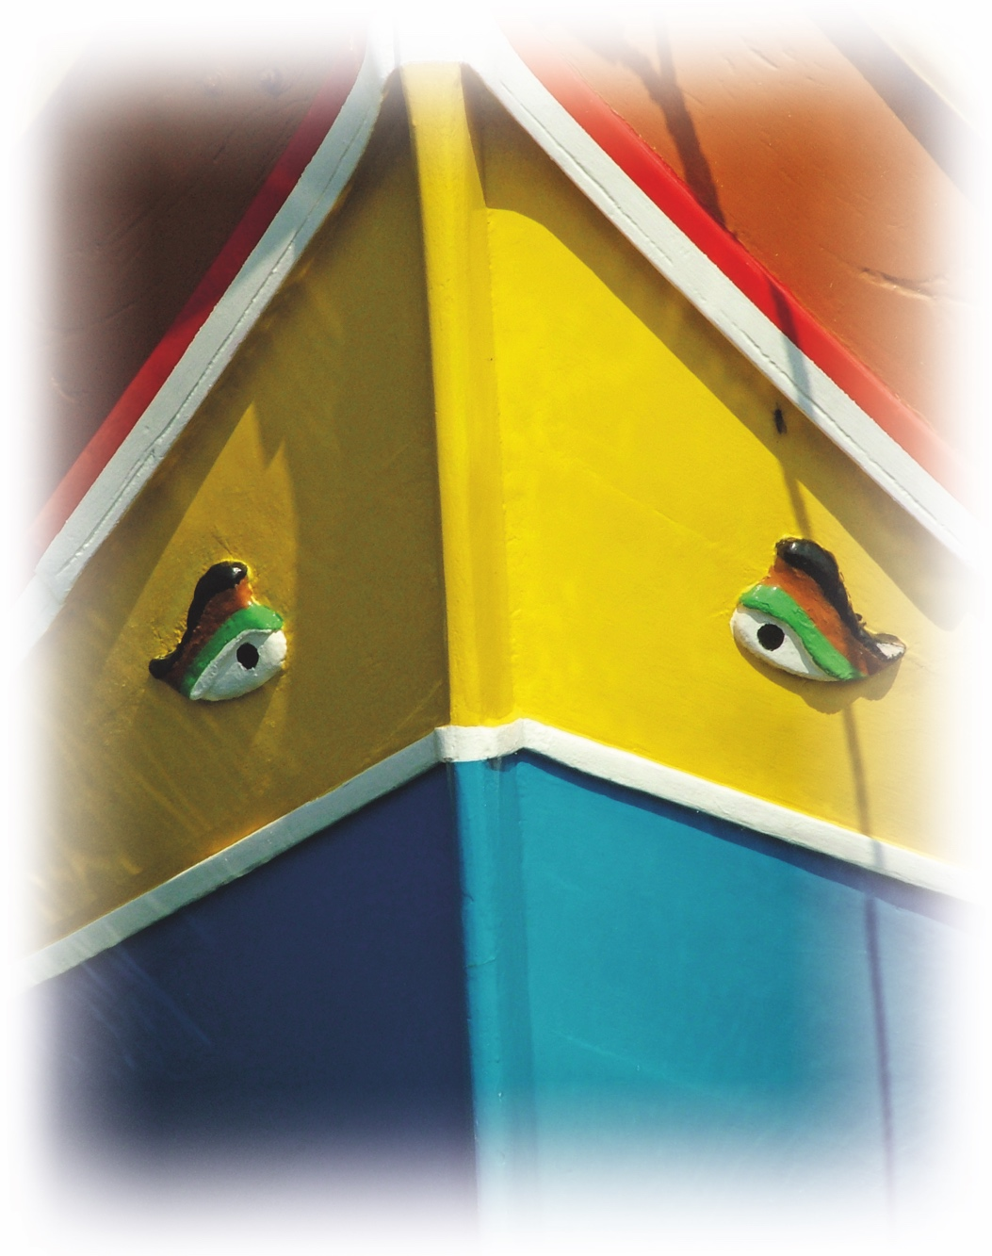

Unusual kindness

28

Dates
The Week of Prayer for Christian Unity is traditionally observed from 18th to 25th January (the octave of St Peter and St Paul). However, some groups choose other times of the year, particularly around Pentecost which is a symbolic date for the unity of the church. Do make your own decision, taking local factors into account. To allow for use at any time in the year, the Days material uses the notation 1-8.
Order of service
The order of service in the centre of the pamphlet can be pulled out and photocopied if you wish. Alternatively, all resources can be downloaded from the CTBI website and you are welcome to further edit or adapt them for local use. Please acknowledge the source of material as Churches Together in Britain and Ireland, Week of Prayer for Christian Unity resources.
Christian unity wall
Please add details and photos of your events, prayers and messages of unity to the Christian unity ‘wall’ at www.weekofprayer.org by posting to Twitter using #wpcuwall hashtag. Posts appear automatically (after a slight delay).
Photo credits
p3, 31: Flickr / Tony Hisgett
p5: Flickr / Paul Stephenson
p7: Flickr / hobbs_luton
p39: Flickr / Martin Lopatka
Week of Prayer for Christian Unity

29
30

Acts 27:23-26
DAY 4
“For last night there stood by me an angel of the God to whom I belong and whom I worship, and he said, ‘Do not be afraid, Paul; you must stand before the emperor; and indeed, God has granted safety to all those who are sailing with you.’ So keep up your courage, men, for I have faith in God that it will be exactly as I have been told. But we will have to run aground on some island.”
Psalm 56
Luke 12.22-34

Reflection
Assailed on every side, I long for a more sustaining image of You God. I need You closer than ever, to be with me through these current horrors. Our dialogue has become coarse and aggressive and I find it difficult to listen to any news and current affairs. Bad news seems everywhere, abuse, cruelty of unspeakable proportions, political divisions and a vortex of hate that creeps into so much of what we do. Are You alone in listening?
Unusual kindness

30
Where am I to find hope? Where should I look? How can I find a route towards healing when I have no sense of what a hopeful future looks like? And yet You speak into this space from below. I am carried even without knowing it, and I can only just sense Your hold on me. Lifting me, stroking my doubt into a soft glow of warmth that might eventually become something more.

‘Don’t be afraid’ is easily said. So I need to trust You again and again, and hold on to what little I see. For I sense You near me, and I long for Your word from long ago, which is still alive in me in Your Saints and incarnate Son.

Adrift
I am floating and at sea
Without direction and fearful of what lies ahead
I come to You, known and yet unknowing
Unfathomable God
Rising and falling
Without bearings
bring me to a safe haven
a place where I can begin
to hope again
to trust again
in You and others.

Prayer
Almighty God,
our personal suffering leads us to cry out in pain
and we shrink in fear when we experience sickness, anxiety
or the death of loved ones.
Teach us to trust You.
May the churches we belong to be signs of Your providential care.
Make us true disciples of Your Son
who taught us to listen to Your word
and to serve one another.
In confidence we ask this in the name of Your Son,
and in the power of the Holy Spirit. Amen.

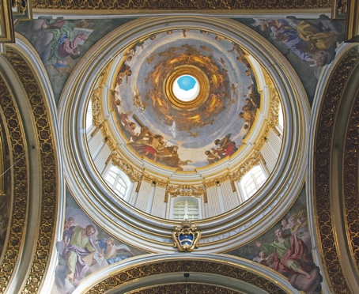

Trust: Do not be afraid, believe

St. Paul’s Cathedral, Mdina, Malta

Questions
- What are the images of God that sustain you through times
of questioning?
- Where are the places and who
are the people who give you hope for the future?

Go and Do (see www.ctbi.org.uk/goanddo)
Global: Be inspired by those who show much resilience in the face of
the storm.

Local: Set up a local group from your churches and community who commit to a deeper listening to one another.

Personal: Spend time with the people or in the place that give you
Week of Prayer for Christian Unity

31
most hope.

Acts 27:33-36

“Just before daybreak, Paul urged all of them to take some food, saying, ‘Today is the fourteenth day that you have been in suspense and remaining without food, having eaten nothing. Therefore I urge you to take some food, for it will help you survive; for none of you will lose a hair from your heads.’ After he had said this, he took bread; and giving thanks to God in the presence of all, he broke it and began to eat. Then all of them were encouraged and took food for themselves.”

Psalm 77
DAY 5
Mark 6:30-44

Reflection
‘You need to eat something,
to keep your strength up’
Paul exhorts them,
breaking bread
giving thanks,
leading the way.
His words of reassurance
that not a hair would be lost
in the depth of the storm
may be a hollow resonance
for some.
Unusual kindness

32

I love coffee
but lost my appetite for it
I love a good read of the bulky
weekend paper
but my brain had no space
for it
too busy processing and preparing
harnessing the little energy reserves I had
to face cannulas and PICC lines
and nauseating chemo.
Every hair from my head would be lost
but I’d be rescued from the storm, hopefully.

And when you can’t eat
to keep your strength up
because the chemo makes you sick on a Wednesday
you chew on the words
that those who wait upon
the Lord
will renew their strength
they’ll rise up on wings like eagles run and not grow weary
trusting that one day
this broken body
might rise again
strong and supple
scarred and scared.
Every hair of my head was lost
but I’d be rescued from the storm, hopefully.
Keep your strength up

And as I look back
these ten years hence
there wasn’t one set of footprints
there were hundreds
of the friends and loved ones
who visited, listened, cried,
prayed and carried
the body of Christ
strengthening me.
Every hair of my head was lost
but I was rescued from the storm, thankfully.

Prayer
Loving God,
Your Son Jesus Christ broke bread and shared the cup with His friends.

May we grow in closer communion
when we share our pain and suffering.

Encouraged by St Paul
and the early Christians,

Questions
- How does the reflection above
make you feel?
- Have you had experiences of when the promises of Scripture haven’t delivered as you’d expected?
- When have you most felt the pain
over disunity in the body
of Christ?
- How might sharing the body of Christ be a source of healing and unity between Christians?

give us strength to build bridges
of compassion, solidarity and harmony.

In the power of the Holy Spirit,
we ask this in the name of Your Son,
who gives His life that we might live. Amen.

Go and Do (see www.ctbi.org.uk/goanddo)
Global: Work for the day when good healthcare is available for all.

Local: Hold a ‘bring and share’ meal together with the churches in your area where you have a conversation about what Eucharist/Communion/Lord’s Supper means to each church.

Personal: Visit, send a card or call someone who is currently unwell that you know.
Week of Prayer for Christian Unity

33

DAY 6
Acts 28:1-2,7
“After we had reached safety, we then learned that the island was called Malta. The natives showed us unusual kindness. Since it had begun to rain and was cold, they kindled a fire and welcomed all of us round it …
Now in the neighbourhood of that place were lands belonging to the leading man of the island, named Publius, who received us and entertained us hospitably for three days”

Psalm 46
Luke 14:12-24


Unusual kindness

34



Reflection
I open my door
and welcome the newness of uncertainty.
The presence of possibility
resides in the unfamiliar received
with outstretched, vulnerable arms.
The gifts brought
are for sharing among us,
not trading equity.

This stranger and I,
we resolve to put warmth in the
cold places,
compassion in the hard places,
hope in the dark places,
and peace deep within.

We kindle the fire together
and gather for warmth,
before the next pilgrim,
brings gifts
for us all.

Hospitality

Prayer
God of the orphan, the widow and the stranger,
instil in our hearts a deep sense of hospitality.
when You ask us to feed You,
to clothe You and to visit You
those with ears to hear, listen,
those with eyes to see, look.
May our churches participate
in the ending of hunger,
thirst and isolation
and in overcoming barriers that prevent the welcoming of
all people.
We ask this in the name of
Your Son, Jesus,
who is present in the least of our sisters and brothers. Amen.

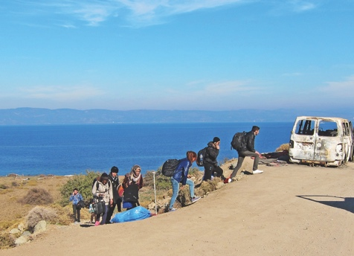

Questions
- Share a story about a time you experienced hospitality in a meaningful way.
- Think about a time when you had to be hospitable that was difficult. In what ways has that changed how you welcome people? Where do you need to go the extra mile?
- Where have you recognised unusual kindness in your community?

Go and Do (see www.ctbi.org.uk/goanddo)
Global: Find out about the united work of the Act Alliance responding to poverty and injustice across the world.

Local: How do we as churches begin or go deeper into a meaningful conversation with the voices we find difficult in society? What can we learn from these voices? Discuss together.
Week of Prayer for Christian Unity

35

Personal: How might you show unusual kindness to someone in your community today?

DAY 7

Acts 28:3-6

“Paul had gathered a bundle of brushwood and was putting it on the fire, when a viper, driven out by the heat, fastened itself on his hand. When the natives saw the creature hanging from his hand, they said to one another, ‘This man must be a murderer; though he has escaped from the sea, justice has not allowed him to live.’ He, however, shook off the creature into the fire and suffered no harm. They were expecting him to swell up or drop dead, but after they had waited a long time and saw that nothing unusual had happened to him, they changed their minds and began to say that he was a god.”
Unusual kindness

36
Psalm 119:137-144
Matthew 18:1-6

Reflection

Monster!
The headlines tear
like shards of glass through
ripped reputations
and tainted talents,
to be heard no more.
Hordes!
Names, stories, lives, compacted
into an anonymised mass.
Contempt for care,
rejection made righteous.
When will we turn
and dare to see the sister in the surge
of displaced existence,
and the brother
in the monster’s shame?

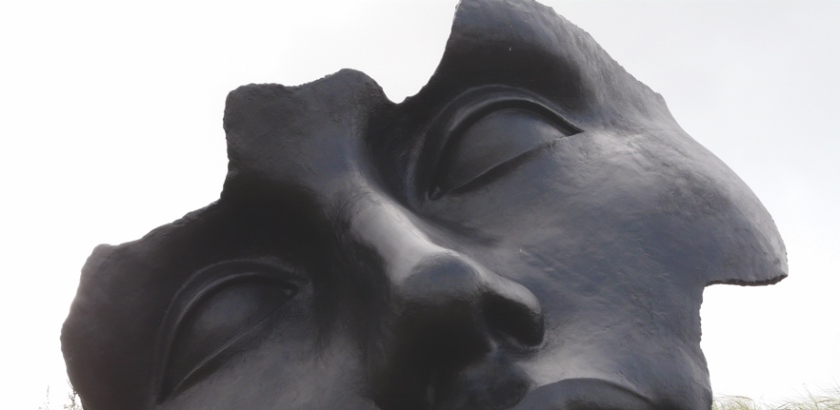
Transformation: Changing our hearts and minds

Prayer
Almighty God,
we turn to You with repentant hearts.
In our sincere quest for Your truth,
purify us from our unjust opinions
of others
and lead the churches to grow
in communion.
Help us let go of our fears,
and so better understand each other and the stranger in our midst,
and dare to love the rejected.
We ask this in the name of the
Just One,
Your beloved Son, Jesus Christ. Amen.



Questions
- Have you ever changed your mind about someone, for the better? Why?
- How has your church related to churches and congregations with very different theological ideas and/or cultures?
- Who are the outcasts in your
community? How can your church better reach out to them?

Go and Do (see www.ctbi.org.uk/goanddo)
Global: Find inspiration from stories of inclusion and overcoming prejudice in India.

Local: How are you as churches working with those on the fringes of society? Find out how you could be supported to do more.

Personal: Take steps to tackle prejudice or exclusion in your life and community.
Week of Prayer for Christian Unity

37
DAY 8

Acts 28:8-10
“The father of Publius lay sick in bed with fever and dysentery. Paul visited him and cured him by praying and putting his hands on him. After this happened, the rest of the people on the island who had diseases also came and were cured. They bestowed many honours on us, and when we were about to sail, they put on board all the provisions we needed”
Unusual kindness

38

Psalm 103:1-5

Matthew 10:7-8

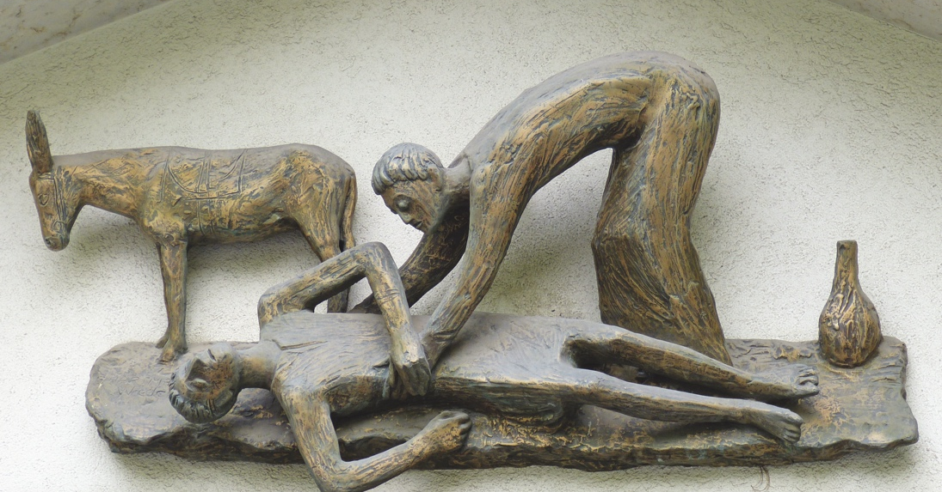

Reflection
I thank
the stranger
for privileging me to receive You.
I thank
the Samaritan
for making me accept Your care
and the love I thought wasn’t in You to give.
I thank
Jesus
for drawing me to Your
precious death
to receive Your poverty
as riches that outweigh the world.
I thank
the others all
who gave to me so much to give.

Prayer
God, giver of life,
we thank You for the gift of Your compassionate love
which soothes and
strengthens us.
We pray that our churches
may be always open to receive Your gifts from one another.
Grant us a spirit of generosity
to all
as we journey together in the path of Christian unity.
We ask this in the name of
Your Son
who reigns with You and the Holy Spirit. Amen.
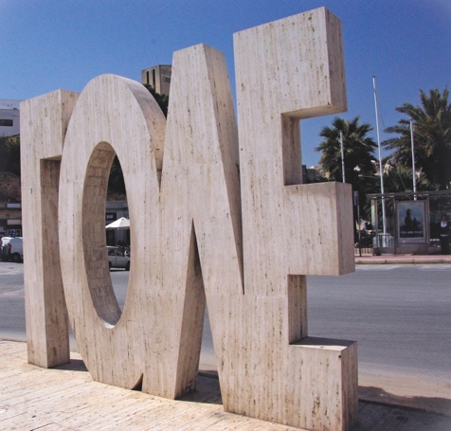

Questions
Generosity: Receiving and giving
- Have you ever received a gift from someone from whom you found it difficult to receive? What did you do with the gift?
- How does your church receive from other Christian traditions?
- How does your church receive from people of other faiths and none?

Go and Do (see www.ctbi.org.uk/goanddo)
Global: Find out how the generosity of churches has made such a difference to communities across the world through the work of
Christian Aid.
Local: Identify your needs as a church or churches and consider who you could approach to help you fulfil those needs.
Week of Prayer for Christian Unity

39
Personal: Ask someone to help you with an outstanding task or need
you have.

Week of Prayer for Christian Unity 2020



Twitter: #wpcu2020
#wpcuwall
Printed copies available from
Norwich Books and Music
Order line: 01603 785925
Original version published by:
Churches Together in
Britain and Ireland
Interchurch House,
35 Lower Marsh, London SE1 7RL
Registered charity no. 1113299
Company limited by guarantee,
registered no. 5661787
Note: this version may have been adapted for local use.
ctbi.org.uk/weekofprayer
Fax: 01603 785915
orders@norwichbooksandmusic.co.uk
online:https://chbookshop.hymnsam.co.uk/

ctbi.org.uk/weekofprayer
weekofprayer.org



