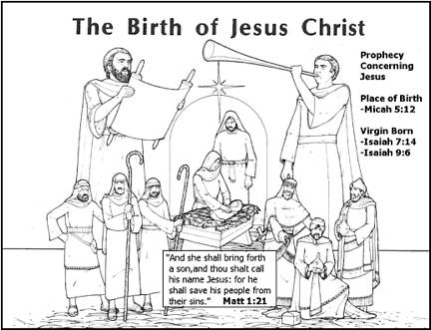
The Birth of Jesus Christ
The birth of Jesus is recorded in Luke 2:1-20. It occurred during the reign of Caesar Augustus, who had declared a taxation on all the people in his kingdom. Because each person was required to go into his native city to be taxed, Joseph and Mary travelled to Bethlehem. While they were there, Mary gave birth to the Christ child in a stable, and laid Him in a manger. The city was so crowded that there was no room for the family to stay in the inn.
An angel proclaimed the birth of the Saviour, Christ the Lord, in Bethlehem to shepherds who were watching over their flocks outside the city. When the angels departed, the shepherds followed their instructions journeying into Bethlehem. They found Mary and Joseph with the baby in the stable. The shepherds told many people of their angelic visit, glorifying and praising God.
Later, wise men came from the east to Jerusalem, in an effort to find the One who was born King of the Jews. This is recorded in Matthew 2. They came first to King Herod in Jerusalem inquiring where the king was to be born. Herod inquired of the chief priests and scribes who told him that Christ was to be born in Bethlehem. King Herod sent the wise men to Bethlehem asking that they return and inform him if they found the child. The wise men departed into their own country another way (Matthew 2:12). The Lord also warned Joseph to take Jesus out of the country into Egypt. This was to protect Him from the anger of Herod, who later killed all the children in the Bethlehem area, who were two years old and under. Herod became very alarmed upon hearing of a King of the Jews being born. When Herod was dead, the angel of the Lord appeared again to Joseph in a dream, and instructed him to return to the land of Israel. Joseph moved his family to Nazareth, in Galilee.
