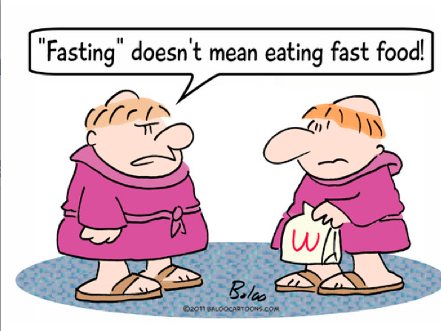

What does it mean to "fast" and to “abstain” in Lent? To fast is to do without food. Its purpose is to experience the effects of not eating. It also serves to be a penance or a sacrifice - for the purpose of strengthening us. When we don't eat, for even a little while, we get hungry. When we get hungry, we have a heightened sense of awareness. If, when we eat too much, we have a sluggish feeling, when we fast, we have a feeling of alertness. Fasting is a wonderful exercise whenever we want to sincerely ask for an important grace from God. It is not that our fasting "earns" God's attention, but by fasting, we clarify our thinking and our feeling. It is purifying and prepares us to pray more deeply. Catholics, as a group, are required to fast on only two days of the year - Ash Wednesday and Good Friday. On these days, fasting means something very specific and limited. It means that one eats only one full meal in a day, with no food in-between meals. It is understood that two other meals, if one eats three meals a day, should not total one full meal. One might fast in a more complete way, i.e., eating only a portion of a single meal. Of course, anyone is free to fast at any time that it is helpful for their prayer and reflection. It is not recommended that anyone with impaired health should fast in any way. It is also important to note that everyone who fasts should drink enough fluids on a fast day.
To abstain is to not eat meat. Its purpose is to be an act of penance - an act of sacrifice that helps us grow in freedom to make much bigger sacrifices. Of course, it would not make sense to make the sacrifice of not eating meat, and then eat a wonderful meal I might enjoy even more. Many people eat a vegetarian diet, for a variety of reasons, and eating meat is not even an issue. It might be possible to abstain from a non-meal that I really like, on all the Fridays of Lent. It should be noted that many people in this world cannot afford to eat meat or do not have access to it. Part of our abstaining from meat can place us in solidarity with so many of our sisters and brothers around the world.

