MARANATHA COME LORD JESUS !
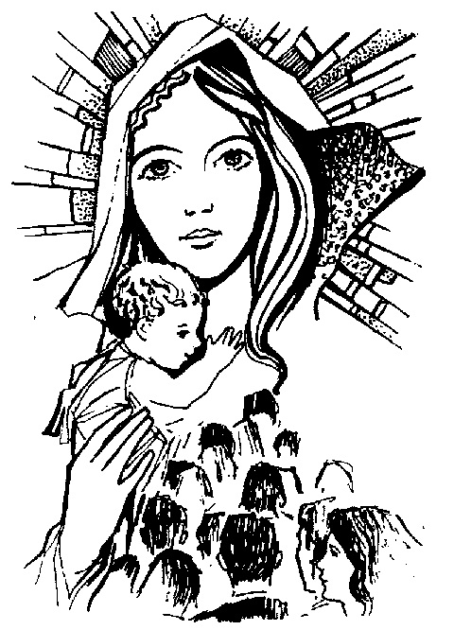

May you remember that you carry the precious gift of Star-light within you.
May you greet this Star-Light with gratitude and amazement each day when you awaken.
May you be led by this Star-Light to the places in your life where love is greatly needed.
May this Star-Light shine radiantly in your life and bring you abundant joy.
J Rupp.
Santa’s Prayer.

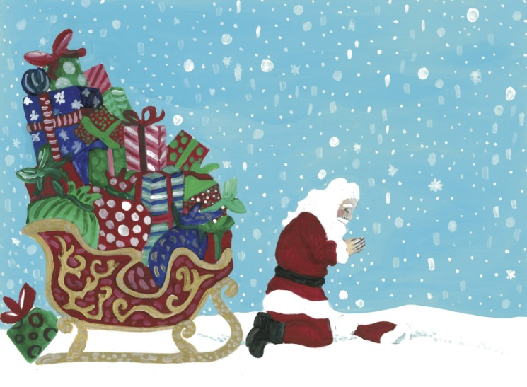T he sleigh was was all packed, the reindeer were fed,
But Santa still knelt by the side of his bed.

“Dear Father, ” he prayed, “Be with me tonight.There’s much work to do and my schedule is tight.
My sack will hold toys to grant all kids’ wishes. The supply will be endless like the loaves and the fishes.

I can do all these things, Lord, only through You. I just need your blessing, then it’s easy to do.

I do this only to honour the birth of the One,
That was sent to redeem us, Your most Holy Son.
So to all of my friends, lest Your glory I rob,
Please, Lord, remind them who gave me this job.”

God, please remind them when they dream of Santa tonight, that You are the reason He is out taking flight.
May his gifts and the presents remind them of You... and the presence you gave when God sent you.

